Manuale d'uso - Fabrick Payment Orchestra for WooCommerce
Installing, configuring, and using the payment plugin on a daily basis

Version: v1.0
Compilation date: 04/08/2026
Prodotto: Fabrick Payment Orchestra for WooCommerce

About the document
Title: User manual - Fabrick Payment Orchestra for WooCommerce

Document Version: v1.0
Compilation date: 04/08/2026
Documented product: Fabrick Payment Orchestra for WooCommerce
Reference plugin version: 0.2.11 or later
Language: Italian
Warning: the screenshots in this manual come from a demo environment connected to the Fabrick sandbox. Names, addresses, orders, amounts and credentials visible in the figures are test data; no real payment has been made. The exact appearance of the screenshots may vary with the theme and the version of WordPress and WooCommerce in use.

Introduction
This manual describes the Fabrick Payment Orchestra for WooCommerce plugin: the payment module that connects a WooCommerce store to the Fabrick Payment Orchestra platform to collect by card and with the alternative payment methods enabled on your contract.
The manual is aimed at those who manage the store: installation and activation, credentials, guided configuration, gateway settings, payment methods, checkout as seen by the customer, saved cards, subscriptions, Pay By Link, order management, refunds, debugging, migration from the GestPay plugin and troubleshooting.

Table of Contents
Introduction | 3
User manual for merchants | 1
Introduction and requirements | 2
Installing and activating the plugin | 6
Obtaining credentials on the Fabrick platform | 10
5-step activation wizard | 14
Gateway settings | 22
Sandbox environment and move to production | 30
Payment methods | 39
The checkout as seen by the customer | 46
Saved cards and OneClick payment | 54
Subscriptions with WooCommerce Subscriptions | 58
Send a payment link (Pay By Link) | 63
Order management and payment statuses | 70
Refunds and cancellations | 76
Debug e log | 84
Migrating from the GestPay plugin | 90
Troubleshooting | 96

User manual for merchants

Introduction and requirements
Fabrick Payment Orchestra is the payment gateway that connects your WooCommerce store to the Fabrick Payment Orchestra platform. Once configured, the plugin creates the payment session on the platform, shows the customer the payment module hosted by Fabrick, receives confirmation of the outcome and updates the WooCommerce order status without manual intervention.
With a single configuration, the store accepts credit cards and alternative payment methods enabled on the Fabrick terminal, manages 3-D Secure authentication, full and partial refunds and cancellation of authorizations from the order screen. Cards saved with OneClick payment, automatic subscription renewals when WooCommerce Subscriptions is active and sending a payment link to the customer directly from the order are also available.
The card data never passes through your server: the customer types them into the payment component served by the Fabrick domains, which transmits them only to the platform. The store only receives the transaction reference and, in the case of saved cards, a token with the last four digits. This architecture keeps the site in the lightest PCI DSS perimeter, the SAQ-A self-assessment questionnaire, and relieves you of the obligation to store or process card numbers and security codes.
Figure 1. The plugin in the list of installed WordPress plugins, with the version you are using.

Prerequisites
Before installing the plugin, check that the store environment complies with the minimum requirements shown in the table. The versions indicated are those declared by the plugin: below PHP 8.0 or WooCommerce 9.0 the gateway does not start and shows a warning on the dashboard.
Technical requirements of the plugin

Requirement | Value | Why you need it
WordPress | 6.4 or higher (verified up to 7.0) | Minimum version supported by the plugin.
PHP | 8.0 or higher | With previous versions the plugin  stops and signals the requirement.
WooCommerce | 9.0 or higher (verified up to 10.0) | The gateway registers among WooCommerce payment methods.
Order storage | Compatible with HPOS, high order storage  performance, and with classic storage | The plugin declares HPOS compatibility, so you can activate it  without losing payment information on orders.
SSL certificate | HTTPS valid throughout the site,  Mandatory in production | The return of the customer from the  payment and platform notifications reach your store addresses: they must be served in HTTPS.
Connection to Fabrick | Outbound HTTPS calls from the server to the Fabrick platform | Creating the payment session, verifying the outcome, refunds and reading active methods  pass through the Fabricic APIs.
Fabrick Contract | Shop Login and API Keys for sandbox and production | These are the credentials with which the plugin communicates with the platform.

WooCommerce Subscriptions | Optional | This is only for subscription products and auto-renewals.

Procedure
Check the requirements on the standard WordPress and WooCommerce screens – it only takes a few minutes and saves you from an installation that crashes at the first warning.
- Open Tools → Site Health → About and expand Server to read the PHP version, then WordPress for the CMS version.
- Open WooCommerce → Status and check the Environment section for the WooCommerce version and site addresses, which in production must start with https://.
- If you want to work with high-performance order storage, open WooCommerce → Settings → Advanced → Features and check the order storage option.
- Retrieve the Shop Login and the API Key of the sandbox environment from the Fabrick backoffice: you need them immediately after installation, when the store runs the activation wizard.

Expected outcome
At the end of the verification, you know that the store meets the minimum requirements and you have the sandbox credentials available. You can then proceed with the installation: after activation, the plugin appears in the list of WordPress plugins and the Fabrick Payment Orchestra gateway appears in WooCommerce → Settings → Payments, initially deactivated, waiting for configuration.

Notes and constraints
  - A single checkout flow. Payment always takes place on the secure payment page of the order, where the Fabrick payment component is loaded. There are no alternative methods to choose from during the configuration phase: those who arrive from the previous GestPay plugin no longer have to decide between Starter, Professional, On Site or iFrame.
  - No configuration of reply URLs. The addresses to which the platform communicates the outcome are sent by the plugin with each payment. You don't have to paste them into the Fabrick backoffice, nor declare IP addresses.
  - Classic and block checkout. The gateway works with both: in both cases, the customer arrives at the same secure payment page.
  - The visible methods also depend on the contract. At checkout, only the methods that are active on the Fabrick terminal and enabled at the same time in the plugin settings are displayed. The activation of a new method on the terminal is requested from the Fabrick sales representative.
  - Sandbox first. The plugin keeps sandbox and production credentials separate: you can test the entire flow with test cards and only go into production when the results convince you.
  - Personal data in logs. The technical log is disabled by default. When you activate it, requests sent to the platform may contain

Customer billing and email: Keep it on only for the time necessary for a diagnosis.

Special cases and errors
  - "Fabrick Payment Orchestra requires PHP 8.0 or higher." The server is using a version of PHP that is too old. Update PHP from your hosting panel, then reload the dashboard.
  - "Fabrick Payment Orchestra requires WooCommerce installed and active." WooCommerce is either absent or deactivated. Install and activate it: without WooCommerce the gateway is not registered.
  - "Fabrick Payment Orchestra requires WooCommerce 9.0 or higher." Update WooCommerce from the plugins screen. Before updating, make a backup copy of the site.
  - The plugin does not appear among the payment methods. Check that you have activated the plugin from the Plugins screen and that no requirement notice remains on the dashboard: as long as a requirement is missing, the gateway does not enter the WooCommerce list → Settings → Payments.
  - Site reachable only in HTTP. In production, platform notifications and customer return must travel over HTTPS. Install a valid certificate and set site addresses in https:// before accepting real payments.

Frequently Asked Questions

Do my customers' card numbers end up on my server?
No. The form in which the customer enters the data is served by Fabrick domains and sends the card number and security code only to the platform. Your site receives the transaction reference and, if you have activated the saved cards, a token with the last four digits. For this reason, the store falls within the PCI SAQ-A perimeter.

Can I keep the old GestPay plugin active during the switch?
It's not convenient: two gateways that manage the same contract at the same time confuse the customer at checkout and make it difficult to understand which plugin has recorded a payment. Configure the new plugin in the sandbox, test the flow, then deactivate the old plugin and activate the new gateway in production. Orders that have already been paid remain viewable.

Do I have to choose an integration mode as I did before?
No. The plugin has only one payment flow and no choice between different contract methods. The only configuration decisions are about the environment, sandbox or production, the payment methods to be offered and optional features such as saved cards.

Do I need to enable high-performance order archiving?
It is not mandatory: the plugin declares compatibility with high-performance order tables and also works with classic archiving. If you activate it, the payment information remains readable on the order screen exactly as before.

Do I need the SSL certificate for sandbox tests as well?
In production it is mandatory. Even in sandbox it is convenient to work on a site reachable in HTTPS: the platform must be able to contact the store's notification addresses to confirm the outcome, and an environment that cannot be reached from the outside leaves orders waiting even when the payment has been successful.

Installing and activating the plugin
The installation brings the plugin into WordPress and makes it available to WooCommerce. These are two separate operations: first you install the package, then you activate the plugin. Only with activation is the Fabrick Payment Orchestra gateway registered among the WooCommerce payment methods and the store opens the configuration wizard.
At the end of this chapter, the plugin is active and the store asks you for your Fabrick credentials. No payment is possible yet: the gateway is deactivated and remains invisible to the customer until you complete the configuration and enable it explicitly.

Prerequisites
  - WooCommerce installed and active, version 9.0 or higher. Without WooCommerce the gateway is not registered.
  - WordPress 6.4 or higher and PHP 8.0 or higher on the store server.
  - A WordPress account that can install and activate plugins, typically a site administrator. WooCommerce management permissions are also required for the wizard.
  - The plugin installation package, if the store doesn't download it from the WordPress plugin directory: it's the .zip file provided by your referee.
  - A recent backup copy of the site and database. Applies to any installation on a store that is already in production.
  - The Shop Login and the API Key of the sandbox environment at hand: immediately after activation the shop asks for them.

Procedure
The plugin is installed with standard WordPress screens. Step 3 and step 4 are two alternative ways: choose the one that suits how you received the plugin.
- Open Plugins → Installed Plugins and verify that WooCommerce is present and in the active state. If it is not, install and activate it before continuing.
- Open Plugins → Add New Plugin.
- Install from the plugin directory. Type Fabrick Payment Orchestra in the search field, locate the plugin tab and press Install Now. When the installation finishes the button changes to Active.
- Install from the zip file. Press Upload Plugin at the top, choose the .zip file you received, and press Install Now. WordPress unpacks the package and shows the outcome with the Activate Plugin link (Figure 2).

Figure 2. The Upload Plugins panel, used when the package arrives as a zip file.

- Press Activate (or Activate plugin if you arrive from the loading screen). WordPress confirms the activation and the plugin appears in the list of Installed Plugins → Plugins with the version number (Figure 3).
Figure 3. The installed plugin is waiting to be activated in the list of WordPress plugins.
- Immediately after activation, the store takes you to the configuration wizard. If, on the other hand, you remain on the plugins screen, open any WooCommerce page: at the top appears the notice Fabrick Payment Orchestra requires configuration before accepting payments. with the Complete configuration link →.
The alert that invokes the configuration, with the direct link to the wizard.

Expected outcome
The plugin is active in the list of plugins and the store opens the first screen of the configuration wizard, which asks for your Fabrick account credentials. The gateway is registered in WooCommerce → Settings → Payments but remains deactivated, so no customers see it at checkout.
Until the configuration is completed, opening the gateway settings automatically takes you back to the wizard: this is the path provided so that you don't leave the credentials halfway through. The configuration wizard is described in the dedicated chapter.

Notes and constraints
  - WooCommerce is a stated requirement. The plugin indicates WooCommerce as a necessary plugin: on WordPress versions that support this declaration (6.5 and later) activation remains blocked and WordPress reports the missing plugin. On previous versions, activation succeeds, but the gateway does not start working and the dashboard shows the requirement warning.
  - Don't rename the plugin folder. If you copy files by hand, the folder should remain
fabrick-payment-orchestra dentro wp-content/plugins/.
  - Only one copy installed. Don't keep two versions of the plugin in your plugins folder: WordPress will show two entries and the update will become ambiguous. To switch to a newer version, update the existing plugin instead of placing a copy side by side.
  - Activation does not affect existing data. It does not modify orders, does not change the settings of other payment methods and does not send anything to the Fabrick platform. The first communication with the platform takes place when you run the connection test in the wizard.
  - Reactivate after a completed setup. If you deactivate and reactivate the plugin on an already configured store, the wizard will not reopen and the saved credentials will remain in place.

  - Deactivation with payments in progress. Deactivation removes outcome checks that are still in the queue. If a customer is paying at that time, the order can be waited: choose a quiet time and check recent orders after reactivation.

Special cases and errors
  - "Fabrick Payment Orchestra requires WooCommerce installed and active." WooCommerce is absent or deactivated. Install and activate it, then reload the dashboard: the gateway appears among the payment methods.
  - "Fabrick Payment Orchestra requires WooCommerce 9.0 or higher." Update WooCommerce from the plugins screen. Back up your site first.
  - "Fabrick Payment Orchestra requires PHP 8.0 or higher." The server is using a PHP version that is too old. Change PHP version from the hosting panel and reload the dashboard.
  - "Fabrick Payment Orchestra: run composer install in the plugin directory." The installed package is incomplete, typically because the zip is not the distribution one. Delete the plugin from the plugins screen and install the official package provided by your contact person again.
  - "The uploaded file exceeds the maximum allowed size" or similar errors when uploading. The hosting upload limit is too low. Ask the provider to increase it, or upload the plugin folder to wp-content/plugins/ with the hosting panel's file manager or via FTP.
  - "The destination folder already exists." A copy of the plugin is already present. If you're updating, use the plugin's update feature; if you're reinstalling, delete the existing entry from the plugins screen first.
  - Activation does not open the wizard. It happens when you activate multiple plugins together, when the account does not have WooCommerce management permissions, or when the configuration was already completed in the past. In the first two cases, open WooCommerce → Settings → Payments → Fabrick Payment Orchestra: you are taken to the wizard.

Frequently Asked Questions

Looking on the Add Plugin screen I can't find Fabrick Payment Orchestra: how do I proceed?
Use the zip file provided by your contact person and install it with Upload Plugin, as described in step 4 of the procedure. Installing from the file and installing from the plugin directory lead to the same result: only the way the package arrives on the site changes.

The activation button is not available and WordPress reports a required plugin to me: what is missing?
WooCommerce is missing, which the plugin declares as a requirement. Install and activate WooCommerce in version 9.0 or higher, then return to the plugins screen: the activation link becomes available.

Can I install the plugin by copying the folder via FTP?
Yes. Unpack the package and copy the fabrick-payment-orchestra folder to
wp-content/plugins/ keeping the original name, then activate the plugin from Plugins → Installed Plugins. This is the recommended route when the hosting upload limit does not allow the upload of the zip.

Does activating the plugin involve risks for the already online store?
Activation registers the gateway but leaves it deactivated, so the checkout remains exactly as before and no customer sees the new payment method. The gateway becomes available only when you complete the configuration and enable it in the payment settings.

I closed the wizard before finishing it: how do I reopen it?
Open a WooCommerce page and use the Complete configuration link in the notice above. Alternatively, open WooCommerce → Settings → Payments → Fabrick Payment Orchestra: until the configuration is complete you are taken back to the wizard, which resumes from the step where you stopped.

What happens if I disable the plugin?
The gateway stops being offered at checkout and the outcome checks still in the queue are removed; credentials, settings and order data remain saved. Avoid deactivating it while payments are in progress, otherwise some orders may remain waiting for confirmation.

Obtaining credentials on the Fabrick platform
The plugin communicates with the Fabrick platform through two pieces of data that identify and authenticate your store: the Shop Login, i.e. the store code on the platform, and the API Key, the secret key that authorizes calls. Without this pair, the gateway cannot create the payment session, verify the outcome of a transaction, read the methods active on the terminal or send a refund.
The credentials are not generated by the plugin and are not obtained from WordPress: you retrieve them from the backoffice of the Fabrick platform, where they are managed in the section dedicated to security. This chapter explains what to look for and how to keep the two environments separate; the insertion in the store takes place immediately after, in the activation wizard.

The two credentials required by the plugin

Credential | What is it? | How the plugin uses it
Shop Login | The code of the store, or terminal, on the Fabrick platform. Identifies the point of sale to which the payment methods and contract conditions are associated. | It is sent in every payment request and appears in the Shop Login field of the gateway settings.
API Key | The secret key associated with the store, managed in the Security section of the Fabrick backoffice. It should be treated as a password. | Authenticates calls to the platform. In the API Key field, it is always masked: the saved value is no longer shown in plain text.

Prerequisites
  - An active contract with Fabrick for online collection services, with the store configured on the platform.
  - A user enabled to access the Fabrick backoffice, with the necessary permissions to consult or generate the API Key. If you do not have the utilities, the reference is your Fabrick sales representative.
  - The name of the Fabrick sales contact or support contact: it is used for the activation of the store, for the activation of payment methods and for the production environment.
  - A safe place to store your API Key, such as your corporate password manager. Don't send it via chat or unsecured email, and don't write it in shared documents.

Sandbox and production: two distinct pairs
The platform provides two separate environments, and each has its own pair of credentials. The plugin stores them independently: changing environments doesn't overwrite what you've already saved, so you can go back to the sandbox for a trial and re-enter production without re-entering anything.
Differences between the two environments

Environment | What it is used for | What it entails
Sandbox | Testing of the entire payment flow with cards and test data. | No real charges. This is the environment with which you set up your store the first time and with which you re-verify after each major update.

Production | Real receipts from the store's customers. | Transactions are effective and refunds move money. Activate this environment only after validating the flow in the sandbox.

The two pairs are not interchangeable: sandbox credentials do not authenticate production calls, and vice versa. If you try to use them in the wrong environment, the plugin's connection test returns an authentication error.

Procedure
- Access the backoffice of the Fabrick platform with the user credentials that were given to you when the contract was activated. The access address and authentication methods are those indicated by your Fabrick contact person.
- Locate the store you want to work on and write down its Shop Login: this is the identification code that the platform associates with the terminal. If your contract includes several stores, check that you have selected the one corresponding to the WooCommerce site you are configuring.
- Open the store security section: this is the area where the platform manages the API Key. Here you can consult the existing key or generate one, according to your user profile.
- Copy the API Key and store it in your password manager right away: some platforms only show the key in plain text at the time of generation. If you lose the value, you will need to generate a new one and update it in the plugin as well.
- Repeat the collection for the production environment when the real store is ready. If the production credentials are not yet available, ask the Fabrick sales representative: they are part of the contract activation path and are not generated by the plugin.
- Go back to WordPress and enter the pair in the Shop Login and API Key fields of the activation wizard, or in WooCommerce → Settings → Payments → Fabrick Payment Orchestra if the initial configuration has already been completed. Immediately afterwards, run the connection test.

Expected outcome
At the end of the process, you have at least the Shop Login and API Key pair of the sandbox environment, and in view of the go-live also the production one, stored securely. With this data, the plugin's connection test returns a positive result and the store can create payment sessions on the platform. After saving, the API Key is no longer visible in plain text in the settings: the field remains masked and, if you leave it empty, the plugin keeps the key already registered.

Notes and constraints
  - The API Key is a secret. Owners can operate on the store through the platform's APIs. Limit sharing to the people who set up the site and revoke it, generating a new one from the back office, if you suspect it has been exposed.
  - If you regenerate the key, update it in the plugin. The old key stops working: until you paste the new one into the settings, payments fail with an authentication error.

  - Fill out both environments before go-live. If you leave the production fields blank, the store doesn't have its own credentials for the real environment. Enter the production pair and retest the connection before accepting real payments.
  - No addresses to configure on the back office. Unlike the previous GestPay plugin, you don't have to declare reply URLs or IP addresses: the plugin communicates the notification addresses to the platform with each payment.
  - Payment methods depend on the contract. Credentials enable dialogue with the platform, they do not decide which methods are available. The activation of cards, wallets and alternative methods on the terminal is requested from the Fabrick sales representative; in the plugin you only choose which of the active methods to propose to the customer.
  - The same applies to collection rules. The behavior of the card after authorization, with contextual or separate posting, is also a terminal configuration defined in the contract and managed on the Fabrick back office.
  - The credentials remain on your site. They are saved in the store's WordPress database: enter them yourself, without passing them on to third parties, and treat the backup copies of the database with the same attention as a password.

Special cases and errors
  - "Shop Login and API Key are required." One of the two fields is empty. Fill in both: the connection test starts only with the full pair.
  - "Authentication failed. Check Shop Login and API Key." The platform does not recognize credentials. Typical causes are a space pasted together with the value, a key regenerated in the meantime, or credentials from one environment used in the other. Copy the values back from the back office and try again.
  - "Fabrick Orchestra declined the request. Please check your credentials." Check that you have selected the correct environment in your settings and that the Shop Login matches the store to which the API Key belongs.
  - "Unable to contact Fabrick Orchestra. Please check your credentials and try again." The site's server could not reach the platform. Check with your hosting that outgoing HTTPS connections are allowed, then repeat the test.
  - "Too many failed authentication attempts. Please wait a few minutes and try again." After a series of failed tests, the plugin temporarily suspends the attempts. Retrieve the correct values from the back office and try again after a few minutes.
  - You come from the GestPay plugin. If the credentials of the previous plugin are still present on the site, the wizard proposes to import them only once as sandbox credentials and asks you to perform a connection test immediately. If the import does not find anything, enter the values by hand.
  - You can't find the keys section in the back office. Your user may not have the necessary permissions, or the store may not be fully active yet. In both cases, the correct channel is the Fabrick sales representative.

Frequently Asked Questions

Can I use the same credentials in sandbox and production?
No. The environments are separate and each one authenticates only its own credentials. Retrieve the pair of the environment you want to use from the backoffice and enter it in the corresponding field: the plugin stores the two pairs independently, so you can switch from one environment to the other without rewriting anything.

I have multiple WooCommerce stores: do I need different credentials for each?
It depends on how your contract is configured. Each site must be connected to the Fabrick store that corresponds to it, so if you have multiple stores on the platform, you will use the Shop Login of the right one for each site. If you have doubts about which code to associate with which site, ask the Fabrick sales representative for confirmation before configuring.

Where does the API Key end up after I save it?
It is registered in the store settings and from that moment the field shows it only masked. If you change other settings and leave the field empty, the saved key remains valid. To replace it, paste the new value and save: the dots you see in the masked field are not interpreted as a new key, so you don't risk deleting the saved one by mistake.

Do I have to communicate my site address or server IPs to Fabrick?
No, not for the operation of this plugin. The addresses to which the platform communicates the outcome are automatically sent with each payment. An exception is the possible activation of Apple Pay in production, which requires you to publish a verification file provided by Fabrick on your domain.

Who provides me with the production credentials?
They go through the contractual path with Fabrick: you request them from your sales representative, who also shows you the activation process of the real store. You enter them in the plugin, in the Shop Login and API Key fields of the production environment; no one configures them for you on the site.

5-step activation wizard
Immediately after activating the plugin, WordPress opens the configuration wizard: five steps that connect the store to your Fabrick account, verify that the credentials work, define which payment methods to offer and determine whether the store should communicate with the sandbox or production environment. Until the procedure is completed, the gateway cannot accept payments, so it is advisable to complete it in a single session.
The procedure is located at wp-admin/admin.php?page=fabrick-orch-setup and occupies the entire browser window. The page does not appear in the administration menus: you can get there with the automatic reference after activation, with the Complete configuration link → of the Fabrick Payment Orchestra notice requires configuration before accepting payments, or by opening the gateway tab in WooCommerce → Settings → Payments: until the configuration is incomplete, that tab refers to the wizard.

Prerequisites
  - Plugin installed and active, with environment requirements already verified (PHP, WooCommerce and order storage).
  - WordPress user with permission to manage WooCommerce: those who do not own it receive the message You do not have permissions to access this page.
  - Shop Login and API Key of the merchant account, taken from the Fabrick backoffice. These are the credentials with which the store authenticates itself to the platform.
  - Outbound HTTPS calls allowed by the server: The connection test really queries the Fabrick platform and without an outbound network it cannot succeed.
  - List of payment methods provided for in the contract, if you want to decide right away which ones to offer at checkout.

Procedure
At the top, the progress indicator with the five steps Welcome, Account, Payment Methods, Environment and Completion is always visible. From the second step onwards, the Back button returns to the previous step without saving the current one, while Exit configuration at the top right returns to the list of WooCommerce payment methods. If you exit before the end, when you reopen the procedure starts again from the step you had reached.
- Welcome. The Welcome to Fabrick Payment Orchestra screen lists the technical requirements on which the plugin rests: the minimum PHP version, the minimum WooCommerce version, and compatibility with high-performance order storage. There are no fields to fill in: press Start.

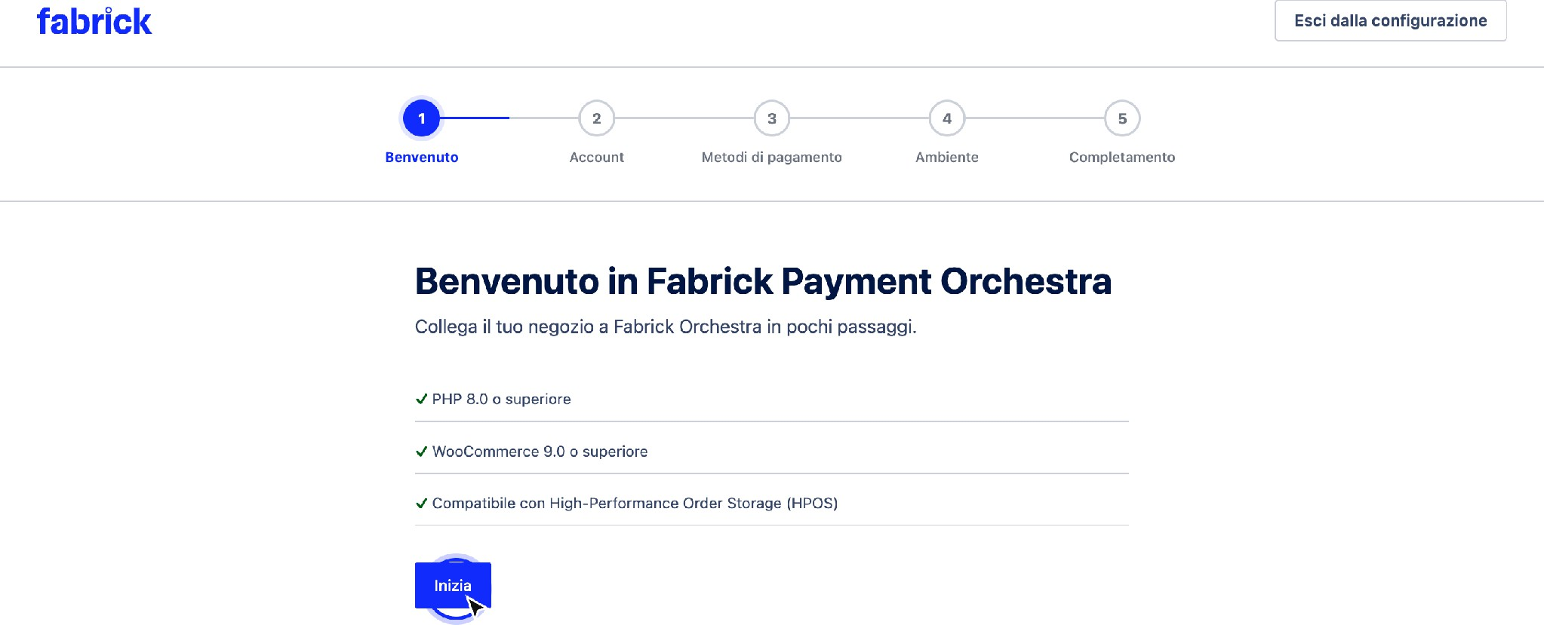

The first step summarizes the technical requirements and shows the progress indicator of the five steps.
- Account. On the Connect your account screen, Fabrick fills in Shop Login with the identifier of your store on the platform, up to 64 characters, and API Key with the associated key. The key field is masked and never repeats the value already stored: if a key is already saved, the field shows a fictitious value and the suggestion Leave blank to keep the API Key saved.

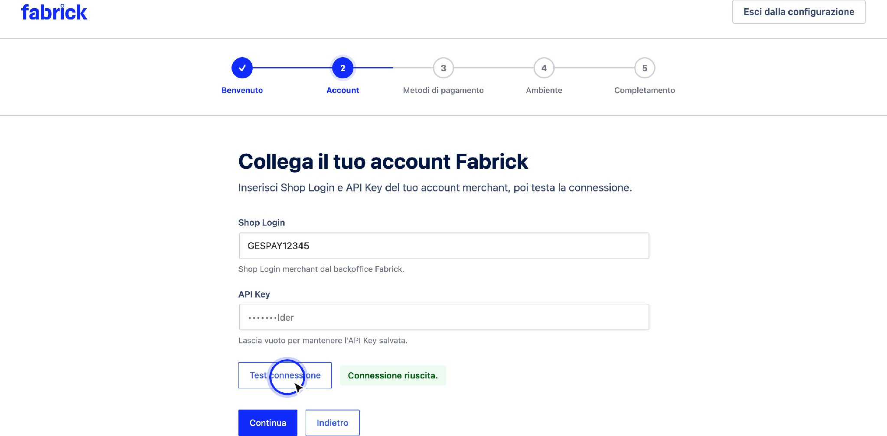

The Account step collects Shop Login and API Key and provides the connection test.
- Credential verification. Press Test connection: the plugin sends the values typed to its server, which queries the Fabrick platform with the indicated account. The label next to the button changes from Not yet tested to Test connection in progress and finally to Connection successful. The key is never returned to the browser or shown in plain text. When the result is positive, press Continue: without a successful test, the procedure remains on track and reports Run a successful connection test before continuing.
- Credentials from the GestPay plugin. If the credentials from the previous GestPay for WooCommerce plugin are still present on the site and have not already been retrieved, the We found credentials from the legacy GestPay for WooCommerce plugin box appears above the fields with the Import legacy credentials button. By pressing it, Shop Login and API Key are copied into the fields of this procedure and the plugin notifies you with Legacy GestPay credentials imported. Run a connection test before continuing. The operation is available only once: after importing, the tile never returns.
- Payment methods. The Choose which alternative payment methods to offer at checkout screen lists the methods with a switch for each, starting with Card (+ wallet if enabled). After a successful test, the list reflects the methods that the platform returns for your account; the items marked as New are those that have appeared compared to the plugin's default list. Some lines may be blocked with the indication Always enabled: these are methods managed by the platform, to be dealt with the Fabrick backoffice or with your sales representative. Turn off what you don't want to propose and press Continue.

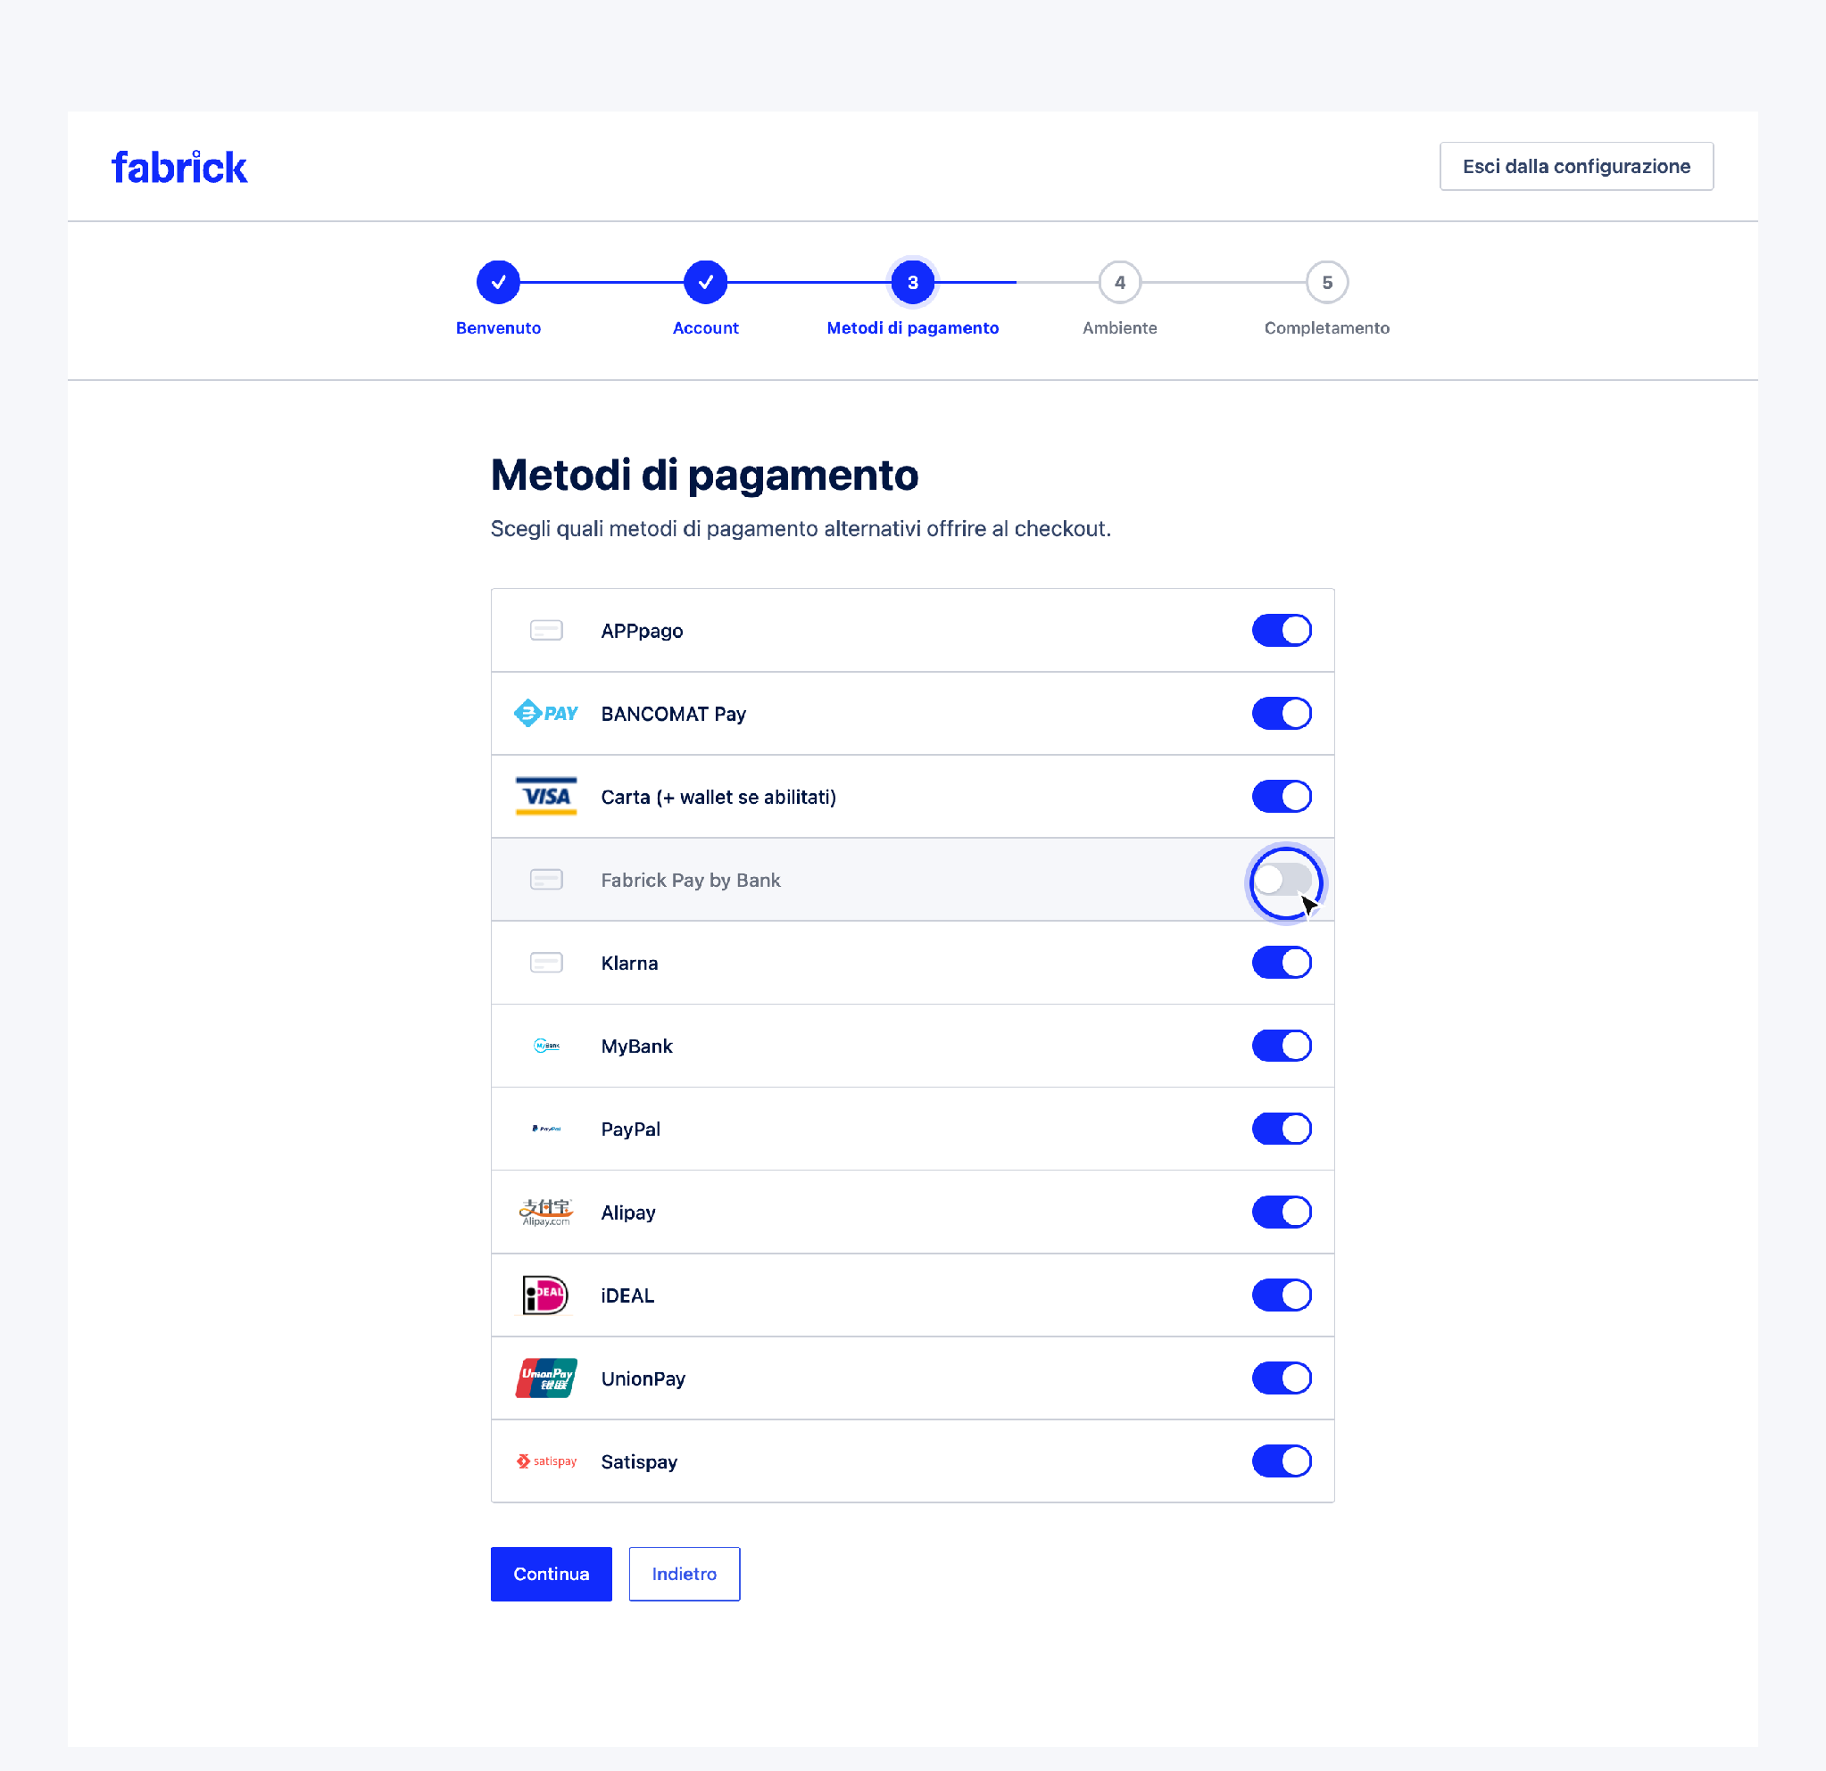
Each method has its own switch; locked rows remain active at all times.
- Environment. The Choose payment environment screen shows the linked account and two options. Sandbox is listed as Recommended during testing. No real charges. Live corresponds to Production Mode. Real payments use the Live Orchestra API: Selecting it displays the real payments warning and the I understand that Live Mode will process real payments box, which you must check to continue. The plugin uses the same account entered in the Account step for production as well and repeats the connection check on the chosen environment before advancing the procedure. Press Continue.

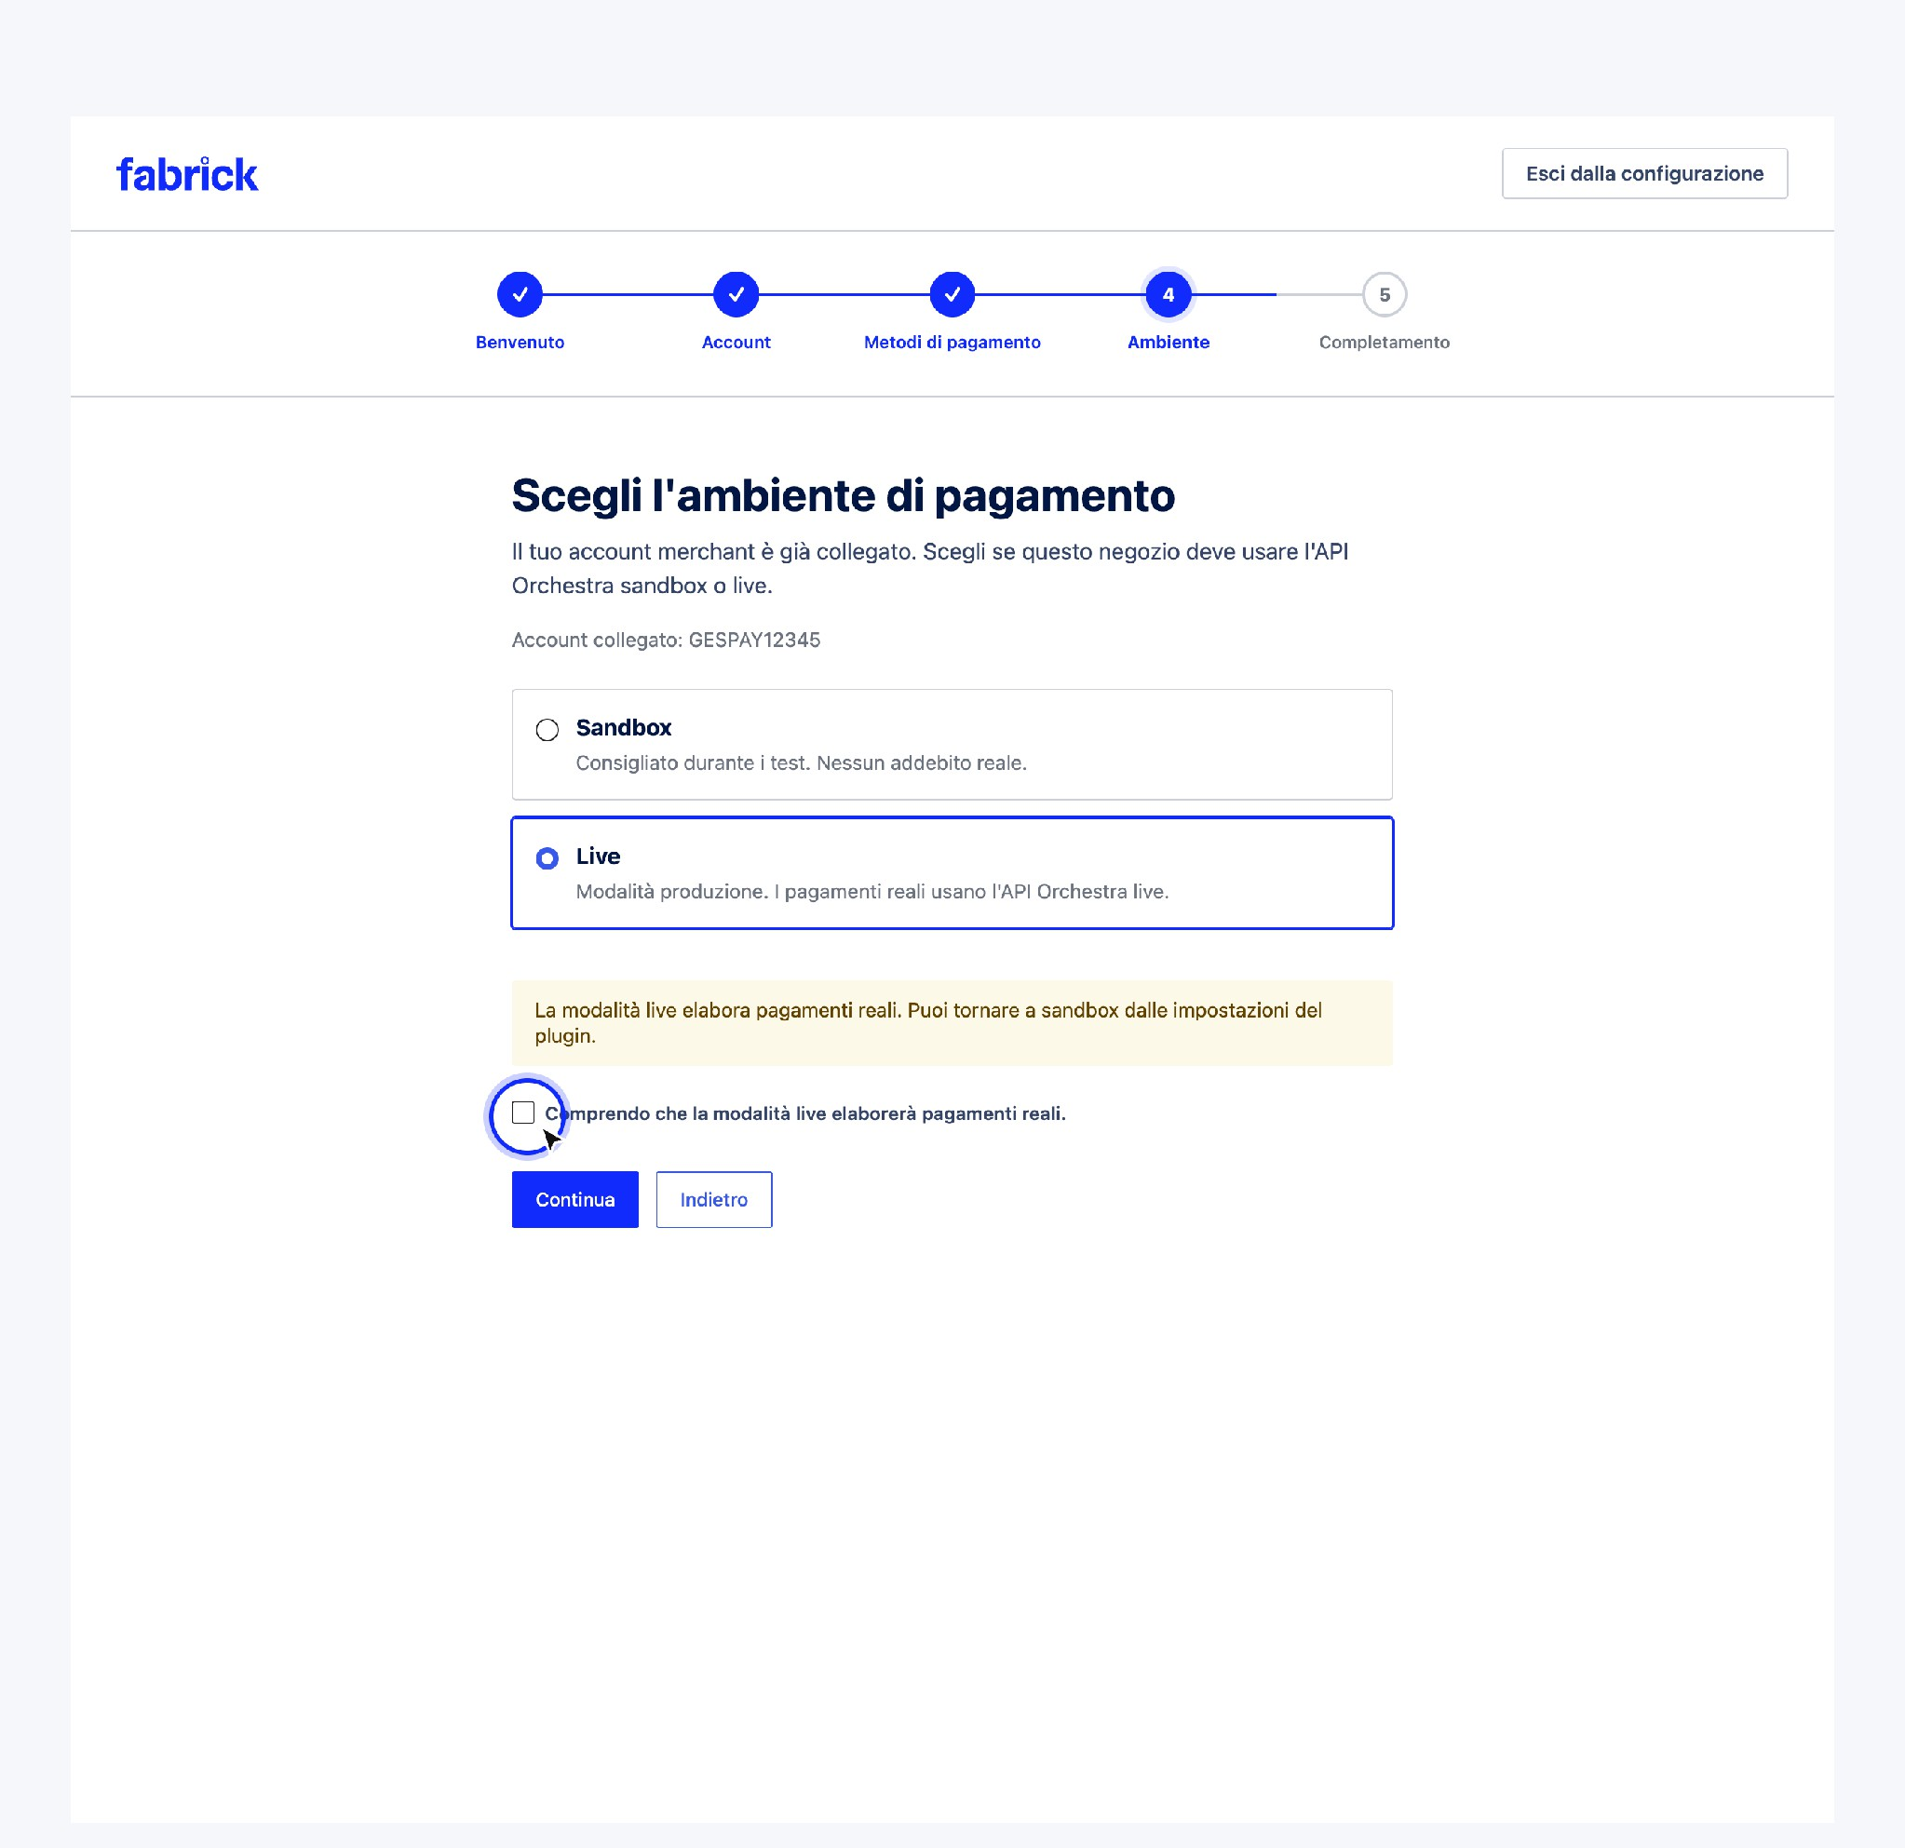
Choosing the live mode requires explicit confirmation before continuing.
- Completion. The You're Almost There screen summarizes Connected merchant account, Connection test passed, and the selected environment, and warns that the gateway will remain disabled until you manually enable it. Press Complete configuration: the plugin records the configuration as completed and takes you to the gateway tab in WooCommerce → Settings → Payments.

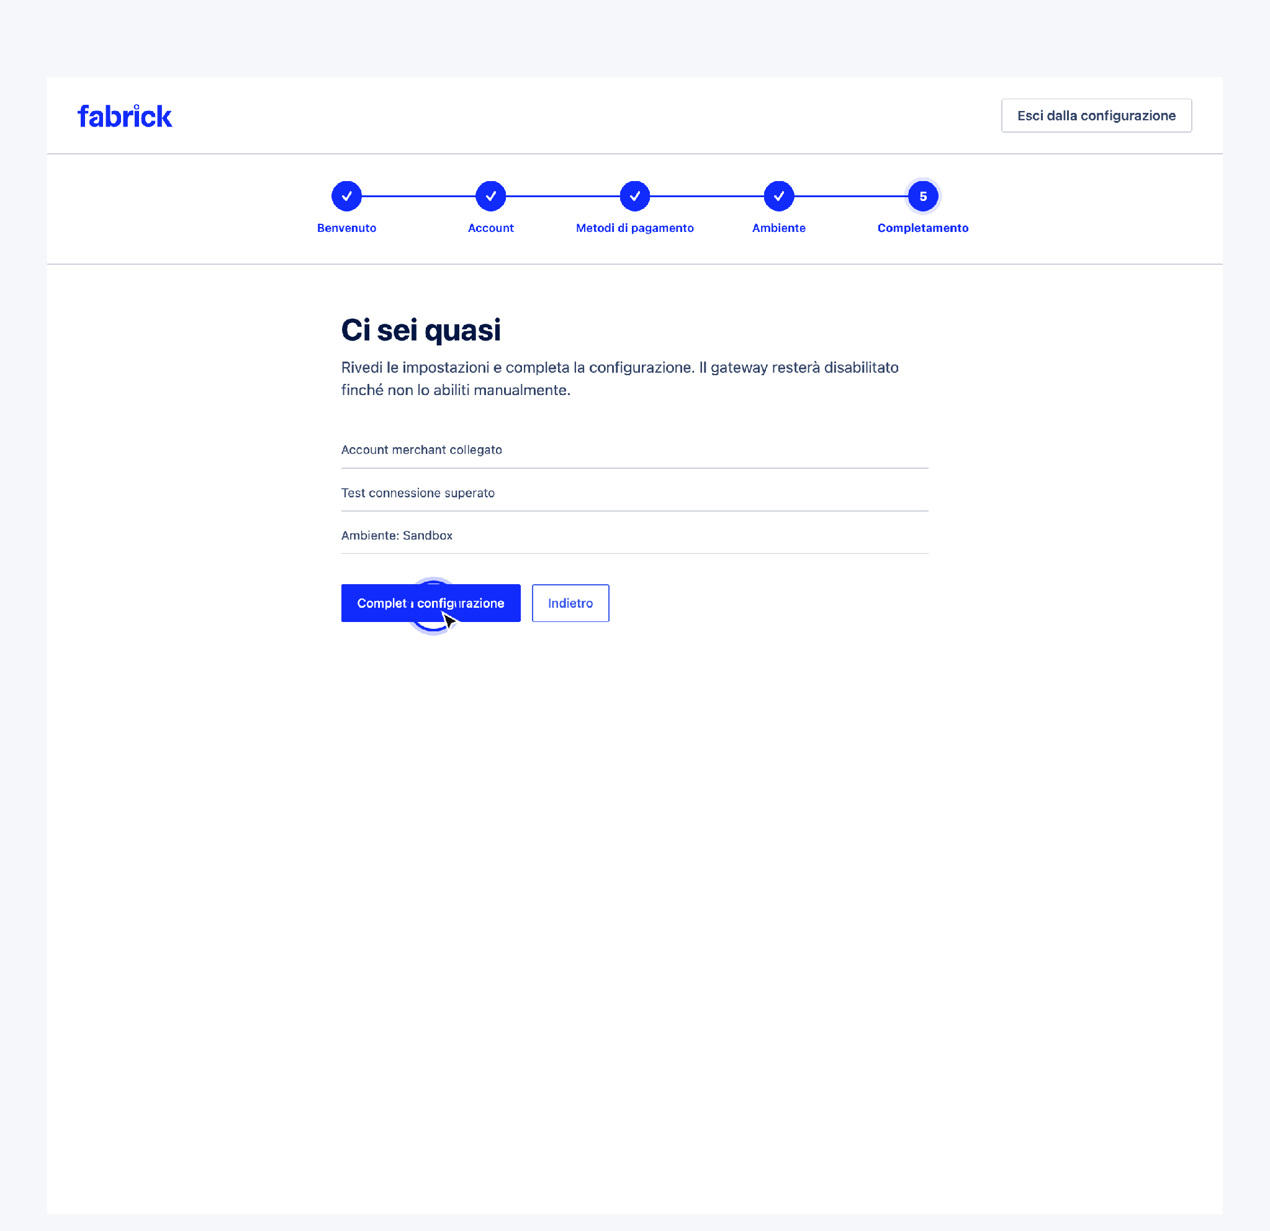
The final summary anticipates that the gateway remains deactivated until it is manually activated.

Expected outcome
At the end of the process, the store is connected to the Fabrick account with verified credentials, has a preference saved on the methods to be proposed and a defined working environment. The plugin opens the Fabrick Payment Orchestra tab among the WooCommerce payment methods and stops showing the incomplete configuration warning. If the chosen environment is the sandbox, the permanent warning Fabrick Payment Orchestra is in sandbox mode appears on the WooCommerce screens. No real charges will be processed.
The gateway, however, remains deactivated: no customer sees it yet at checkout. Activation is a separate and voluntary step, which is performed from the gateway tab and is described in the chapter dedicated to gateway settings.

Notes and constraints
  - The connection test is not optional. Moving from the Account step and closing the procedure both require a successful test with the credentials actually saved.
  - Changing your credentials cancels the test. If you change your Shop Login or API Key after a successful verification, the previous result no longer applies and you must retake the test before continuing.
  - The key is never seen. The saved API Key is not reprinted in the form, is not sent to the browser, and does not appear in error messages. To replace it, simply write the new value in the field.
  - Only one account for the two environments. The credentials entered in the Account step are also used in production when you choose live mode; there is no second credential module within the procedure.
  - The choice of methods is not final. The switches can be found in the gateway settings and can be changed at any time.
  - At checkout, only the methods that are active on both sides appear. A method can be seen if it is provided by the Fabrick terminal and, at the same time, turned on here. If it is missing on the contract, turning it on in the plugin does not make it available.
  - The gateway tab is closed during setup. Until the process is complete, opening the gateway tab in WooCommerce takes you back to the wizard.

Special cases and errors
  - "Shop Login required." The field is empty. Enter the store identifier taken from the Fabrick backoffice and try again. The value cannot exceed 64 characters: beyond that length the save is not successful.
  - "API Key required." There is no key stored and the field has been left blank. Paste the account key and retest.
  - "Authentication failed. Check Shop Login and API Key." The credential pair is not recognized by the platform. Check that you have copied the values of the correct environment, with no leading or trailing spaces.
  - "Unable to contact Fabrick Orchestra. Please check your credentials and try again." The call to the platform did not arrive at its destination: it is usually a block of the server's outgoing connections or a temporary network problem. Try again, and if it persists, ask the provider to unblock the outgoing HTTPS calls.
  - "Too many failed authentication attempts. Please wait a few minutes and try again." After a series of failed tests, the plugin temporarily suspends calls. Wait a few minutes, correct your credentials, and try again.
  - "Run a successful connection test before continuing." You pressed Continue without a valid verification for your current credentials. Run the test and wait for success.
  - "Confirm that you want to go live before continuing." You chose production without checking the confirmation box. Tick it and press Continue again.
  - "Unable to prepare for live mode. Please check the merchant account in step 2." You are missing a Shop Login or API Key to carry over to your production environment. Go back to the Account step, complete the fields, retest, and try your environment choice again.
  - "Connection test failed for the selected environment. Please check your credentials and try again." Credentials work on one environment but not the one you chose: it happens

when the trial account is used for production. Check with the Fabrick contact which credentials are valid in production.
  - "Run a successful connection test before completing the setup." The last check, performed at final confirmation, did not find a valid result for the active environment. Go back to the Account step, repeat the test, and finish again.
  - "No legacy GestPay credentials found to import." The old plugin options are no longer present or the recovery has already been performed. Enter the credentials by hand.

Frequently Asked Questions

Can I skip the connection test and set everything up afterwards?
No. The plugin only lets you advance beyond the Account step with a successful test and repeats the check both at the choice of the environment and at the final confirmation. It is a protection: without valid credentials, the store could not create any payment.

I updated the API Key and the label went back to "Not Tested Yet" - is this a problem?
No, this is the expected behavior. The stored result only applies to the pair of credentials with which it was obtained, so any changes reset it. Press Test connection again and continue when the confirmation appears.

If I choose the live mode, do I have to enter a second Shop Login?
Not in this procedure: the plugin reuses the account from the Account step and verifies it on the production environment. If your contract has different credentials for production, enter them in the Account step before choosing live mode, otherwise the final check fails.

What happens if I close the window mid-procedure?
Nothing irreparable. The data of the steps already confirmed remain saved and when you reopen the procedure starts again from where you left off. You can find it from the notice link on the bulletin board or by opening the gateway tab among the WooCommerce payment methods.

I imported the credentials from the old GestPay plugin: have orders and saved cards also migrated?
No. The recovery only concerns Shop Login and API Key, which are copied in the fields of this procedure, and must still be followed by a connection test. Historical orders remain available in WooCommerce as before, but are not reprocessed by the new plugin.

Can customers already pay at the end of the procedure?
Not yet. The procedure configures the connection with the platform, but leaves the gateway deactivated: the last screen explicitly declares it. The method appears at checkout only after you enable it from its tab in WooCommerce → Settings → Payments, as explained in the chapter on gateway settings.

Gateway settings
Once the configuration wizard is complete, everything related to the daily operation of the payment method is governed from a single screen: the gateway tab in WooCommerce → Settings → Payments → Fabrick Payment Orchestra. Here the gateway turns on, takes the name that customers read at checkout and shows the credentials with which the store talks to the platform.
The screen corresponds to the address
wp-admin/admin.php?page=wc-settings&tab=checkout&section=fabrick_orchestra and can also be reached by clicking on the method name in the WooCommerce list → Settings → Payments. At the top, next to the Fabrick Payment Orchestra title, the Back to Payments link takes you back to the full list of methods.
The content is organized in five boxes, in order: the box with the Fabrick logo that collects Payment Environment and Credentials, then Checkout View, Payment Methods, Saved Cards and Debug. At the bottom of the page there is only one Save Changes button: it applies to all the boxes together.

Prerequisites
  - Setup Wizard complete. If it is not, opening this tab returns to the wizard and the tiles are not shown.
  - WordPress user with permission to manage WooCommerce.
  - Shop Login and API Key already verified with a successful connection test on the active environment.
  - Decision made on how to call the method at checkout, if the default name isn't the one you want to show to customers.

Procedure
- Open WooCommerce → Settings → Payments and click on Fabrick Payment Orchestra. The page opens on the five panes, with the account one at the top (Figure 1).

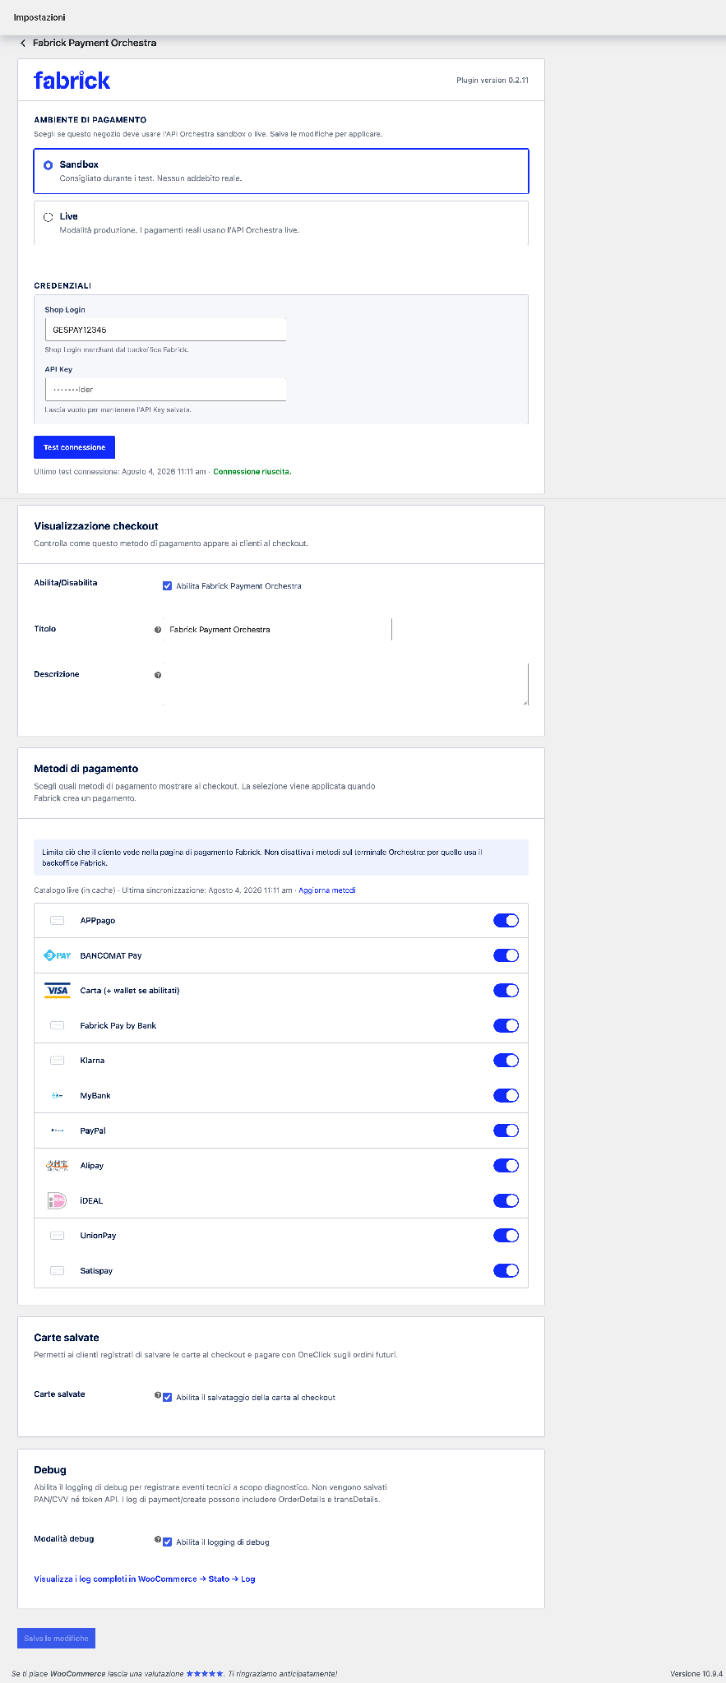
Figure 1. The gateway card collects accounts, checkout appearance, methods, saved cards, and diagnostics on a single page.

- In the Checkout View pane, check Enable Fabrick Payment Orchestra. It's the toggle that makes the method visible to customers: the configuration wizard deliberately leaves it off, so until you check it here no one can pay with Fabrick (Figure 2).
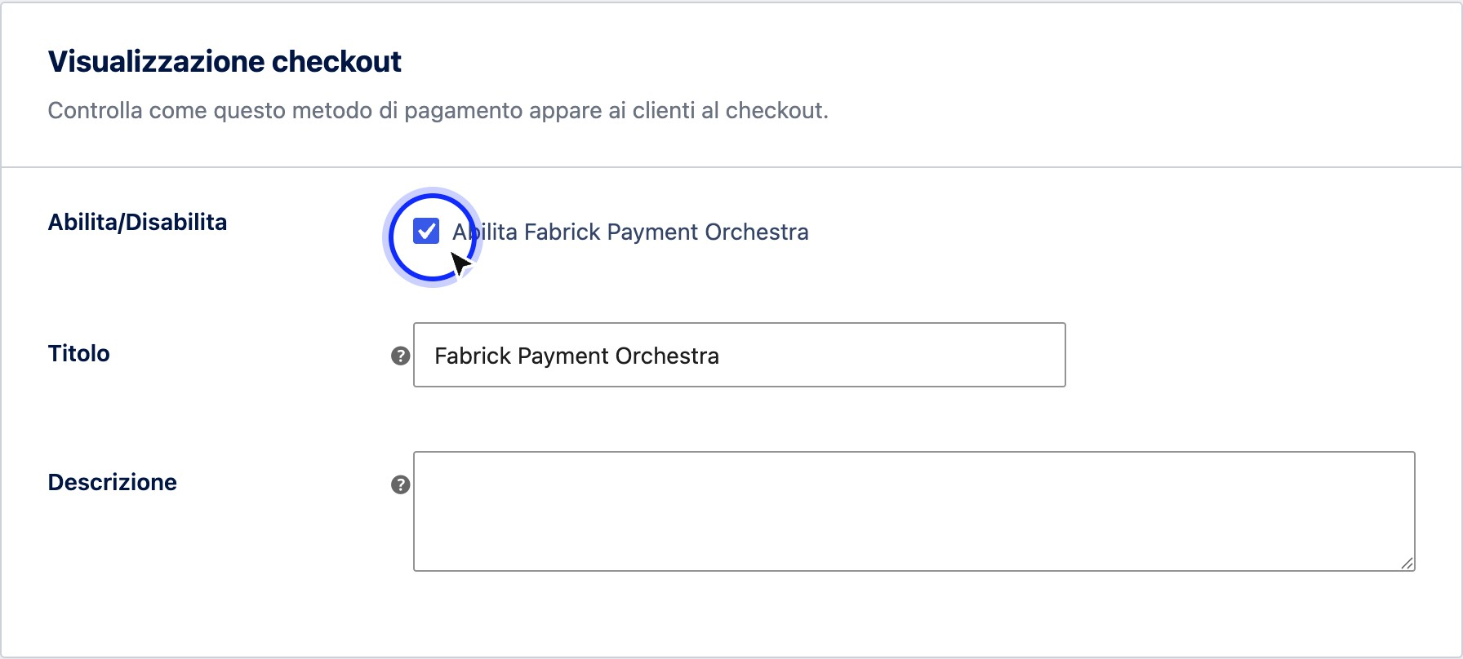
Figure 2. Enabling the gateway is an explicit check in the Checkout View pane.
- In the same box, check Title and Description: these are the two texts that the customer sees next to the payment method. The default title is Fabrick Payment Orchestra, the description is empty.
Checkout Display pane

Field | Description
Enable/Disable | Enable Fabrick Payment Orchestra box. Off at installation: as long as it remains off, the method does not appear at checkout. By turning it on, the method enters the store's payment choices.
Title | The name of the method shown to customers at checkout. Default value Fabrick Payment Orchestra: You can replace it with a formula that is more recognizable to your customers, such as Credit Card and others  methods.
Description | Optional text shown below the title at checkout. Blank by default. Useful for anticipating that the payment is completed on a secure page.

- Go up to the box with the Fabrick logo and verify the account. The Payment environment section shows which of the two environments is active, the Credentials section contains Shop Login and API Key, and below the fields the Test connection button with the status line Last connection test. The key field is masked: if a key is already saved it shows a dummy value and the suggestion Leave blank to keep the API Key saved (Figure 3).

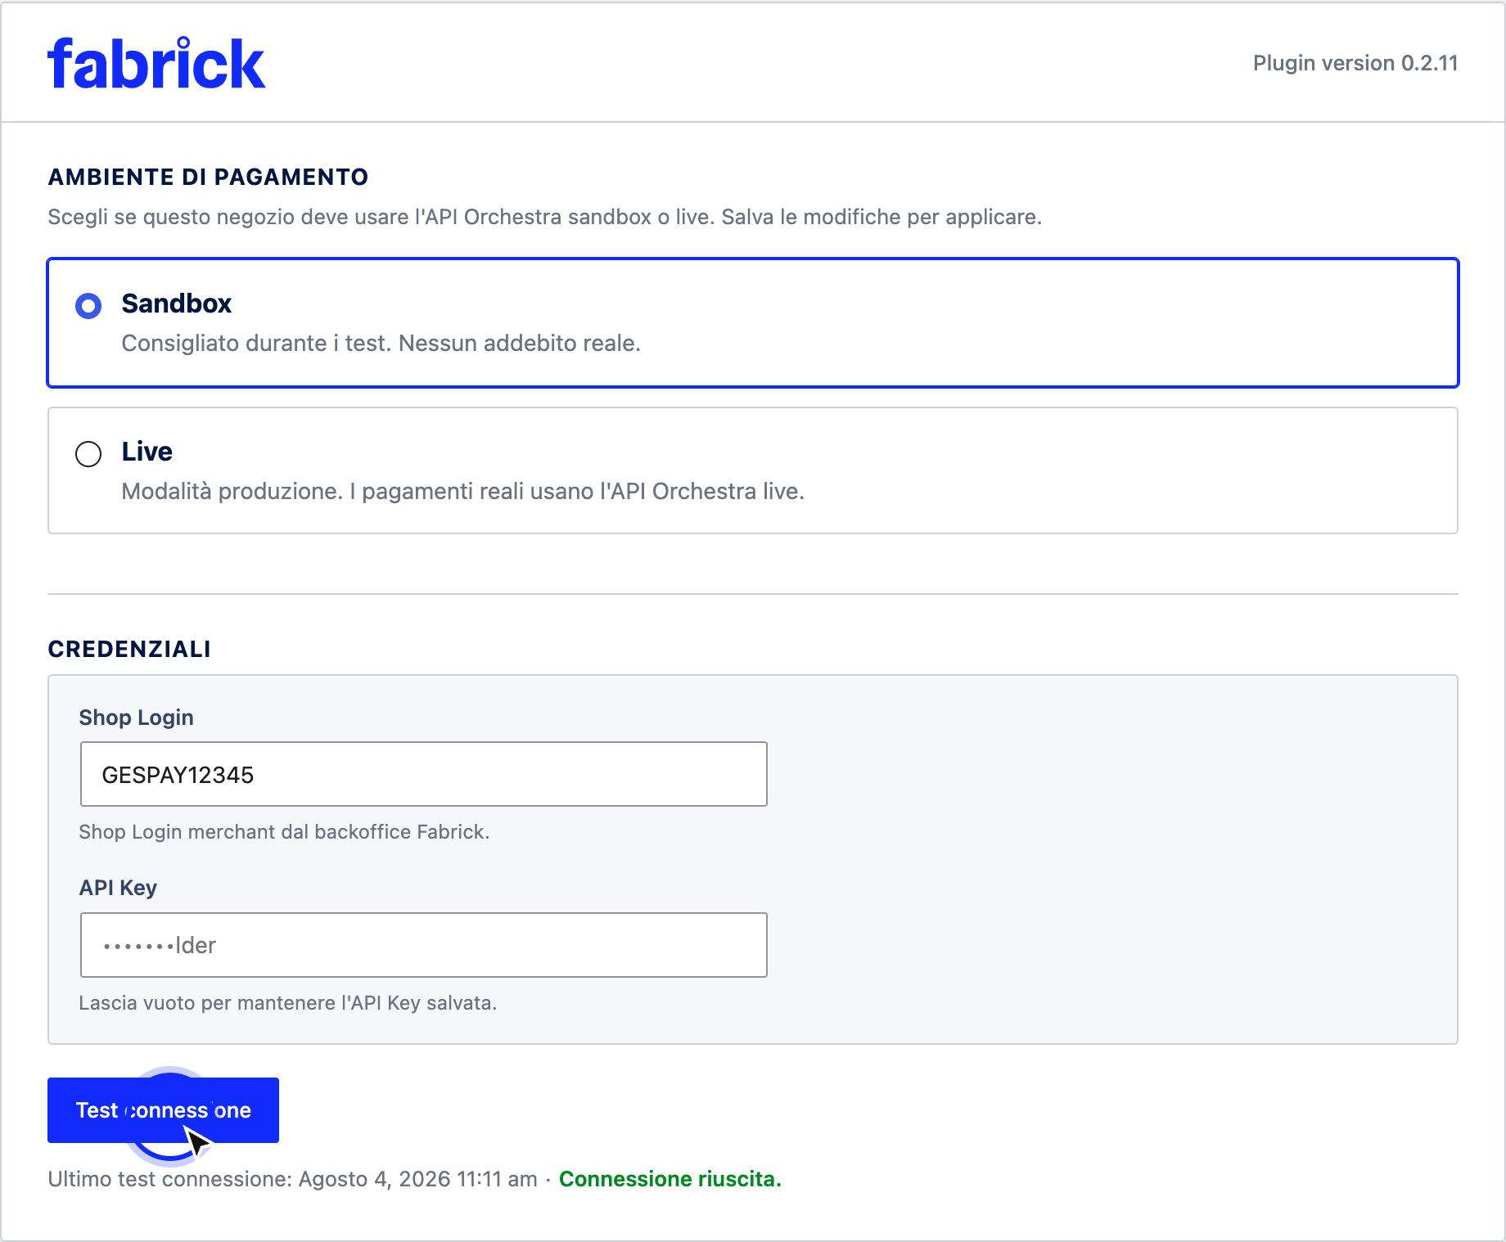
Figure 3. The account tile summarizes the environment, credentials, and date of the last connection check.
Account tile

Field | Description
Payment environment | Two alternative options, Sandbox (Recommended during testing. No real charges. ) and Live (Production mode. Real payments use the Live Orchestra API. ). The choice takes effect when you save. Selecting Live brings up the real payment confirmation box, without which the save stops.
Shop Login | Store identifier on the platform, with the Shop Login merchant suggestion from the back office  Fabrick. Required field: saving the page always requires it to be valued.
API Key | Key associated with the account, in a field  masked that never repeats the saved value. Leave it blank to keep the existing key, or type the new key to replace it.
Connection test | Button that queries the platform with the values present in the fields, without reloading the page. The status changes from Test connection... to Connection successful. or to a message of  error.
Last connection test | An information line with the date and time of the last check and its outcome. It also indicates when the check is no longer trusted, e.g. Credentials

have changed since the last test. Run the test again.

- Scroll through the last three panes to confirm that they're consistent with what you want to offer. Payment Methods lists the methods to show at checkout, Saved Cards contains a single switch for saving the card, Debug turns on technical event logging, and offers the View Full Logs in WooCommerce link → Status → Logs. Each of these three themes has a dedicated chapter (Figure 4).
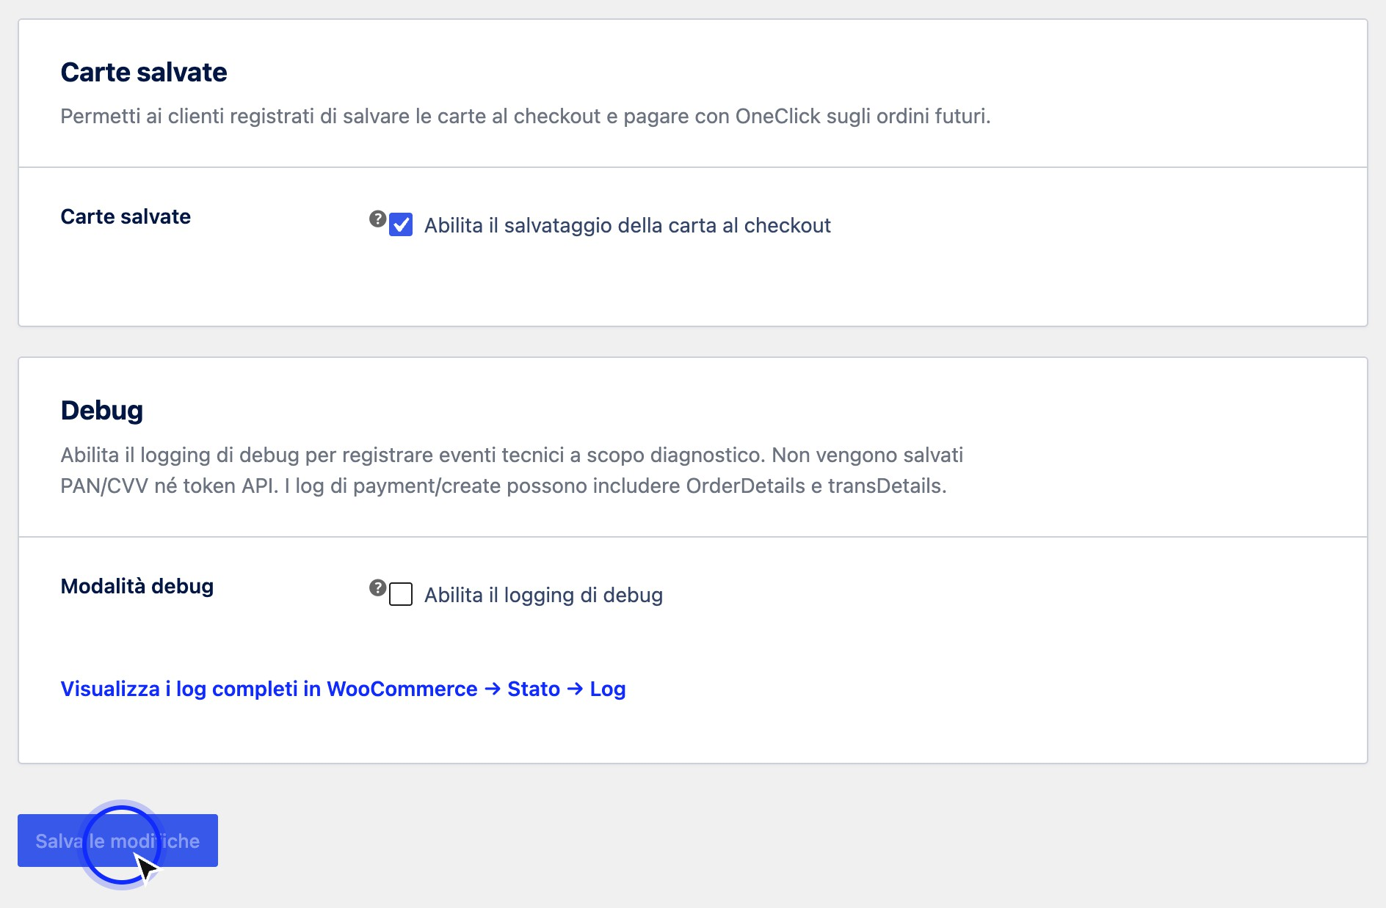
Figure 4. At the bottom of the page, a single button saves the changes of all the panes.
Boxes with dedicated chapter

Field | Description
Payment methods | List of methods with a toggle each, the information line on the origin of the catalog and the Update methods command. The pane warns that the selection filters only what the customer sees on the Fabrick payment page and does not touch the terminal, which is managed from the Fabrick backoffice.
Saved Cards | Enable card saving at checkout box, turned off by default. By activating it, registered customers can save the card and pay with  OneClick on subsequent orders.
Debugging | Enable debugging logging box, turned off by default, with the link to WooCommerce logs. With debugging active the page also shows the most recent log entries.

- Press Save changes. The page reloads with the recorded values; in the WooCommerce list → Settings → Payments, the method is active and shows the title you have chosen.

Expected outcome
The gateway is enabled and appears at checkout with the title and description set. The saved credentials are verified for the active environment, with the date and time of the last test highlighted in the account tile. At this point, a customer who arrives at the payment sees the Fabrick method among the available choices and, by selecting it, is taken to the payment page of his order.
If the active environment is sandboxed, the WooCommerce screens continue to show the warning Fabrick Payment Orchestra is in sandboxed mode. No real charges will be processed. - The gateway is turned on, but payments don't generate true charges.

Notes and constraints
  - The configuration wizard does not turn on the gateway. It is a product choice: connecting with the platform and listing the method are two separate decisions. The last screen of the procedure declares this, and this tab is the place where the activation takes effect, when you are done checking everything else.
  - It cannot be turned on before the configuration has been completed. If you try to save the check with the incomplete wizard, the plugin responds Complete the Fabrick configuration before enabling this gateway. and the box is disabled again.
  - Only one save for the entire page. The button at the bottom records enablement, title, description, environment, credentials, methods, saved cards, and debugs together. If any of these parts fail the checks, the save stops and the correct changes must also be repeated.
  - The connection test doesn't require you to save. The button works on the values you typed at that moment, so you can verify a new key before confirming it. Conversely, fields that you have changed and not saved are lost if you leave the page.
  - Changing the credentials invalidates the verification. After a change of Shop Login or API Key, the status line indicates that the previous verification is no longer valid: repeat the test to return to a trusted result.
  - The title does not change orders that have already been posted. Renaming the method only changes what customers see from that point forward; historical orders retain the name under which they were paid.
  - With block checkout, you need the dedicated integration. If your store uses block checkout but the Fabrick integration for that checkout is not present, the Checkout view tile shows a warning: customers on block checkout will not see the method until the integration is restored, while classic checkout works normally.
  - With active subscriptions saved cards become necessary. If WooCommerce Subscriptions is installed and the gateway is enabled but saved cards are not, this screen warns you to activate them, otherwise automatic renewals cannot charge anything.
  - Switching environments has its own rules. Moving from sandbox to production requires explicit confirmation and successful connection verification on the new environment: the complete procedure is in the chapter dedicated to the environment and the transition to production.

Special cases and errors
  - "Complete the Fabrick configuration before enabling this gateway." You tried to turn on the gateway with the configuration wizard not completed. Go back to the procedure, complete the missing steps and try to enable again from this tab.
  - "Shop Login required." The field was emptied before saving. Re-enter the store identifier, within 64 characters, and save again.
  - "API Key required." There is no key stored for the active environment, and the field is empty. Paste the account key and save.
  - "Unable to save credentials." The credentials were not written successfully and the rest of the page was not registered. Reload the card, check what values are present, and repeat the operation.
  - "Connection failed. Check the credentials." The platform does not recognize the Shop Login and API Key pair you just tried. Check that you are using the credentials of the active environment, with no spaces in the head or queue.
  - "Unable to contact the server. Please try again." The test did not reach its destination – it is usually an outbound connection blocked by the server or a momentary network outage. Try again, and if it persists, ask the provider to allow outbound HTTPS calls.
  - "Your credentials have changed since the last test. Please take the test again." You are reading a result obtained with different credentials than your current ones. Press Test connection to refresh it.
  - "The last test was run in another environment. Run the test again." The stored result is for sandboxes while the active environment is production, or vice versa. Repeat the test on the current environment.
  - "Confirm that you want to activate live mode before saving." You selected the production without checking the box to confirm real payments. Tick it and save again.
  - "Connection test failed for the selected environment. Check the credentials and try again." The saved credentials are not valid for the environment you have chosen. Check with your Fabrick contact which credentials are valid in production before repeating the change.
  - The tab opens on the wizard. It's not a mistake: it happens when the configuration is still incomplete. Complete the steps and the tab with the tiles becomes reachable.

Frequently Asked Questions

I have completed the guided configuration but I don't see Fabrick at checkout: what is missing?
The Enable Fabrick Payment Orchestra checkmark is missing in the Checkout View pane, which the wizard deliberately leaves off. Check it, press Save changes and reload the checkout: the method appears with the title set.

Can I change the Shop Login and API Key from here without repeating the Setup Wizard?
Yes. The two fields are in the account box and can be edited at any time. After editing, press Test connection to check the new pair, then save the page: the wizard does not need to be redone.

I saved a new API Key but the field remains masked: was the change successful?
Yes. The saved key is never reprinted in the form, so the field shows a dummy value with the suggestion to leave it blank to keep it. The confirmation is the line of the last connection test: run it after saving and check that the result is positive.

What title should I use at checkout?
A text that the customer recognizes as a payment method, not the technical name of the service. Since the same item collects paper and alternative methods, a generic formula such as Credit Card and other methods works well, possibly with a short description explaining that the payment is concluded on a protected page.

If I disable the gateway, do I lose my settings or credentials?
By unchecking the checkbox, the method stops appearing at checkout, but the title, description, credentials, environment, and method selection remain saved. Turning it back on will reveal everything as you left it.

A notice appears inviting you to enable saved cards for subscriptions: is it mandatory?
It is if you sell subscriptions with WooCommerce Subscriptions: automatic renewals need the stored card to charge without the customer in front of the screen. On the other hand, if you don't sell subscriptions, you can leave the saved cards deactivated and the warning does not apply to you.

Sandbox environment and move to production
The store communicates with the Fabrick platform in only one of two environments at a time: the sandbox, where each payment is simulated and does not produce charges, or the live, where transactions are real and the money really moves. The choice lives in the card at the top of the gateway settings and is the last switch to touch before opening sales: until then it is better to work in the sandbox, try the checkout with the test cards and correct what doesn't add up.
This chapter explains how to change environment from the Fabrick Payment Orchestra tab in WooCommerce → Settings → Payments, what checks the plugin performs when saving, how to recognize at a glance a store still in the sandbox and which cards to use for testing. It closes with a list of checks to be checked before the first real collection.

Prerequisites
  - Initial configuration already completed: the card with the environment appears only when the activation wizard has been completed.
  - WordPress user with permission to manage WooCommerce.
  - Shop Login and API Key of the account you want to use in the target environment. Fabrick provides the production credentials through the back office or your contact person: the plugin does not generate them.
  - Outbound HTTPS calls allowed from the server to hosts in the target environment (table below).
  - For testing: A purchasable product and the test papers listed in this chapter.

Where the store points in each environment
The selected environment determines both the address of the application calls and the origin from which the customer's browser loads the payment form. If network rules, an application firewall or a content security policy are at work on the site or in front of the site, these are the values to be authorized.

Hosts contacted by environment
Environment | Calls from the store server | Payment form in the customer's browser
Sandbox | https://sandbox.gestpay.net | https://sandbox-web.axerve. com
Live | https://ecomms2s.sella.it | https://web.axerve.com

The addresses to which the platform communicates the outcome of payments, on the other hand, are not configured anywhere: the plugin calculates them from the store domain and sends them together with each payment request. Changing environment therefore does not require any intervention in the Fabrick backoffice on response URLs or lists of IP addresses.

Procedure
- Open WooCommerce → Settings → Payments and select Fabrick Payment Orchestra. The first card contains the Payment Environment section, with the description Choose whether this store should use the sandbox or live Orchestra API. Save the

changes to apply, and immediately below the Credentials section with Shop Login, API Key and the Test connection button. The credentials shown are always those of the active environment at that moment (Figure 1).

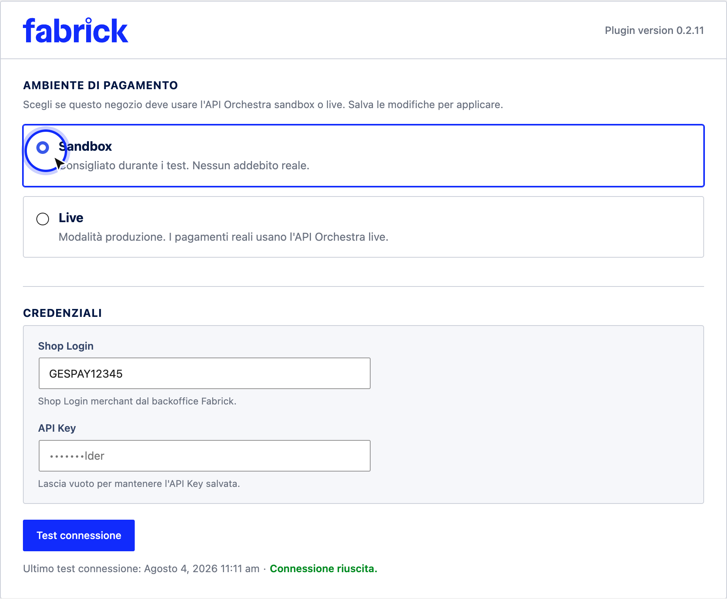
Figure 1. The initial gateway settings card brings together the environment, credentials, and connection verification.
- Before switching environments, complete the sandbox test: one card payment successful, one card declined, and one test for each alternative method you plan to propose. The cards to use are those from the Test Cards section of this chapter.

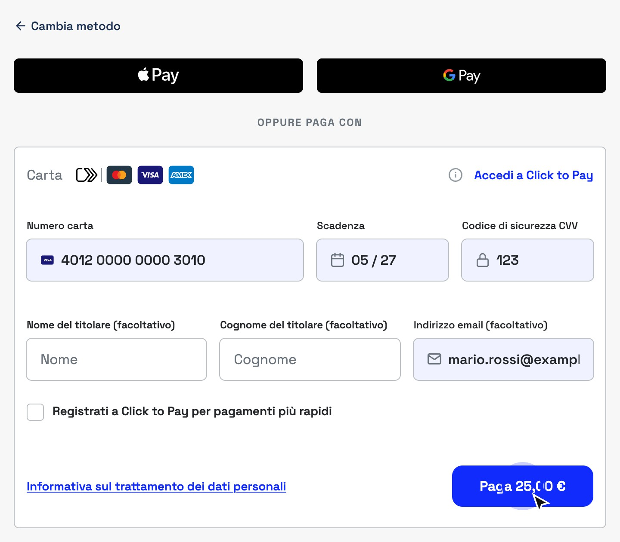

Figure 2. In sandbox, the payment module only accepts test cards published by Fabrick.
- When testing is closed, select the Live option, described as Production Mode. Live Payments use the Live Orchestra API. The Live Mode Processes Real Payments warning appears. You can switch back to sandbox at any time and the I understand that Live Mode will process real payments box – check it, otherwise the save will be rejected (Figure 3).

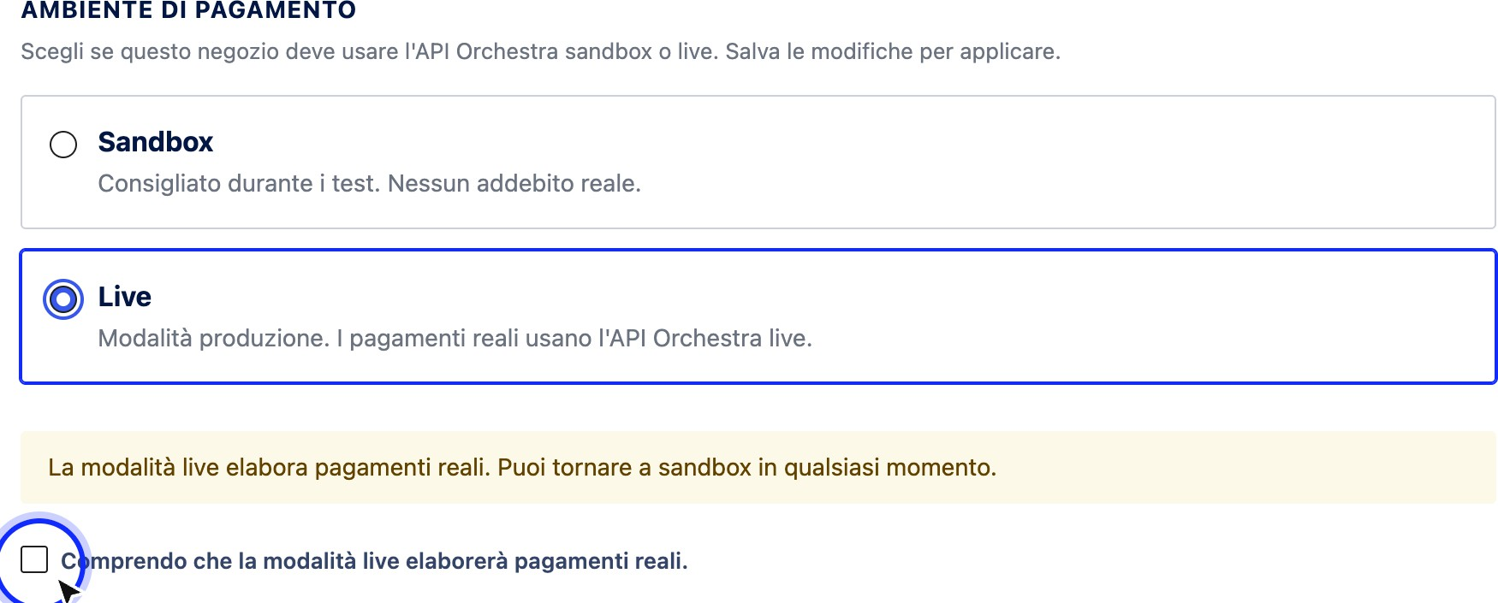

Figure 3. Selecting the live mode requires explicit confirmation before saving.
- Press Save changes. The plugin performs three operations in sequence: it returns the merchant account stored for the sandbox to the production environment, registers the new environment, and verifies the connection to the production hosts. If the verification fails, the message Test connection failed for the selected environment appears. Check the credentials and try again: the environment has already changed anyway, so the next step is not to go back but to fix the credentials.
- If your production account is different from the one used in the sandbox, now the Credentials section shows the fields of the live environment: enter the production Shop Login, paste the production API Key and save. Then press Test connection and wait for the confirmation Connection successful. The Last connection test row keeps track of the date, time and outcome of the last test.
- On the Payment Methods card, press Update Methods: The list is read back by the production terminal, which can expose methods other than the active ones in the sandbox. Check that the toggles reflect what you want to offer to real customers.
- In the Debug card, uncheck Enable debug logging, if you had it enabled for testing: the description of the field itself recommends keeping it disabled in production. Finally, check that in the Display at checkout card, the Enable Fabrick Payment Orchestra box is checked and save (Figure 4).

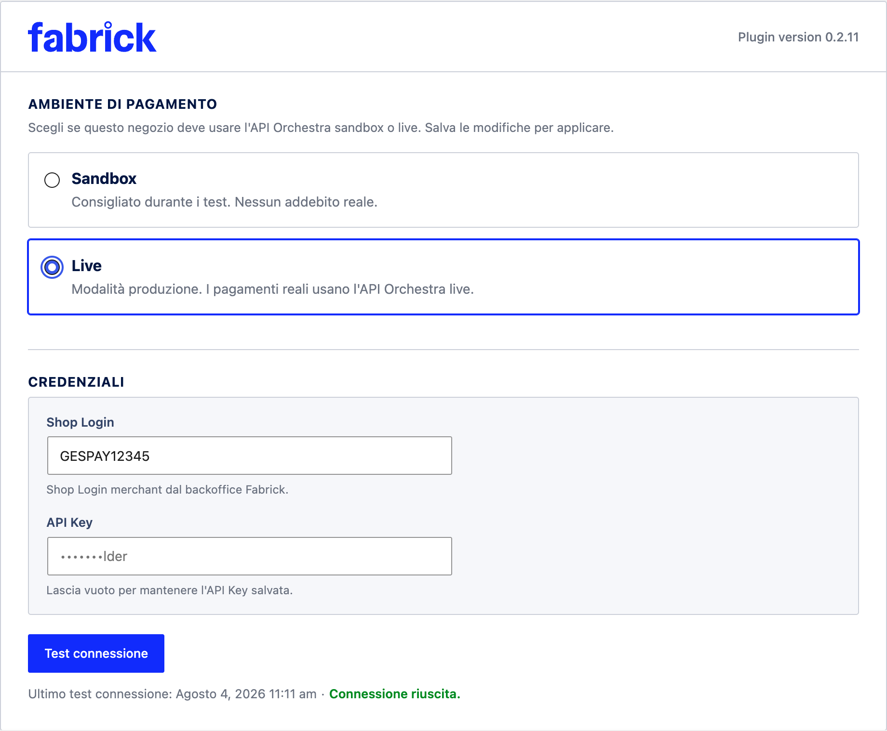
Figure 4. At the end of the step, the environment remains on Live and the status line shows the last successful test.

The Sandbox Mode Reminder
As long as the store is working in sandbox, a yellow warning appears on the WooCommerce admin screens: Fabrick Payment Orchestra is in sandbox mode. No real charges will be processed. It is used to avoid the most expensive mistake of all, which is opening sales convinced that you will collect while each payment is simulated.
  - Only users who can manage WooCommerce see it, never the customers of the store.
  - It does not appear in the gateway tab, because there the active environment is already indicated by the selected option, nor during the activation wizard.
  - It disappears by itself when the environment switches to Live: it is the most immediate sign that the transition has been successful.

3DS2 Test Cards
The test environment only accepts cards published by Fabrick. Any other number, even a valid real card, is rejected with the message Cannot use this card in test environment, please use one of the provided cards. Each card corresponds to one

3D Secure authentication scenario, so you can see how the store reacts to both a success and a rejection.
Fabrick sandbox test cards available here

  - When the card opens the authentication screen, the password to be typed is password.
  - On both American Express and Mastercard cards, you can fail by getting your password wrong three times or by canceling the authentication – these are the most reliable way to prove how the store handles an unauthorized payment.
  - The security code is not indicated by the Fabrick documentation: in tests performed in sandbox a three-digit value such as 123 is accepted.
  - Test cards only work in sandboxes. In production, you need real cards, and each payment involves an actual charge.

Checks before the first real collection
There is no button declaring the store ready – the step is a sum of checks, some on the plugin and others on the contract. This list puts them in a row.

Step-Up Checklist

Verification | Where to check it out
At least one successful card payment and one declined in sandbox, with the WooCommerce order finished in the expected state. | Test orders on the sandbox store.
Try alternative methods you want to offer, for those that can be tested with a test account. | Checkout in sandbox, card Payment methods.
Production credentials available and stored  safely. | Backoffice Fabrick o referente Fabrick.
Contract payment methods active on the production terminal. | Fabrick sales representative: the plugin can only hide what the terminal displays, not enable it.
Agreed card handling method, because it depends on what you can do after payment has been made (total cancellation or even partial refund). | Fabrick contract and backoffice.
Outbound HTTPS calls allowed to  production hosts. | Hosting provider or system administrator.
Updated site security rules with production domains, if you apply a  Content-Security-Policy or an application firewall. | Configuring the security server or service.
Checkout served in HTTPS with valid certificate. | Browser on the real site.
Environment on Live, connection test successful, sandbox alert disappeared. | Gateway settings initial card.
Gateway enabled, title and description revised as li  will see the customer. | Card Display at checkout.

Diagnostic log disabled. | Card Debug.
A real order of minimum amount, paid with a real card, verified on the order screen and then cancelled or refunded. | Site checkout and WooCommerce order screen.

Expected outcome
At the end of the step, the Live option is selected, the status line shows a successful connection test on the production environment and the yellow sandbox warning no longer appears on any WooCommerce screen. From the first payment onwards, orders arise from real transactions: the platform charges the customer and each refund moves actual money.
Returning to the sandbox remains possible at any time and does not require confirmation: just select Sandbox and save. Orders already created in production are not touched, but as long as the environment is test no new payment is real, so do not leave a store open to the public in this state.

Notes and constraints
  - One environment at a time. It is not possible to combine test payments and real payments on the same store: the setting applies to the entire site, including checkout and payment links.
  - Switching to Live brings the sandbox account back. Each time the environment changes from sandbox to live, the plugin copies the Shop Login and API Key stored for the sandbox to production. If your production account is different, it should be re-entered after the change, and re-entered if you take a sandbox test drive in the future and then return to production.
  - The confirmation is only used to turn on the live. The return to the sandbox does not ask for checks, because it does not expose you to economic risks.
  - The connection test is an authentication check, not a payment. It confirms that the Shop Login and API Key are valid on the chosen environment; it says nothing about which methods the terminal has active.
  - The test result is tied to a pair of credentials and an environment. If you change your credentials or change environments, the status line prompts you to retest.
  - Other settings are not environment-dependent. The title, description, choice of methods, saved cards, and diagnostic log remain as you left them; change the account with which the store authenticates and the list of methods that the terminal displays.
  - No return configuration in the back office. The addresses to which the platform notifies the results travel with each payment request, so they do not have to be declared by hand or updated when the environment changes.

Special cases and errors
  - "Confirm that you want to activate live mode before saving." You chose Live without checking the confirmation box. Tick it and save again: nothing has been changed so far.
  - "Unable to prepare for live mode. Please check your merchant credentials in the wizard." The Shop Login or API Key to be brought back to production is missing. Complete the credentials in the Credentials section, save and try the change again.
  - "Connection test failed for the selected environment. Please check your credentials and try again." The account is not recognized on the chosen environment: this is typically the case for

Test credentials used in production. However, the environment has already changed: enter the correct credentials and repeat Test connection until confirmed, or return the environment to the Sandbox if the switch was premature.
  - "Unable to save environment setting." The writing of the setting was not successful. Reload the page, check which option is selected and try again; if it repeats, the problem is in saving the WordPress options and should be reported to those who manage the site.
  - "The last test was run in another environment. Please run the test again." You are reading the result of a test done on the previous environment. Press Test connection to get a valid match on the current one.
  - "Credentials have changed since the last test. Please run the test again." The Shop Login or API Key has changed since the last successful test. Retest.
  - "Cannot use this card in test environment, please use one of the provided cards." A card has been placed in the sandbox that does not belong to the test list. Use one of the cards in the table.
  - A test card does not reproduce the scenario described. The results of the sandbox depend on the configuration of the platform and may vary over time. If you need a certain rejection to test error handling, use the American Express or Mastercard card and get the password wrong three times; if the difference blocks you, report it to the Fabrick contact indicating the date, time and amount of the test.
  - The payment form does not appear to the customer after it goes into production. It is usually a site security rule that blocks the source of the form. Verify that the production domains are authorized by the Content-Security-Policy and the application firewall, then reload the payment page.

Frequently Asked Questions

Do I have to communicate to Fabrick the return address of the store or have an IP address authorized when I go into production?
No. The plugin sends notification addresses along with each payment request, calculating them from the site's domain. There is nothing to configure in the back office when the environment changes, unlike what the old GestPay plugin required.

Do my customers see the sandbox mode warning?
It only appears on WooCommerce admin screens and only to users who can manage it. The customer's checkout doesn't show any indication of the environment, which is all the more reason not to leave a public store in sandbox.

Can I try test cards in production, or pay with my real card in sandbox?
Neither one nor the other. In sandbox any card out of the list is rejected with the message
Cannot use this card in test environment, and in production test cards do not exist. For the final test in production use a real card with a minimum order amount, then cancel or refund it.

Our website has a content security policy: what do I have to change for production?
The domain from which the browser loads the payment form changes from
sandbox-web.axerve.com to web.axerve.com, so it must be updated where the policy authorizes

Built-in connections and tiles. The module script must also be authorized according to the rules of your policy. The configuration depends on the server and the theme, so agree with the site manager and verify the checkout immediately after the change.

Switching to production do I lose the configuration made in sandbox?
The title, description, choice of methods, saved cards, and diagnostic settings remain in place. Change the account with which the store authenticates and change the list of available methods, because it is the production terminal that displays it: press Update methods in the Payment methods card and check the switches again.

After the go-live, can I re-enter the sandbox to try out a change?
Yes, at any time and without confirmation, but while the store is in the sandbox no customer payment is real: if the site is open to the public, suspend sales or work on a test copy. When you return to production, double-check your credentials, because the switch to Live brings the account stored for the sandbox back into production, and repeat the connection test.

Payment methods
The gateway tab contains a section dedicated to the methods that the store offers when the customer arrives on the Fabrick payment page: card, wallet and the alternative methods provided for in your contract. Here you decide which ones to show, update the list when Fabrick activates or deactivates something on your terminal and check from which origin the list you are seeing comes.
The rule that governs the whole chapter is simple and it is worth keeping in mind before touching any switch: only the methods active on both sides appear at checkout, i.e. those enabled on the Fabrick terminal and, together, turned on on this page. The plugin filters, does not activate: if a method is not provided for in the contract, turning it on here does not make it available; if, on the other hand, it is active on the terminal but turned off here, the customer will not see it.

Prerequisites
  - Setup Completed Wizard and Verified Credentials: Without a connected account, the plugin cannot query the platform and only shows its default list.
  - WordPress user with permission to manage WooCommerce.
  - Methods already activated on the Fabrick terminal for your store. Activation takes place on the Fabrick side, according to the contract, and is requested from the Fabrick sales representative or from the Fabrick backoffice, not from WooCommerce.
  - Outbound HTTPS calls allowed by the server: The updated list is read in real-time by the platform.
  - Active environment awareness: sandbox and production have different terminals and therefore potentially different method lists.

Procedure
- Open WooCommerce → Settings → Payments and select Fabrick Payment Orchestra. Scroll down to the Payment Methods tab, under the sections dedicated to account and checkout. The description of the tab reminds you that the selection is applied when Fabrick creates a payment, and a second warning clarifies the perimeter: Limit what the customer sees on the Fabrick payment page. It does not deactivate methods on the Orchestra terminal: for that it uses the Fabrick backoffice (Figure 1).

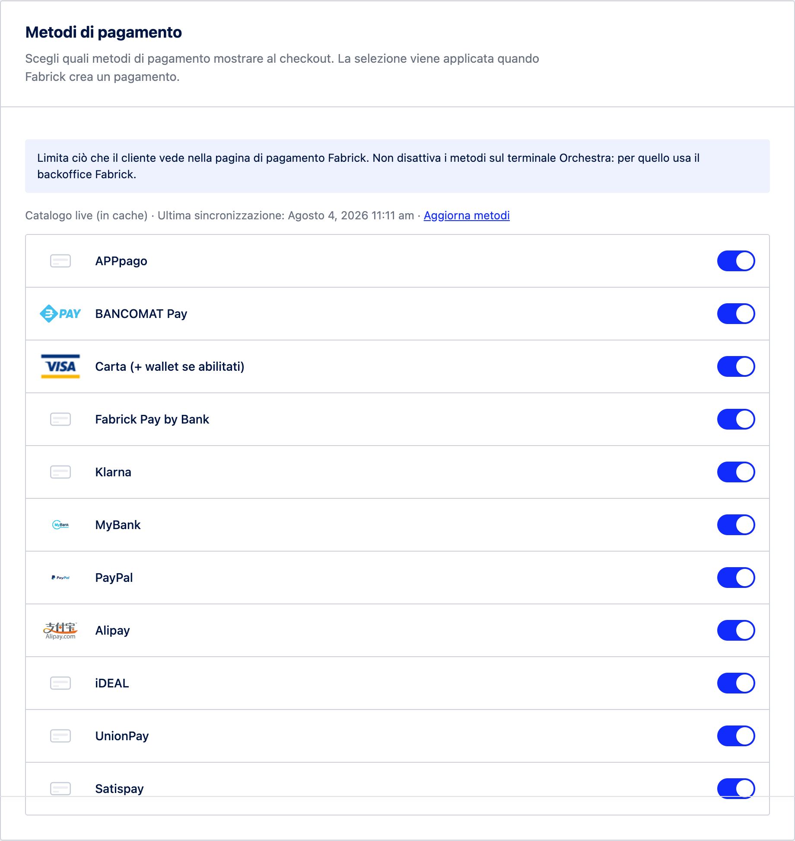
Figure 1. The payment methods tab brings together the list source, update command, and individual method toggles.
- Look at the service line above the list: it indicates where the methods shown come from. Live catalog means that the list has just been read by the platform, Live catalog (cached) which is the copy kept since the last read, with the Last synchronization and date and time next to it. Static fallback catalog instead reports that the platform has not responded or has responded incompletely: in that case the plugin shows its default list, which does not necessarily reflect your contract.
- Press Update Methods to immediately reread the list from the terminal. The label changes to Update Methods... and when it is finished, an outcome box appears below the service line: Catalog Updated: N payment methods, no changes detected when nothing has changed, or Catalog Updated: N payment methods. Check the changes below when there are differences from the previous reading. The differences are grouped into New Methods, Removed Methods, and Removed but still

enabled in your selection. If you have a partial selection saved, next to the new methods the plugin adds the indication Enable them below if you want buyers to see them at checkout (Figure 2).
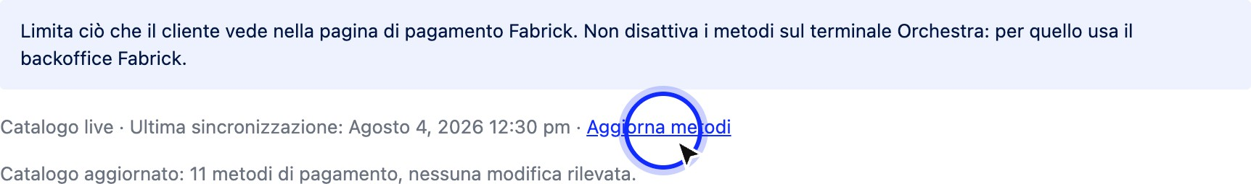

Figure 2. After the update, the plugin declares how many methods it has found and, if necessary, which ones have appeared or disappeared since the last reading.
- Scroll through the list and turn the switches on or off. Each line shows the logo provided by the platform (or a generic icon when missing), the name of the method and its switch. The Card item (+ wallets if enabled) also includes Apple Pay and Google Pay: wallets do not have a switch precisely because they rely on the card category and showing them separately would be misleading. The methods that appear compared to the default list of the plugin bear the label New (Figure 3).
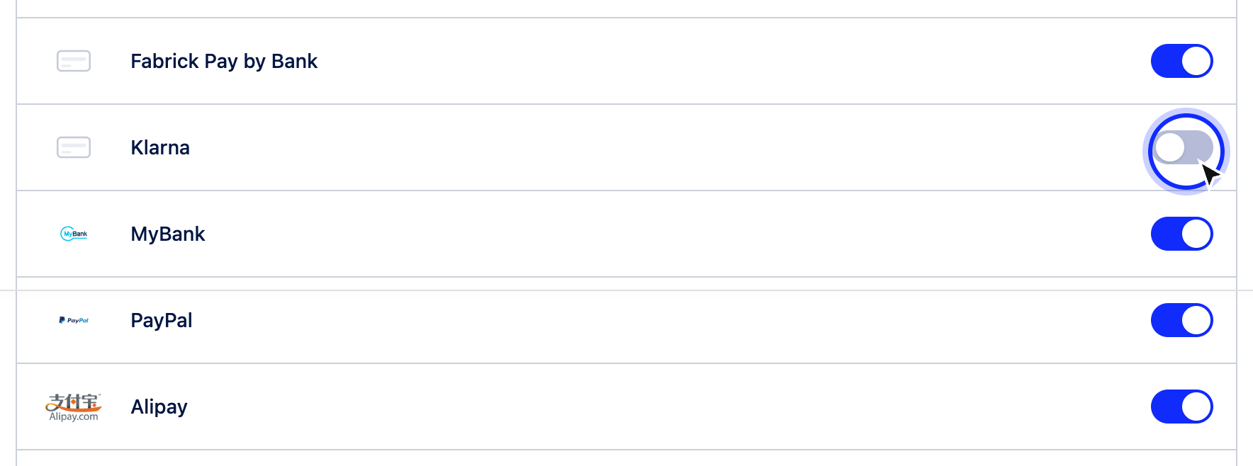
Figure 3. The off switches remain visible in the list: they are methods available on the terminal but excluded from checkout.
- Some rows may appear without a switch, with the indication Always enabled and the message This method is always enabled and cannot be deactivated here. Manage it in the Fabrick backoffice or contact your account manager. If, on the other hand, you have saved a partial selection, the same row shows Excluded from filter and Hidden with active filter: the method remains managed by the circuit and appears at checkout only when no filter is active, i.e. when all the switches are on.
- Press Save Changes at the bottom of the page. Refreshing the list and selecting the switches are two separate operations: rereading the catalog saves nothing, and without saving the checkout continues to use the previous selection. If all the switches are on when finished, the plugin does not apply any filters and lets the terminal decide what to show.

Expected outcome
After saving, the Fabrick payment page offers exactly the methods that are switched on and active on the terminal. With all switches on, the customer sees the entire offer of the terminal,

including the methods that Fabrick should activate later. With only one method turned on, the platform skips the choice screen and takes the customer directly to that method.
The selection applies to the classic checkout, the block checkout and the payment links generated by the plugin, because the filter is applied when the store asks Fabrick to create the payment.

Supported Methods and Fabrick Documentation
The table lists the methods that the plugin recognizes and manages, with the code used by the platform (the same as in the order notes and registers) and the official Fabrick page to consult for requirements, amount limits and supported countries. The presence in this table does not mean that the method is active on your store: the activation depends on the contract.

Method | Code | Page Fabrick
Card (+ wallet if enabled) | CREDIT CARD | Wallet inclusi: Apple Pay,Google Pay
PayPal | PayPal | PayPal tab
MyBank | MYBANK | MyBank tab
BANCOMAT Pay | BANCOMATPAY | ATM Pay Card
Satispay | SATISPAY | Satispay card (requires a business account and store identification codes to be communicated to Fabrick)
APPpago | APPPAGO | APPpago Card
Klarna | KLARNA | Scheda Klarna
Przelewy24 | PRZELEWY24 | Scheda Przelewy24
iDEAL | S2PIDE | iDEAL Sheet
UnionPay | S2PUNI | UnionPay tab
Alipay | S2PALI | Alipay tab
Giropay | S2PGIR | Giropay tab
Amazon Pay | AMAZONPAY | Amazon Pay tab
EPS | S2PEPS | Overview of alternative methods
Fabrick Pay by Bank | FABRICKPASS | Overview of alternative methods

If the terminal exposes a method that the plugin does not yet know, the line still appears with the name and logo provided by the platform and with its own switch: you don't need to update the plugin to be able to offer it.
Not all methods behave in the same way after payment. Some, for example deferred payment solutions, may return a provisional outcome: the order remains on hold until the circuit confirms. Others, such as app-based or phone-based methods, require a dedicated activation and a verification session agreed with Fabrick. Before announcing a new method to customers, check with the Fabrick contact person to make sure it is operational on your terminal.

Notes and constraints
- The plugin filters, not activates. The switches decide what to ask Fabrick to show. The activation of a method on the terminal goes through the contract and the Fabrick sales representative, or from the Fabrick backoffice where provided.
- Each environment has its own list. Sandbox and production read separate terminals: after switching to production, it is advisable to open the tab, press Update methods and check the selection again.

- The list is kept for one day. Between one read and another, the plugin reuses the saved copy, so as not to query the platform every time the page is opened. Update methods forces immediate reading; even changing Shop Login resets the copy stored for that environment.
- All on means no filter. In that condition the plugin does not send any preferences and the customer sees everything that the terminal displays, including the news activated by Fabrick after your last visit to this page.
- The selection corrects itself. If a saved method is no longer active on the terminal, the plugin excludes it from the request before contacting the platform, notes it in the logs and removes it from the saved selection, so the checkout is not interrupted due to a configuration that is no longer valid.
- Wallets linked to the card. Apple Pay and Google Pay do not have a standalone switch: they depend on the card line and their enabling on the Fabrick and device side.
- The same switches are in the wizard. The selection made during the initial setup can be found here and can be changed at any time.

Special cases and errors
- Warning "The Fabrick terminal offers payment methods not enabled in the saved selection". It appears in the WooCommerce screens when your partial selection excludes methods that the terminal displays; the warning lists them after the phrase Available but not enabled and offers the link Review payment methods →. Open the tab, turn on what you are interested in and save. If the choice is intentional, close the warning: it does not reappear as long as the catalog and selection remain unchanged.
- "Fabrick returned an unexpected response. The previous catalog was kept." The manual update was not successful and the plugin kept the previous list so as not to lose the configuration. Try again after a few minutes and, if the source remains Static Fallback Catalog, verify credentials and server outbound connections.
- Source "Fallback Static Catalog". The store is not reading the terminal: you are seeing the default list of the plugin. Do not save a selection in this condition without first resetting the reading, otherwise you risk retaining methods that your contract does not provide.
- "Removed but still enabled in your selection" box. After an update, some methods you had turned on are no longer exposed by the terminal. Turn them off and save, or ask Fabrick why they disappeared from the terminal.
- "No payment method is enabled for Fabrick checkout. Please check your gateway settings." The customer receives this message when you have saved the selection with all switches off. Turn back on at least one method and save.
- "We were unable to start the payment. Please try again or choose another payment method." This is the generic message shown to the customer when the platform rejects the creation of the payment. Among the possible causes is a selection that contains only methods that are no longer active on the terminal: in that case in the plugin logs you will find the annotation on the methods that are no longer active and the error code 1403 returned by Fabrick.
- The method appears on this page but not at checkout. Check that you have saved after turning on the switch, that you are in the right environment and that the method is still present after a list update. Some methods also have their own currency, country or amount constraints, described on the dedicated Fabrick page.

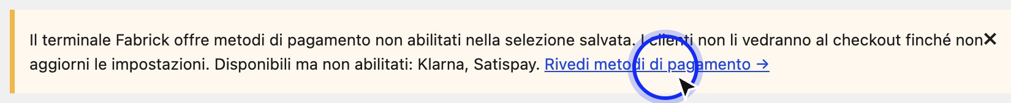

When the saved selection excludes methods available on the terminal, the plugin signals this in the WooCommerce screens with a direct link to the tab.

Frequently Asked Questions

I turned on a method here, but customers don't see it. Where am I wrong?
In all likelihood, the method is not active on the Fabrick terminal: the switch alone does not enable it. Press Update methods and check that the row still appears in the list read by the platform; if it disappears or remains absent, the activation must be requested from the Fabrick contact person.

How do I activate a method that I don't have today, for example a deferred payment solution?
Activation is not done from WooCommerce. Contact your Fabrick sales representative: the method is enabled on the terminal based on the contract and any circuit requirements, such as dedicated accounts or store identification codes. When the activation is complete, go back to this tab, press Update methods, turn on the new switch and save.

What's the difference between turning off a method here and turning it off on Fabrick?
Turning it off here hides it only from the customers of your WooCommerce store, and you can turn it back on at any time without involving anyone. By deactivating it on the Fabrick side you remove it from the terminal, therefore from all channels connected to that account, and to get it back you need a new request.

I read a 1403 error in the logs after a payment attempt. What does this mean?
It is the platform's response when the store asks to show a method that the terminal does not have active. The plugin almost always prevents the situation by excluding methods that are no longer active before contacting Fabrick, but if the saved selection contains only invalid codes, the request starts anyway and is rejected, without the customer seeing the payment page. The care is the same: Update methods, fix switches, save.

Why do some lines not have a switch?
These are methods that the platform manages directly and that the plugin cannot exclude from the filter: the label next to the name declares it. They remain visible at checkout when you have not activated any filter; if you save a partial selection, those rows indicate that the method will not appear. To change their status, you need the Fabrick backoffice or your account manager.

Should you leave all the switches on?
If you want to offer everything that the contract provides, yes: in that configuration the plugin does not send any filter and the methods that Fabrick activates in the future appear at checkout without any other intervention. Use partial selection when you have a specific reason to limit the offer, for example costs, return management or markets that you do not serve.

I went from sandbox to production: do I have to redo the choice of methods?
It's worth checking it again. The catalog is read separately for each environment, because the two terminals can have different methods. After the step, open the tab, press Update methods, check the toggles, and save before opening the store to real payments.

The checkout as seen by the customer
From the buyer's point of view, paying with Fabrick Payment Orchestra means going through two screens: the store's checkout, where they choose the payment method and confirm the order, and the order payment page, where the secure payment module provided by Fabrick appears. The card data never passes through your server: it is collected inside the Fabrick module and, for many methods, directly on the payment page of the platform or on the website of the chosen supplier.
The path is the same with both types of checkout supported by WooCommerce, the classic and the block checkout: upon confirmation of the order, the store opens a payment session on the platform and takes the customer to the order payment page. This chapter describes what the customer sees in each step, what outcomes they may encounter when they return to the store and how they tie into the order statuses that you find in the administration.

Procedure
- The customer chooses Fabrick at the classic checkout. In the list of payment methods, the entry with the Title set in the gateway settings appears, by default Fabrick Payment Orchestra, followed by the Description if you have filled it in. The plugin does not add any other fields at this stage: the payment data is entered later, in the Fabrick form. The only exception is the saved cards function, if active, which here shows the cards already stored by the customer and the box to save a new one.

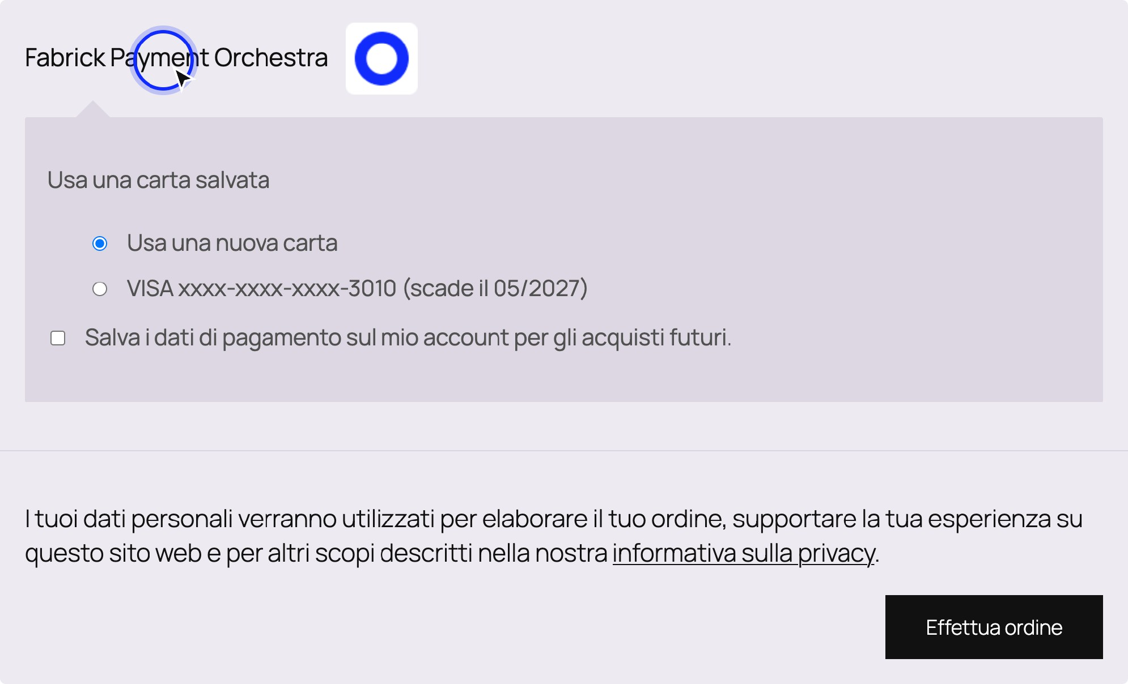

Figure 1. At the classic checkout, the customer only sees the title and method options: no card fields are asked about the store.
- In block checkout, the customer also receives a notice. The payment block shows the title and description like the classic checkout and adds the phrase You will complete the payment on the secure Fabrick page after confirming the order. When the store is in sandbox, the label Test mode appears above the description with the note Use only Fabrick sandbox credentials: it is a reminder that that checkout does not produce real charges, so it must be removed by going into production. The classic checkout does not show either of these two indications.

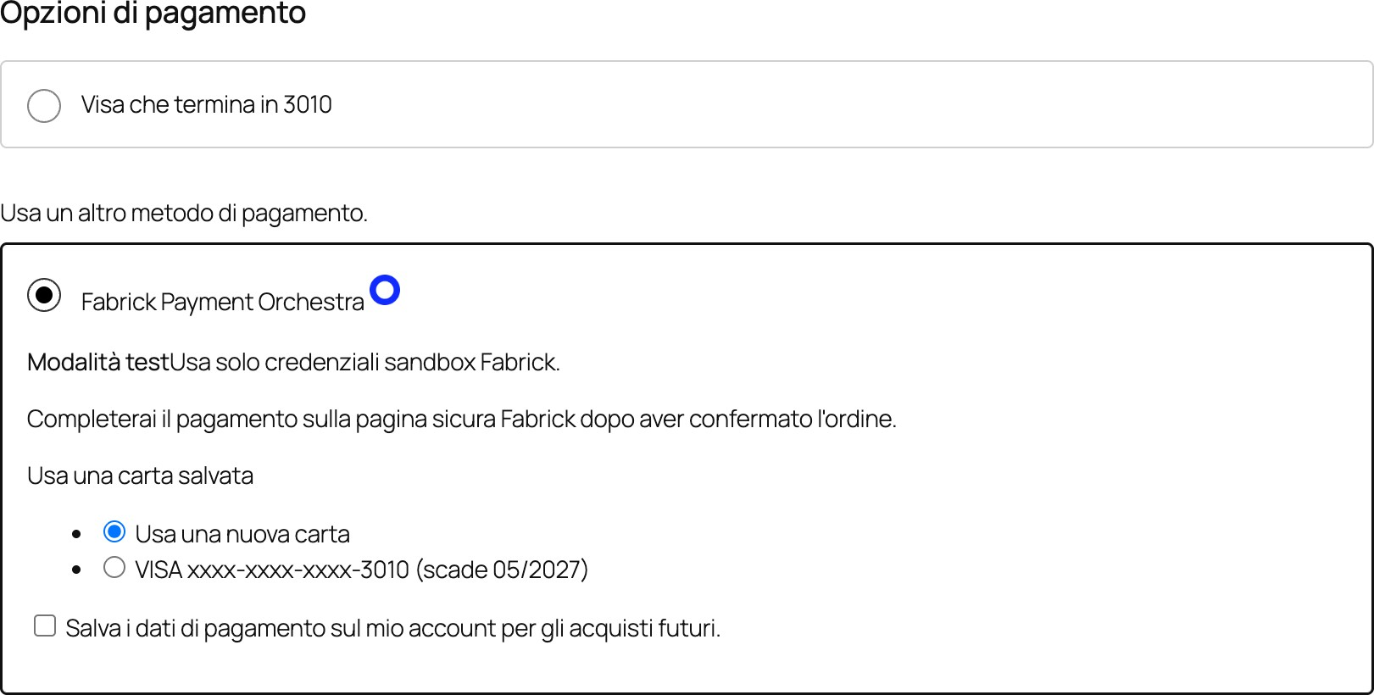

Figure 2. In the block checkout, the plugin anticipates that the payment is completed on the secure Fabrick page and signals the test mode.
- The customer confirms the order. WooCommerce creates the order, the plugin opens a payment session on the Fabrick platform and brings the order to the Pending payment status with the note Waiting for payment Fabrick. Immediately afterwards the customer is directed to the payment page of the order. If something prevents the session from opening, the customer remains at checkout with an error message and no charge is attempted: the most frequent errors are listed below.
- The order payment page shows the Fabrick module. It is the WooCommerce page dedicated to the payment of an already created order, reachable only with the order key in the address. The plugin opens the section with the phrase Complete the payment securely with Fabrick Payment Orchestra and below it inserts the Fabrick module, which lists the methods available for your store. The module is loaded only here: no page of the store requires paper data.

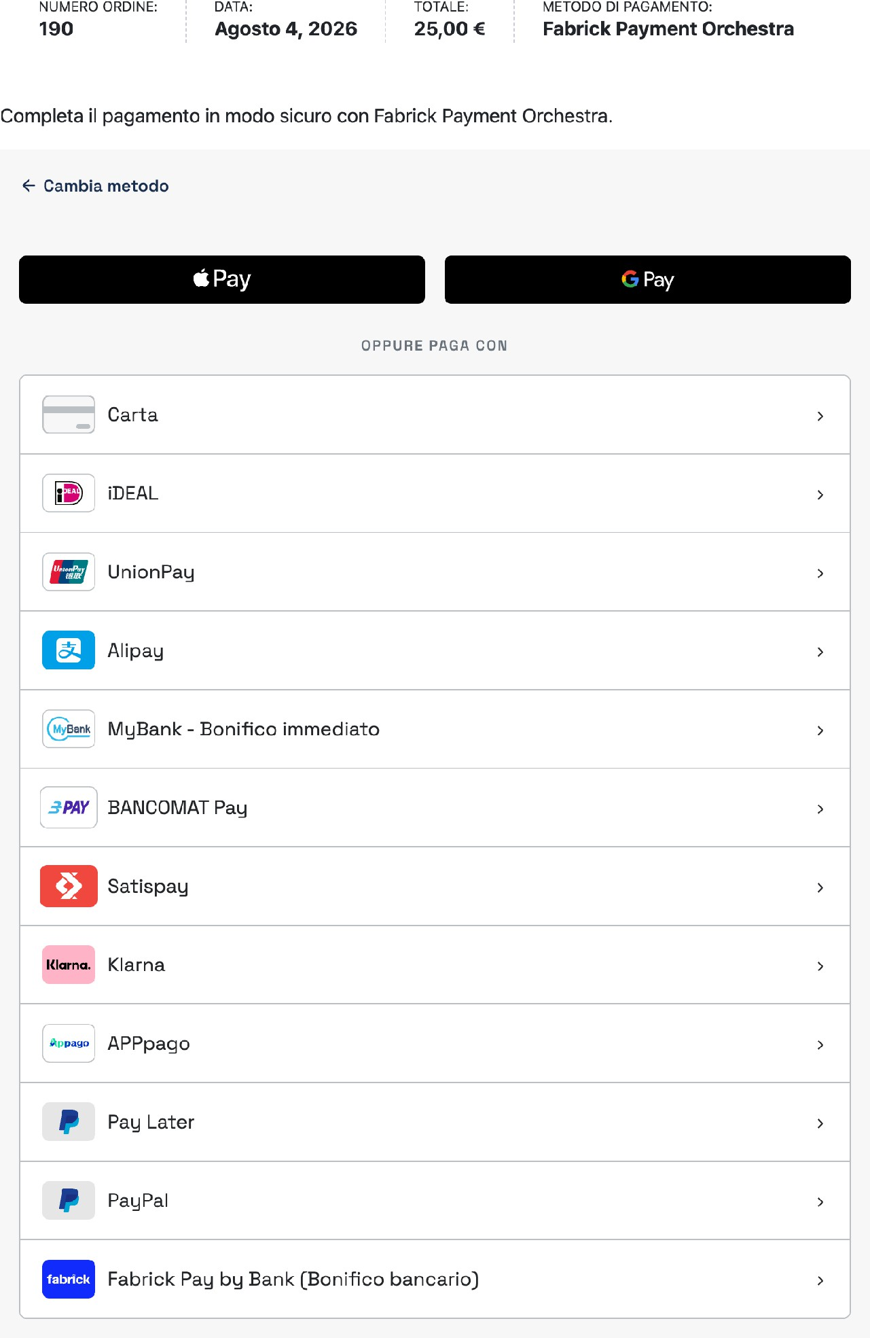

Figure 3. On the order payment page, the Fabrick module presents the methods enabled for the store.
- The customer chooses the method and completes the payment. With the card, the module leads to the payment page of the Fabrick platform, where the data and, when required, the strong authentication of the issuing bank are requested. With the alternative methods, the customer continues on the website of the chosen provider. During the operation, a status message may appear above the form: Payment processing in progress. Wait when the form signals that it has concluded, or Additional authentication is required to complete the payment when an extra step is needed. These are courtesy instructions for the customer: the status of the order does not depend on them.
- The customer returns to the store and sees the outcome. When returning from the platform, the store does not trust what comes from the browser: it queries the Fabrick platform to find out the status

and only then decides where to take the customer and how to update the order. The possible outcomes are described in the following section.

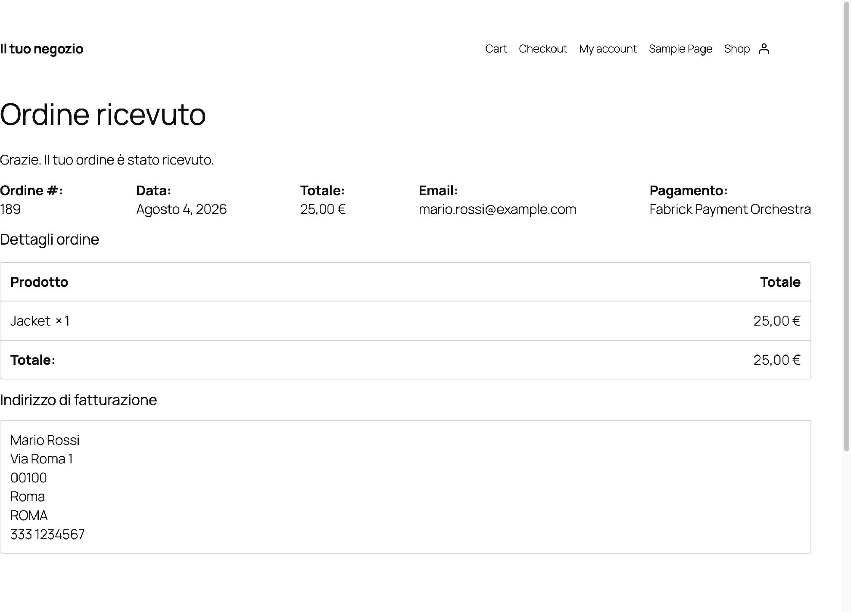
Figure 4. With the payment confirmed by the platform, the customer arrives at the order confirmation page.

Expected outcome
The plugin recognizes three outcomes, always established by server-side verification and not by the screen that the customer has seen on the platform.
  - Payment approved. The customer arrives at the order confirmation page. In administration, the order is paid, with the Fabrick transaction identifier recorded as a reference and the note Fabrick payment approved (payment ID ...) . The next status is the one provided by WooCommerce for a paid order, usually In progress or Completed for products that do not require shipping.
  - Payment declined. The customer returns to checkout with the notice Payment was not completed. Please try again or choose another payment method. In administration, the order goes to the failed status and receives the note Fabrick payment declined (Payment ID
..., code ...) , where the code is the one returned by the platform.
  - Payment awaiting confirmation. It happens with methods that confirm collection asynchronously. The customer sees the order confirmation page with the notice We are confirming payment. The order will automatically update in a few moments, while the order is put on hold with the note Fabrick payment awaiting confirmation (payment ID ...) . When the platform communicates the final outcome, the order updates itself.

There is a fourth, less frequent case: the browser returns to the store but the platform does not yet have a verifiable outcome. In order not to push the customer to pay twice, the plugin takes him to the order page with a warning explaining not to repeat the payment, because the order will update itself as soon as the confirmation arrives. The order remains pending and must be followed from the orders screen.

Notes and constraints
  - A single flow for the two checkouts. Classic checkout and block checkout converge on the same payment page of the order and on the same Fabrick module. It's a product choice: the plugin doesn't insert the payment module inside the checkout page, because with the card and alternative methods, the customer still goes out to the platform or to the chosen provider. The intermediate step, in return, gives the store an already consolidated order on which to open the payment session and a single point where the external module lives.
  - Only the store decides the status of the order. The messages that the customer sees above the form serve to orient them while waiting. The payment is only recorded after direct verification with the platform, so an optimistic message in the browser is never equivalent to a paid order.
  - No return addresses to configure. The store communicates the return and notification addresses to the platform at each payment. You don't have to set them manually in the Fabrick backoffice, unlike what the previous plugin required.
  - The payment page is secured. It can only be accessed with the address that contains the order key, so the link is not guessable. If the order no longer needs to be paid, the person who opens that page is taken to the order confirmation.
  - The payment session is renewed when needed. If the customer reopens the payment page after abandoning an attempt, the plugin checks with the platform if the session is still usable and, if it is not, opens a new one before showing the form. The customer does not have to recreate the order.
  - Which methods appear in the module. The list is the result of cross-referencing the methods provided by the Fabrick terminal and those lit in the plugin's switches. The chapter dedicated to payment methods explains how to intervene.
  - The customer can pay later. An order that is awaiting payment retains its link to the checkout page, so the customer can resume the attempt without going through the cart again.

Special cases and errors
  - "No payment method is enabled for Fabrick checkout. Check the gateway settings." The customer stays at checkout because the plugin's selection of methods doesn't let anything through. Turn back on at least one method in the gateway settings and check that it's in the contract.
  - "Fabrick Payment Orchestra is not yet configured. Please complete the configuration." The merchant account for the active environment is missing. Complete the configuration wizard or re-enter the credentials from the gateway tab.
  - "We were unable to initiate the payment. Please try again or choose another payment method." The platform did not open the session. Typical causes are credentials that are invalid for your environment, outbound calls blocked by the server, or a

Method not active on the terminal. Activates the technical log to read the error code returned.
  - "This payment session is no longer valid. Please go back to checkout and try again." The payment page has been opened for an order that does not have a usable session, for example an old link fished out of the history. The customer starts again from the checkout.
  - "This payment session has expired. Please try again." The module declares the session expired. The plugin tries once to open a new one showing Restarting the payment session and reloading the page: if it fails, the customer sees the session expired message and can try again.
  - "The payment was not completed. Please try again or choose another payment method." It appears above the form when the attempt is declined, and as a checkout alert when the customer returns with a verified failure. The existing order remains in administration with the rejection note.
  - "There was a problem with the payment module. You can try again or choose another method." The external module reported an error of its own. Here, too, the plugin tries to regenerate the session first, because the current one may already be unusable on the platform.
  - "The payment form is taking longer than expected. Refresh the page or try a different browser. If the problem persists, create a new order from checkout." The form didn't load within the expected time. It's usually due to slow connections or browser extensions blocking external scripts; if this happens systematically, check with your hosting for any rules that restrict external content from loading.
  - The customer returns and the outcome is not yet verifiable. The notice he receives expressly asks him not to pay again and informs him that the order will be updated automatically. Do not cancel the order immediately: check the order notes after a few minutes and, if it remains unsuccessful, follow the instructions in the chapter on order management.
  - "This order no longer requires payment." Attempting to restart the session is for an order that has already been paid or canceled. No action is required: the order is out of the payment flow.

Frequently Asked Questions

Why does the customer see an extra page after confirming the order?
Because the secure payment module lives on that page, not in the checkout. It is the standard WooCommerce page for paying for an already created order: it guarantees that the amount, billing data and transaction reference are final before opening the session with the platform. With the card and alternative methods, the customer still continues on an external page, so there is only one additional step.

Can I show the payment form directly on the checkout page?
No, it's not a settings option: the module only loads on the order checkout page, with both classic and block checkout. This keeps the external code confined to a single store page, which has security benefits and uniform behavior.

Does block checkout behave like classic checkout?
Yes, the payment path is identical and passes through the same page. The only differences visible to the customer are in the payment block: the phrase that anticipates completion on the secure Fabrick page and, when the store is in sandbox, the test mode label.

The customer closed the browser during the payment process: what happens to the order?
It waits for payment, with the note signaling the wait. The customer can resume from the payment link of the order, for example from the one you sent him, and the plugin verifies the previous session by opening a new one if it is no longer usable. If the order is never paid, handle it like any other unpaid WooCommerce order.

A customer claims to have paid but the order is not paid: what do I check?
Open the order and read the notes: the plugin always writes the verified outcome with the Fabrick transaction identifier and, in case of rejection, the error code. If there is still no outcome note, confirmation may be on the way, so wait a few minutes before intervening. For details of the checks, refer to the chapter on order management.

Do I need to configure return or notification addresses in the Fabrick backoffice?
No. The store transmits them with each payment along with the order reference, so you don't need to fill them out by hand or maintain lists of IP addresses. Just make sure that the store is reachable in HTTPS from the outside.

Saved cards and OneClick payment
Saved cards allow a registered customer to store the card used for a purchase and reuse it in subsequent orders without re-entering the data. The store does not store the card number: in its place it keeps a reference generated by the Fabrick platform, together with the only elements that serve to recognize the card in the list, i.e. circuit, last four digits and expiration.
The OneClick payment is based on the reuse of that reference: the customer chooses the card already saved directly at checkout and, after confirming the order, the store sends the debit request to the platform without showing him any card entry form. This chapter describes how to activate the function, what changes for the customer at checkout and in his reserved area, and how to manage stored cards.

Procedure
- Activate the feature in the gateway settings. Open WooCommerce → Settings → Payments → Fabrick Payment Orchestra and locate the Saved Cards tab, introduced by the phrase Allow registered customers to save cards at checkout and pay with OneClick on future orders. Check Enable card saving at checkout and save. The option is disabled by default: until you activate it, the checkout shows neither the list of cards nor the save box.
- The customer asks to save the card during a purchase. With the function active, a customer connected to his account finds the Save payment data on my account for future purchases box under the Fabrick method. The check is optional and does not change the payment path: the customer confirms the order and completes the payment on the secure Fabrick page as usual. The store, when opening the payment session, signals to the platform that a reusable reference must be produced for that transaction.
- The card is stored only after an approved payment. When the platform communicates the result, the store does not just read it: it verifies the transaction directly and, if it is approved and contains the card reference, creates the entry among the customer's payment methods. If the reference is not yet available at the time of verification, the store automatically repeats the check for a limited number of attempts

so the card can appear moments after the order is confirmed. A declined payment leaves nothing on file.
- The customer finds the card in their member area. In My Account → Payment Methods , the card appears with a bank-style label, e.g. VISA
xxxx-xxxx-xxxx-3010, and with the expiration date in the dedicated column. Below the list, the plugin reminds you how to add a card: Fabrick cards are saved during checkout: choose Fabrick Payment Orchestra, check "Save payment details to my account", then complete the payment. The button to manually add a payment method is not available for Fabrick, because a card is only stored together with a payment that is actually authorized.
- The next time they make a purchase, the customer pays with OneClick. At checkout, under the Fabrick method, the list introduced by Use a saved card appears: the first item is Use a new card, selected at the start, followed by the stored cards with their expiry. If the customer chooses a saved card and confirms the order, the store opens the payment session and immediately sends the debit request to the platform with the reference of that card. The customer does not see any data entry form: on the order payment page he finds at most the courtesy message Processing payment with saved card in progress. Wait or Payment approved. Redirection in progress.
- When needed, the bank's authentication remains. If the platform requires additional verification, the customer is taken to the issuing bank's authentication page and returns to the store at the end. Again, the outcome of the order is determined by server-side verification, not by the screen shown to the customer.
- The customer deletes a card that he no longer uses. From the same Payment methods screen, he can remove the saved card. The item disappears from his list and the store asks the Fabrick platform to delete the corresponding reference as well, so that it does not remain usable elsewhere. The removal always starts from the customer: in the administration panel there is no management of other people's cards.

Expected outcome
With the setting active, a registered customer who completes a card payment and has asked to save it finds the card in his reserved area and finds it again at the next checkout. By choosing it, the order is paid without re-entering the data and continues exactly like an ordinary payment: the same sequence of statuses, the same order notes with the reference of the Fabrick transaction, the same possibility of reimbursement from the order screen. No new items appear in the administration: the difference lies only in the path followed by the customer.

Notes and constraints
  - The function is optional and part is off. It is a conscious choice: storing a payment instrument concerns your customers' data, so activation remains a decision of the store. If you deactivate it, the checkout goes back to not offering saved cards; cards already stored remain in the customer profile but are no longer offered.
  - Only customers with accounts. Buyers as a guest do not see the save box and do not generate any stored cards, even if the payment is successful. If you are interested in the feature, check that the store's checkout allows registration or access.

  - No paper data on your server. The store keeps the circuit, last four digits, expiration date and the reference generated by the platform. Full number and security code do not pass through the site and do not end up in the database.
  - Each card belongs to the customer who saved it. Before using or deleting a card, the store checks that it really belongs to the connected user and that it is a Fabrick card: a manipulated reference in the address does not allow you to pay with another customer's tool.
  - Saving follows payment. The card is only stored after an approved outcome and verified with the platform. There is no path that registers a card without a payment – it is also the reason why the manual add page is not available.
  - Card only. Wallets and alternative methods remain out of the function: for those methods, the customer repeats the path of the chosen provider each time.
  - With subscriptions, this setting is mandatory. If WooCommerce Subscriptions is active and the gateway is enabled while saved cards are turned off, the WooCommerce Subscriptions is active warning appears in the settings : enable "Saved Cards" on this gateway to charge MIT renewals with stored tokens. Without a stored card, automatic renewals cannot be charged.
  - Cards from the old GestPay plugin are not carried over. Customers who had a card stored with the previous plugin must save a new one on their first purchase with Fabrick Payment Orchestra. The migration chapter describes the perimeter of what is inherited.
  - The deletion is permanent. Once removed by the customer, the card must be saved again with a new payment. If the deletion on the platform fails, the removal from the store remains valid and the anomaly is noted in the technical log.

Special cases and errors
  - Nothing of what is described appears at checkout. In order: check that Enable card saving at checkout is checked and saved, that the customer is logged into their account and that they are choosing the Fabrick method. On the first purchase, it is normal to see only the save box: the list appears when there is at least one card stored.
  - The payment was successful but the card does not appear. Wait a few moments and reload the customer's payment methods screen: the store automatically repeats the verification for a limited number of attempts. If after a few minutes the card continues to be missing, the order is still valid and the technical register reports that the reference has not been acquired.
  - "The selected saved card is invalid. Please choose another payment method." The selected card can no longer be used or does not belong to the linked user, for example because it has been deleted from another session in the meantime. The customer chooses another card or proceeds with a new one.
  - "This payment session is no longer valid. Please go back to checkout and try again." The payment page was opened for an order that does not have a usable session, typically an old link. The customer starts over from checkout.
  - "The saved card payment was not completed. Please try again or use a new card." The platform has declined the charge. The causes are those of a normal card rejection, from the deadline passed to the issuer's failure. The return code is visible in the technical log.

  - "We were unable to process the payment with the saved card. Please try again or choose another payment method." The request did not reach the platform or received a usable response. Please verify that outbound calls from the server are allowed and try again.
  - "We were unable to redirect you to complete the card authentication. Please try again or use a new card." The platform asked for additional authentication but the destination address was not recognized as trustworthy. It is a protection against unexpected redirects: if it happens repeatedly, it reports the case to Fabrick support indicating the date, time and order number.
  - "Fabrick Payment Orchestra is not yet configured. Please complete the configuration." The credentials for the active environment are missing, so the charge request does not start. Re-enter the Shop Login and API Key and run the connection test.
  - "This card cannot be deleted because it is used by an active subscription. Please change the subscription payment method first, then try again." The customer attempted to remove the card with which an active or suspended subscription is renewed. They must first update their subscription payment method, which is a protection that prevents renewals that are destined to fail.

Frequently Asked Questions

Does my store keep my customers' card number?
Only the circuit remains on the store, the last four digits, the expiry date and a reference generated by the Fabrick platform, which alone does not allow you to reconstruct the card number. The complete number and security code are collected by the secure payment module and never pass through your server.
Can a customer register the card from his reserved area, without buying anything? No, and it is not a temporary limitation: the card is only stored together with an authorized payment. For this reason, the manual add button is not proposed for
Fabrick and under the list of payment methods there is an indication to save the card
during checkout.

Does the customer still need to authenticate with the bank with a saved card?
It can happen. Saving card payment does not eliminate strong authentication: when the platform requires it, the customer is taken to the page of the issuing bank and returns to the store at the end. When not needed, the order closes without additional steps.

If I deactivate saved cards, what happens to the cards already stored?
They remain in the customer profile but stop being proposed: the checkout no longer shows the list or the save box. By reactivating the setting, they become available again. Keep in mind that with WooCommerce Subscriptions enabled, deactivation prevents automatic renewals from being charged.

If a customer deletes the card, is it also deleted on Fabrick?
Yes: when removed from the reserved area, the store asks the platform to delete the corresponding reference as well. If the requested one is not successful, the card has already disappeared from the store and the error is recorded in the technical log, where you can check it by activating debugging.

Subscriptions with WooCommerce Subscriptions
If the store sells subscription products with the WooCommerce Subscriptions extension, the Fabrick gateway can collect both the first payment and subsequent renewals. The two moments are different: the first payment is made by the customer, who inserts the card and completes the strong authentication required by his bank; renewals , on the other hand, start on their own when they expire, with the card stored and without the customer having to be connected to the site.
This connection between the two moments is the central point of the chapter: the Fabrick platform authorizes recurring charges only if it can trace them back to the first authenticated payment. For this reason, saving the card is not an accessory option but a prerequisite, and for this reason a renewal can fail by asking for a new authorization from the customer. The chapter explains how to set up the store, what happens at each expiration, how to read a failed renewal and how to turn off subscriptions without leaving scheduled charges pending.

What is supported and what is not
Perimeter of subscriptions with the Fabrick gateway

Appearance | Behavior
Payment methods | Card only. Alternative methods and wallets available in regular checkout cannot be used for a subscription, because renewals require a stored card.
Subscription type | Standard subscriptions with a fixed amount and periodicity (e.g. €19.90 per month). Subscriptions with a variable amount do not fall within the current perimeter.
First payment | Always performed by the customer on the  Secure payment, with 3-D Secure authentication and card saved on your account.
Automatic renewals | Debit with no customer attached, initiated by  WooCommerce Subscriptions when they expire and hooked to the first authenticated payment.
Subscription Actions | The gateway declares suspend, wake,  Cancellation and change of the payment method, both from the administration and from the customer area.
Changes not available | The gateway does not declare the change of the amount, the change of renewal dates, or multiple subscriptions in the same order: WooCommerce Subscriptions does not offer these operations on subscriptions  paid with Fabrick.

Prerequisites
  - The WooCommerce Subscriptions extension installed and active. It is a separate product, with a license paid for by the store: the Fabrick plugin integrates with it, does not replace it and does not include it.
  - The Fabrick Payment Orchestra gateway configured, enabled, and passed the connection test in your environment.
  - The Saved Cards option is enabled in the gateway settings. Without a stored card, renewals have nothing to charge.
  - The card enabled on the Fabrick terminal and, if your contract provides for it, the processing of recurring payments agreed with the sales representative.

  - A subscription product configured in WooCommerce with a fixed billing amount and period.
  - Customers with on-site accounts : The card is saved to the account, and renewals retrieve it from there. A purchase without registration leaves no card usable for subsequent expirations.

Procedure
- Install and activate WooCommerce Subscriptions. From that moment on, the Fabrick gateway presents itself to WooCommerce as compatible with subscriptions and remains selectable in the checkout of recurring products.
- Open WooCommerce → Settings → Payments → Fabrick Payment Orchestra, go to the Saved Cards tab, and check Enable card saving at checkout. Save the settings. As long as the option remains disabled, the message "WooCommerce Subscriptions is active: enable "Saved Cards" on this gateway to charge MIT renewals with stored tokens" appears on the settings page.
- Create or verify the subscription product: recurring amount and billing period must be fixed. If you expect a subscription to expire, set it in the product: the plugin communicates it to the platform along with the periodicity. For subscriptions without an expiration date, a conventional date is sent very far in time.
- Perform a sandboxed test purchase with a customer linked to their account. The checkout takes the customer to the secure payment page, where they enter their test card and complete the authentication required by the bank. This is the first payment in the chain – without it, there are no automatic renewals.
- When finished, check the order and subscription you just created. The order is paid and the subscription is active; in the list of subscriptions in the customer area, the payment method is indicated with the card code and the last four digits.
- Force a renewal from the subscription screen, using the renewal processing action provided by WooCommerce Subscriptions. This is the decisive verification: the charge must be completed without any customer intervention.
- Open the newly generated renewal order and read the notes. A successful renewal bears the note "MIT Fabrick Subscription Renewal Approved." and the order changes to paid. If the note reports an error, see the special cases section.
- Repeat the same sequence, first payment and forced renewal, after going into production with real credentials, before opening subscription sales to the public.

Expected outcome
Once the configuration is complete, the store collects the first payment with customer authentication and, at each expiration, WooCommerce Subscriptions generates the renewal order and the plugin charges it to the stored card. The operation takes place on the server, without a confirmation email to the customer from the gateway and without pages to open: the renewal order changes to paid, receives the approval note and reports the Fabrick transaction reference, while the subscription remains active with the next renewal date already calculated.
In some cases, the platform accepts the charge but confirms the outcome shortly after, with the notification it sends to the site. In that situation, the order is still paid and shows the note "Submit MIT Fabrick subscription renewal accepted; server notification awaited." : it is not an error and does not require any intervention.

Deactivate subscriptions without leaving pending charges
Subscriptions have a queue of expirationies already scheduled by WooCommerce Subscriptions. Deactivating the gateway or uninstalling the plugin doesn't clear that queue – it just prevents charges from going through. If you stop selling subscriptions, or change revenue providers, follow this order.
- Remove subscription products from your catalog, or take them out of sale, so you don't create new subscriptions while you close old ones.
- Take care of existing subscriptions: Cancel them from the WooCommerce screen or ask customers to move them to another payment method. A subscription left active will continue to generate renewal orders.
- Only then disable the gateway in the payment settings. Deactivation removes Fabrick from the checkout, but does not cancel the deadlines already in the queue: as long as there are active subscriptions linked to Fabrick, the plugin will continue to try to charge when they expire.
- Finally, check WooCommerce → Status → Scheduled Actions and look for pending actions related to the scheduled payment of subscriptions (item woocommerce_scheduled_subscription_payment_fabrick_orchestra appears). If you still find any pending, it means that some subscriptions have not been closed or moved: go back to step 2 before uninstalling the plugin.
If you uninstall the plugin leaving subscriptions active, no one handles the charge when it expires: renewal orders remain to be paid and customers continue to receive WooCommerce Subscriptions communications. This is the situation to avoid, because it produces pending orders and support requests without a visible cause.

Notes and constraints
  - The first payment is the reference for the entire chain. Each renewal is linked by the platform to the initial transaction. Refunding that payment is allowed and does not stop subsequent charges, but canceling the initial transaction breaks the link and forces the customer to make a new authenticated payment.
  - The initial authorization provides for a margin. At the first payment, the plugin communicates to the platform a reference amount equal to the claimant increased by 25 percent, so that small price changes remain covered by the authentication already obtained.
  - The periodicity is translated into days. The plugin communicates to the platform the minimum interval between two charges: one day for daily subscriptions, seven for weekly subscriptions, thirty for monthly subscriptions, three hundred and sixty-five for annual subscriptions, multiplied by the interval set in the product.
  - Automatic renewal and manual payment are not the same thing. If a customer pays for a renewal order by hand from their member area, that payment takes place on the secure page with authentication, as a first payment, and becomes the new reference for the following deadlines.
  - The change of card requires the customer. Replacing the payment method on an existing subscription also goes through a new authenticated authorization: it is not an operation that the store can complete on its own.
  - The card used by a subscription is protected. If the customer tries to delete it from the payment methods section of their account while a subscription is active or suspended, WooCommerce displays the message "This card cannot be deleted

because it's used by an active subscription. Please change the subscription payment method first, then try again."
  - No double charges on retrying. When a charge has already been submitted for a renewal order, the plugin logs it and ignores subsequent retries on the same order, even if the scheduled task queue repeats the operation.
  - Deadlines depend on scheduled WordPress tasks. If the site receives low traffic or scheduled tasks are blocked, renewal orders can be processed late – this is a behavior of WooCommerce Subscriptions and not the gateway.
  - Only one subscription per purchase. Verified operation has one subscription in the cart at a time; do not count on purchases that combine more than one subscription in the same order.

Special cases and errors
When a renewal fails, the plugin brings the subscription into the suspended state provided by WooCommerce Subscriptions, writes a note on the renewal order that starts with "MIT Fabrick renewal failed:" and leaves WooCommerce Subscriptions to send the customer the failed payment email, if active. The customer can then pay for the renewal order from their reserved area, with authentication. The final part of the note indicates the cause.
  - "Saved card token not found for subscription renewal." There is no longer a card that can be used on the customer's account, for example because it has been removed or because the subscription arrived without a stored card. A new authenticated customer payment is required.
  - "MIT First payment reference is missing. A new First authentication is required." Missing link to first authenticated payment: This typically happens with subscriptions created before the gateway was activated or imported from another system. Ask the customer to manually renew the subscription or update the payment method: the authenticated payment reconstructs the reference.
  - "MIT renewal refused" with code 8026. It is a technical refusal with which the customer's bank asks for a new authentication. The plugin adds the note "MIT soft decline (8026): the customer must complete a new First authentication (01F) before the next renewal" and does not repeat the automatic charge: the customer must pay for the subscription from their reserved area.
  - "MIT renewal declined" with another code. The charge was rejected by the network or bank, such as insufficient funds, expired card, or blocked card. The customer must update the payment method and settle the renewal order.
  - "Fabrick credentials not configured." The active environment is missing a Shop Login or API Key. Complete the credentials and run the connection test: until then no renewal can start.
  - "MIT renewal: payment/create failed." or "Response created without session identifiers." The platform did not open the payment session. Verify credentials and environment, check that the site reaches the platform, and try again to process the renewal.
  - "Invalid subscription renewal order." The order you attempted to charge is not linked to a subscription. This happens on orders created or edited by hand: check the link between order and subscription in WooCommerce.

  - Notice in the gateway settings. The message inviting you to enable saved cards appears as long as the option is deactivated with WooCommerce Subscriptions active. It does not block the store, but it signals that subscriptions will not be able to renew on their own.

Frequently Asked Questions

Does the plugin manage subscriptions even without WooCommerce Subscriptions?
No. The expiration calendar, renewal orders, and managing subscription statuses are the tasks of WooCommerce Subscriptions, which is a separate extension with a license paid for by the store. The Fabrick plugin provides cashout: without that active extension, the gateway works like a regular payment method for one-time purchases.

Does the customer need to authenticate every time they renew?
No. Strong authentication is performed only once, on the first payment, and is valid as consent for subsequent recurring charges. Renewals start without the customer. An exception is the refusal with code 8026, with which the bank expressly asks for a new authentication: in that case the customer must return to pay from his reserved area.

Can I charge for a subscription with PayPal or an alternative method?
No, for subscriptions the Fabrick gateway only works with the card, because the automatic renewal requires a stored card. The other methods remain available for individual purchases. If a customer insists on a different method, the practical alternative is to manually collect each deadline, for example with a payment link.

Can I change the price of an existing subscription?
Not through WooCommerce: the gateway does not declare the change in the amount, so WooCommerce Subscriptions does not offer that operation on subscriptions paid with Fabrick. To apply a different price, the correct way is to close the current subscription and have the customer subscribe to the new plan, with the relevant authenticated payment.

What happens when the customer's card expires?
The renewal is refused and the subscription is suspended, with the error note on the renewal order. The customer must update the subscription payment method from his reserved area, with a new authenticated authorization, and from that moment the subsequent expirations use the new card.

How do I verify renewals before opening subscription sales?
Do a full cycle in sandbox: purchase with customer linked and test card, then forced renewal from the subscription screen as described in the procedure. If the renewal order closes as paid with the approval note, the chain works. Repeat the trial in production with a minimum amount before publishing recurring products.

Send a payment link (Pay By Link)
Not all orders are born from a completed checkout. A customer can order over the phone, close the browser before paying or see the first attempt rejected by the bank. In these cases, the plugin allows you to generate a payment link and send it by email to the customer, who pays on a page hosted by Fabrick without having to rebuild the cart. In administration, the function appears as an item in the Order Actions pane, on the order card.
The link comes from a payment session created on the Fabrick platform when you generate it: it opens the payment page hosted with the same methods that the store offers at checkout and, when the customer pays, the outcome returns to the store by the same route as ordinary payments, updating the order by itself. The email to the customer is sent by the store, not Fabrick: this allows the plugin to write the order number, the total and a text in the language of the site.

Procedure
- Open the order to be paid. Go to WooCommerce → Orders and open the order tab. Check two details before proceeding: the status, which must be one of the three unpaid statuses listed above, and the billing email in the customer data section. If the email is wrong, correct it and save the order: the link will be sent to that address.
- Choose the action in the Order actions pane. In the side pane, open the list of actions and select Send Fabrick payment link. If the item does not appear, the order is not eligible: the conditions and checks are in the section dedicated to special cases (Figure 1).

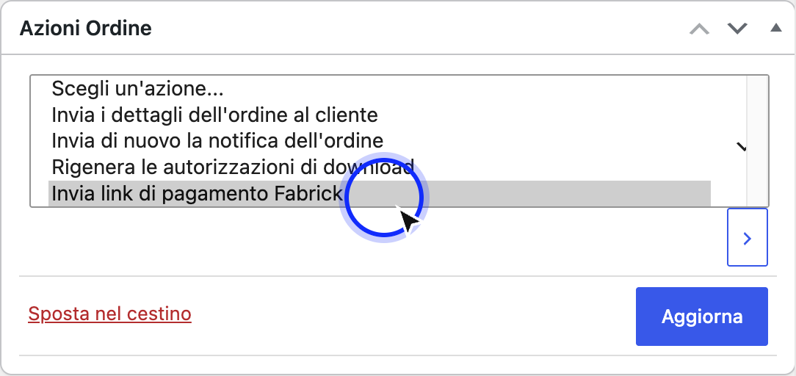
Figure 1. The entry appears in the Order Actions pane only for Fabrick orders that have not yet been paid.
- Confirm the action. Press the confirm button next to the list. WooCommerce performs the action immediately, without any further confirmation requests. The plugin opens a new payment session on the platform, saves the link and transaction references on the order, then sends the email to the customer. If a link already existed on the order, the plugin first tries to cancel the previous session.
- Read the confirmation notice. When the operation is successful, the page reloads and a green notice appears at the top with the link generated and the address to which it was sent: A new Fabrick payment link has been generated... and sent to Previous links to
Payment are no longer usable. The link in the notice opens in a new tab: use it only for a check, not to pay for the customer. Above the order card WooCommerce also shows the message A new Fabrick Pay By Link has been generated and emailed to the customer. The previous payment links are no longer usable. (Figure 2)
Figure 2. The warning reports the link generated, the recipient, and the fact that the previous links are no longer valid.
- Please check the order note. In the order notes box, the plugin writes the outcome of the submission with the recipient's address and the full address of the payment page: Link Pay By Link Fabrick sent to ... . Payment URL If you're replacing a link
The previous note says this explicitly, remembering that the old links are no longer usable. This note is your reference copy: from here you can retrieve the address if the customer asks you to send it to them on another channel (Figure 3).

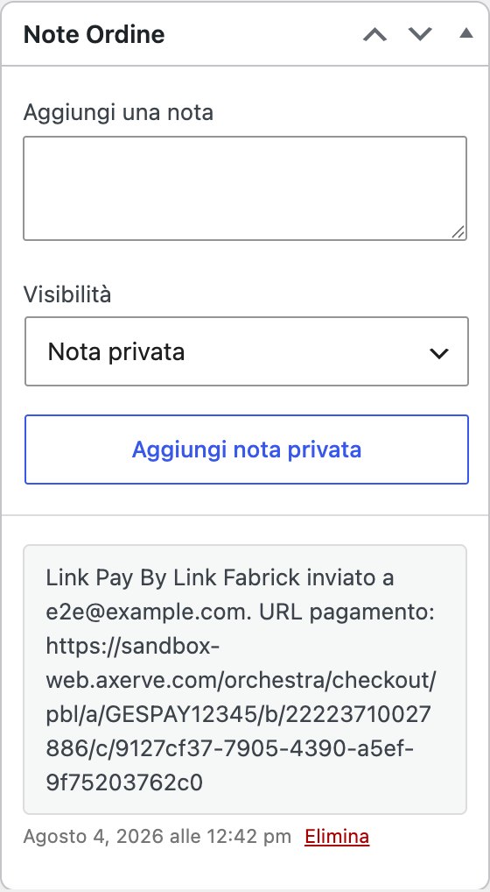

Figure 3. The order note retains the recipient and address of the link that was sent.

- The customer receives the email and pays. The message arrives with the subject Complete the payment of the order #... on ... , where the order number and the name of the store appear. In the body the customer finds the greeting, the phrase You can complete the payment of the order #... on ... using the secure link below, the order total, the indication This payment link is valid for 48 hours, the Pay now button and, in the queue, the same link as text (Pay here) for mail programs that do not show the buttons. The sender is the name of the store with the site's admin email address.
- Wait for the outcome. When the customer completes the payment on the hosted page, the platform communicates the outcome to the store and the order updates itself, with the corresponding note. You don't have to return to the order to record the collection by hand. The possible statuses and checks in case of a long wait are in the chapter on order management.

Expected outcome
Once the submission is successful, you will find three consistent feedbacks:
  - the green notice in administration with connection and recipient;
  - the note on the order with the address of the payment page, which remains available even after days;
  - the email in the customer's mailbox, with the link and indication of the 48 hours of validity.
Something that you don't see also changes on the order: the plugin stores the reference of the new payment session, the address generated, the time of submission and the calculated deadline. If the order was in Failed status, it returns to Waiting for payment with the note Waiting for payment Pay By Link Fabrick: it is correct, because from that moment there is an open payment attempt. Orders that are already pending or pending keep their status.
When the customer pays, the order follows the same path as a payment made at checkout: payment approved with the transaction ID recorded, or rejected, or waiting for confirmation for methods that confirm collection asynchronously.

Notes and constraints
  - Valid for 48 hours. This is the value used by the plugin: it is written in the email and recorded on the order as the expiration of the connection. After that time, consider the connection passed and send a new one. The plugin does not recalculate the expiration and does not make it configurable from the settings.
  - Each send creates a new link. There is no resend of the same message: the action always opens a new payment session and, before doing so, try to cancel the previous one. Links sent in the past are no longer usable, so the customer must use the last email received. If the cancellation of the previous session fails, the plugin still continues with the new one and records it in the technical log.
  - The recipient is the order billing email. There isn't a field to choose another address. To send to a different address, update the order billing email and repeat the action.
  - The email is sent by the store. The message starts from your site with the same mechanism as other WordPress emails, so the delivery depends on the store's mail configuration. If you use a dedicated sending service, the link will follow that route.

It's not one of the WooCommerce emails – you can't find it in the WooCommerce list →
Settings → Email and does not inherit that graphic template.
  - Translated text, not customizable by the administration. Subject and body follow the language of the site, in Italian and English. There are no fields to rewrite them from the settings; sender and sender name derive from the site name and the administration email address, so they are changed from there. Code customizations are described in the developer appendix.
  - The payment page offers the same methods as the checkout. The list is the result of crossing the methods provided by the Fabrick terminal and those turned on in the plugin's switches, just like at the store's checkout.
  - No return addresses to configure. The return and notification addresses are transmitted to the platform together with the request, as with checkout payments. You don't have to set them up in the Fabrick backoffice.
  - Active environment. The link is valid in the environment with which it was generated: in sandbox it does not produce real charges and must be used with Fabrick test cards. If you go into production, the links created in sandbox are no longer useful.
  - Non-Fabricic orders. On an order created with another payment method, the entry does not appear. The plugin does not convert the order: if necessary, it creates a new order with the Fabricic method.

Special cases and errors
  - The item "Send Fabricic payment link" does not appear in the list. There are four possible causes: the order is already paid, it was not created with the Fabricic method, it is in a status other than Awaiting payment, Pending or Failed (e.g. cancelled or refunded), or your user does not have permission to modify orders. Check the status and payment method in the order summary column.
  - "This order cannot receive a Fabrick payment link." The order changed between the time you opened the page and the moment you confirmed the action: in the meantime, it may have been paid or taken to another status. Reload the order sheet and check the updated status.
  - "Fabrick Payment Orchestra is not yet configured. Please complete the configuration." You are missing a Shop Login or API Key for your active environment. Complete the OOBE or re-enter your credentials in the gateway settings, then resubmit.
  - "The order does not have a valid billing email address." The field is blank or contains an invalid address, which is common on hand-created orders. Fill out the billing email, save the order, and repeat the action.
  - "We were unable to create the payment link. Please try again or verify your Fabricic credentials." The platform did not open the session. Typical causes are credentials that are not valid for your environment, outbound calls blocked by the server, a Pay By Link service that is not active on the terminal, or an inaccessible payment method. Activate the technical log to read the error code returned and, if it concerns the activation of the service, contact Fabrick.
  - "The payment link was created but the email was not sent. Copy the link from the order notes or try again." The payment session exists, but the site was unable to send the message: it is almost always a problem with the configuration of the store's mail. The first time you send the note with the payment address is not written, because the

plugin only records it after the email has been delivered: in that case, repeat the action after fixing the email sending. If the order had already received a link in the past, remember that the one reported in the oldest notes is no longer valid.
  - Order note "Failed to send the Fabricic Pay By Link: ...". Each failed attempt leaves a note on the order with the reason. Read it back before trying again: it's the quickest way to understand if the problem was the email, credentials or order status.
  - The customer reports that the link no longer works. They may have opened an old email, superseded by a subsequent send, or a link that is more than 48 hours old. In both cases, generate a new send and ask them to use the last message they received.
  - The order is on hold after the customer has paid. With some methods, confirmation comes shortly after. Wait a few minutes, then check the order notes: the plugin always writes the verified outcome with the transaction ID. If the wait is longer, follow the instructions in the chapter on order management.

Frequently Asked Questions

Can I send the link to a different address than the order address?
Not directly: the plugin uses the order billing email and does not ask for an alternative recipient. If you need another delivery, edit the billing email in the order, save and repeat the action. Alternatively, copy the payment address from the order note and send it with the channel of your choice, keeping in mind that it is a link reserved for that customer.

The customer lost the email: do I have to place the order again?
Repeat the action on the same order: the plugin generates a new payment session and sends a new message. The only attention is to warn the customer to use the last email received, because the previous links are no longer valid.

What is the difference between this link and the order payment page?
They are two different paths towards the same result. The order payment page is the page of your store that hosts the Fabrick payment module, and is the one that the customer encounters after checkout. The Pay By Link link, on the other hand, leads to a page hosted directly by Fabrick, created on request by the store administration: it is the right solution when the customer is not at checkout, for example in an order taken over the phone.

Can I change the text or graphics of the email?
Not from the admin screens: the message is not part of WooCommerce emails and does not have an editable template. However, you can intervene on two elements that appear in the message, the name of the store and the site administration email address, because the plugin uses them as a sender. The text exists in Italian and English and follows the language of the site. For deeper customizations, you need the developer hooks described in the appendix.

What happens if the customer opens the link after 48 hours?
The link must be considered outdated: the plugin records it as expired on the order and the email explicitly declares it to the customer. There is nothing to unlock, just repeat the action to generate a valid one. The duration cannot be changed from the plugin settings.

Do you need to configure something in the Fabrick backoffice to receive the result?
No. As with checkout payments, the store transmits the return and notification addresses to the platform along with the request, so you don't have to fill out lists of addresses.
The only requirement is that the store is reachable from the outside in HTTPS, so that the payment confirmation can arrive and update the order.

Order management and payment statuses
When a customer pays with Fabrick Payment Orchestra, the status of the order is not decided by the screen that the customer has seen or even by the message that the browser brings back to the store. The plugin queries the Fabrick platform to know the real result of the transaction and only then updates the order, writes a note with the payment ID and records the transaction reference. For you this means that the WooCommerce order screen remains the only place to look: what you see there is already verified.
This chapter explains how to read the statuses that the plugin assigns, what the order notes tell, how to deal with a payment that has been waiting for confirmation and why the return of the customer from the payment circuit can never produce an order paid by mistake. This applies both to payments born from the checkout and to those initiated with a payment link.

Prerequisites.
  - WooCommerce scheduled actions working. Notifications that arrive from the Fabrick server are processed in the queue, so the order updates as soon as the queue spins: you can check it in WooCommerce → Status → Scheduled actions.
  - No configuration in the Fabrick back office. You don't have to enter reply-to addresses, notification addresses or IP addresses to be authorized - the store transmits them with every payment. The point is taken up in detail below.

Procedure
- Open the list of orders. Go to WooCommerce → Orders: the Status column tells you at a glance at what stage each payment is. Orders paid with the gateway follow the standard WooCommerce statuses, the plugin does not add its own, so you can use the status filters and views you already know. For a quick check after a day of sales, look at the Pending and Failed orders: these are the two statuses that deserve a reading of the notes (Figure 1).

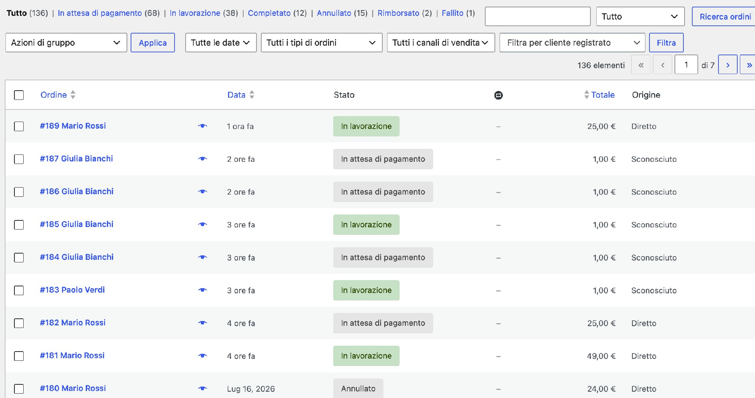
Figure 1. In the order list, the Fabrick results can be read with the standard WooCommerce statuses.
- Open the order and check the data box. In the order tab you will find the Current Status and, for collected orders, the reference of the Fabrick transaction in the transaction identifier field. It is the number to be quoted when you open a report to Fabrick support or when you search for the same operation in the platform's back office. The plugin records it together with the authorization code returned by the circuit, so each order remains linked to its operation even after some time (Figure 2).
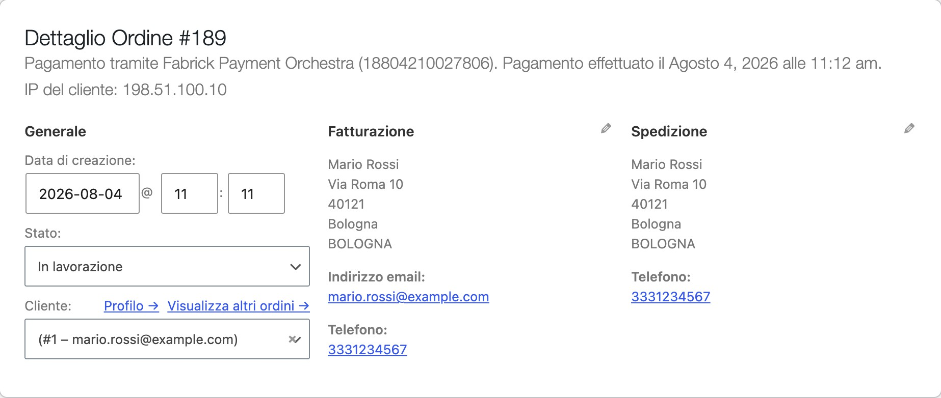
Figure 2. The reference of the Fabrick transaction is stored on the paid order.
- Read the order notes. In the side column, under Order notes, the plugin leaves the history of what happened: the waiting for payment at the time of order confirmation, then the verified outcome with the payment identifier and, in case of rejection, the error code returned by the platform. They are private notes, visible only in administration, and never contain card data. If an outcome note is not there yet, the order has not yet received a verified confirmation (Figure 3).

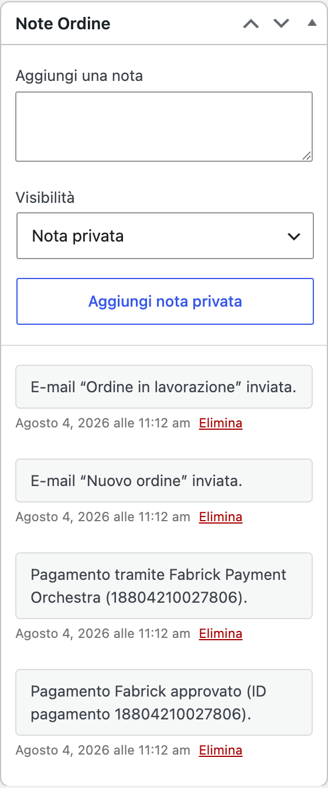
Figure 3. The order notes are the register of the results verified with the platform.

- Manage an order that has been pending. The Pending status accompanied by the confirmation waiting note means that the platform has taken charge of the payment but does not yet have a final result, a typical situation of methods that confirm the collection in a deferred way. Do not ship the goods and do not force the status by hand: as soon as the confirmation arrives, the plugin updates the order by itself and adds the corresponding note. If the confirmation is delayed beyond the time required by the payment method, check the same transaction in the Fabrick backoffice using the identifier written in the note.
- Close the case and, if necessary, look at the technical log. When the order has its outcome verified, there is nothing left to do: the processing resumes as with any other WooCommerce order. If, on the other hand, something doesn't add up, activate the log from the gateway settings and retrace the order: the plugin records every notification received and every verification performed. The chapter dedicated to debugging explains where to read it.

Expected outcome
The plugin recognizes three verified outcomes and always translates them in the same way, regardless of the payment method used by the customer and the channel through which the confirmation arrived.

Verified outcome with the platform | Order status | Recorded note about the order
Payment approved | Order Paid, then Work in Progress or Completed according to WooCommerce rules for the products in the order | Approved Fabrick payment (payment ID...)
Payment declined | Failed | Fabrick payment declined (payment ID..., code...) , followed by the payment status change note  Fabrick rejected (code ...)
Outcome not yet final | Pending | Fabrick payment pending confirmation (payment ID ...) , followed by the status change note The Fabrick payment is pending confirmation

Before these three outcomes, there is the starting state: when the order is confirmed, the store opens the payment session and brings the order Awaiting payment with the note Awaiting payment Fabrick. An order that remains like this is not a mistake: it is an attempt that the customer has not yet completed.
The code that appears in the rejection note is the one returned by the platform for that transaction. It is used to distinguish a refusal by the issuing bank from a renunciation by the customer on the website of the chosen provider: communicate this to Fabrick support when you ask the reason for a recurring refusal.

Notes and constraints
  - No reply address and no IP address to configure. The previous GestPay plugin asked you to manually record the three reply addresses of the store and the IP address to be authorized in the back office. No need here: with each payment request, the plugin transmits the notification and return addresses of your store to the platform, calculated from the site address. If you move the store to another domain, the new addresses start already correct at the next payment, without touching anything on the Fabrick side.

  - The confirmation comes on two independent channels. The platform notifies the store with a server-to-server notification and, in parallel, brings the customer back to the site. Both channels lead to the same check: the plugin asks the platform for the real status of the transaction before touching the order. If the customer closes the browser during the return, the server notification still does its job.
  - Repeated notifications do not produce duplicate effects. The platform can send the same notification multiple times. The plugin keeps track of those already processed for each order, so you don't find duplicate notes, double-counted collections, or repeated status changes.
  - An order that has already been paid is not downgraded. If a negative signal arrives after a verified positive outcome, the order remains paid. It is the protection that avoids inviting the customer to pay a second time for a collection that has already been successful.
  - One order at a time. While one confirmation is processed, the order is blocked for the others: the competing confirmation is postponed for a few seconds and resumed immediately afterwards. For this reason, the update may appear with a small delay compared to the moment the customer has finished paying.
  - It's best not to force statuses manually. Manually changing the status of an order doesn't tell the platform anything – the cashout remains what it is. If you need to return money or cancel an authorization, use the features described in the chapter on refunds.
  - Orders born from a payment link follow the same rules. The confirmation path is identical, only the initial note that signals the waiting for payment via link changes.

Special cases and errors
  - The order remains pending longer than expected. Some methods conclude the investigation even after hours. Check the status of the transaction in the Fabrick backoffice with the identifier shown in the note: if it is collected and the order has not been updated, collect the identifier and date and contact Fabrick support before intervening on the order.
  - The customer says they have paid but the order is still waiting for payment. If there is no outcome note, the store has not received confirmations. Typical causes are a site that is not reachable from the outside, an invalid HTTPS certificate, or outbound calls blocked by the server. Also check that the WooCommerce scheduled action queue is not stopped.
  - The customer has seen an unconfirmed payment message. It happens when the browser returns before the platform has an outcome to communicate. The store invites the customer not to repeat the payment and leaves the order on hold. Check the notes after a few minutes: if the confirmation has arrived in the meantime, the order is already updated.
  - The customer has returned to his account page instead of the order confirmation. This happens when the references that accompany the return do not correspond to those recorded on the order, for example with an old link reopened from the history. This is intentional: the store does not show the confirmation of an order that it cannot attribute with certainty to that session. The order is still updated by the server notification.
  - A notification appears in the register without a corresponding order. It means that the reference arrived cannot be linked to any order in the store: it happens with notifications relating to another site that shares the same Fabrick account, or after the permanent deletion of a test order. No order is touched.
  - The verification with the platform fails. If the check request fails, the plugin does not change the status of the order and notes the error in the log: it prefers to leave the order

rather than deciding without a trusted response. A subsequent notification tries again on its own; if the error recurs, it verifies credentials and server outbound connectivity.
  - An order is paid but the customer claims otherwise. Trust the outcome note and the transaction reference: they are written only after the platform has confirmed it. Compare the identifier with the transaction in the Fabrick backoffice before proceeding with a refund.

Frequently Asked Questions

How long does it take between the customer's payment and the order is updated?
Usually a few seconds. The notification that comes from the Fabrick server is queued and processed by WooCommerce's scheduled actions, while the customer's return to the store performs the verification right away. If you notice systematic delays, the first place to check is the queue in WooCommerce → Status → Scheduled Actions.
Can I consider a pending order paid if the customer sends me the receipt? Better not. The pending status indicates that the platform has not yet given a final outcome, and forcing it by hand does not collect anything. Verify the transaction in the back office
Fabrick with the identifier shown in the notes: if it is approved and the order is not
update, it is a case to be reported to support.

Why did an order remain paid even though the customer came back with an error?
Because the outcome is asked directly to the platform and its answer prevails over what the browser reports. If the transaction is approved, the order remains paid: downgrading it would expose the customer to the risk of paying the same order twice. If you don't need the collection, proceed with a refund or cancellation from the order sheet.

The customer paid for the same order twice: what do I do?
The plugin discards repeated confirmations of the same transaction, so a double charge arises from two separate payments, usually a repeated attempt after a return gone wrong. On the order you will find the reference of the registered one: look for the other transaction in the Fabrick backoffice and refund it from there, or ask for support by indicating both identifiers.

Where can I find the number to communicate to Fabrick support?
In the order sheet: it is the transaction identifier shown in the order data box, the same one that appears in the outcome notes. Together with the date and amount, it is sufficient to find the transaction on the platform.

Refunds and cancellations
An order paid with Fabrick Payment Orchestra is refunded from the same order screen you use for all other WooCommerce orders. The plugin adds a refund button that talks to the Fabrick platform: before moving a penny it queries the platform to find out what state that transaction is really in, then decides whether it needs a reversal of the money already collected or the cancellation of an authorization that is still suspended. They are two different operations with different rules, and this is the reason why sometimes a partial refund is not accepted.
The chapter explains how to perform a full and partial refund, when a partial refund is not available and why, how to cancel an authorization, and how the WooCommerce Manually Refund button differs from the refund performed through Fabrick. The latter distinction is the most frequent source of error: the two buttons stand side by side, and only one returns money to the customer.

Prerequisites
  - A user with WooCommerce order management permissions, i.e. an Admin or Store Manager. Anyone who cannot edit orders does not see the refund area.
  - An order paid with Fabrick Payment Orchestra and with the outcome already verified: the refund button through Fabrick appears only if the payment ID is recorded on the order. On orders of other methods, or on an order that has never been successful, only manual reimbursement remains available.

Procedure
- Open the order and go down to the item summary. In WooCommerce → Orders, open the order you want to refund. Under the list of order lines, next to the totals, you will find the Refund button. Before clicking, check in the data box that the payment method is Fabrick Payment Orchestra and make a note of the transaction ID: you need it if you need to find the same operation in the platform's backoffice.

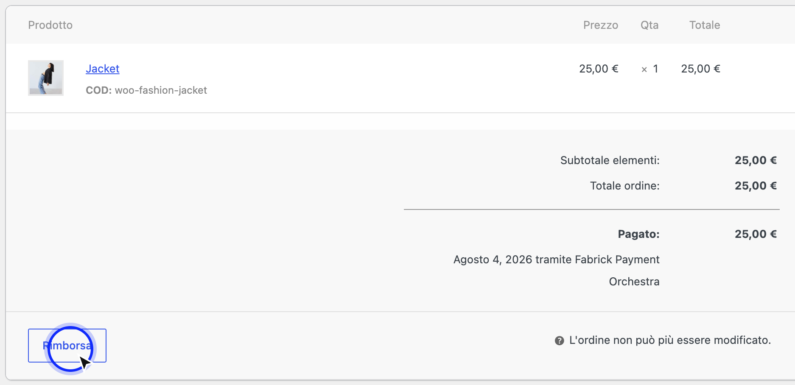

The refund starts from the button below the order lines, as with any WooCommerce order.
- Indicate how much you want to return. Clicking on Refund opens the refund fields on each order line. You can set the quantities to be returned, letting WooCommerce calculate taxes and fees, or write the figure directly in the Refund amount field. In the Reason for refund field you can note the reason: it remains in the order notes as an internal reminder, is not transmitted to the platform and does not reach the customer. For a full refund, leave the amount equal to the refundable residue that WooCommerce offers.
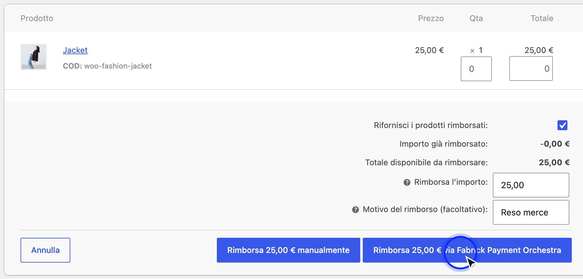
The two buttons at the bottom of the refund area do different things: only the one that names the gateway returns the money.
- Choose the right button. At the bottom of the refund area, WooCommerce shows two buttons with the amount indicated. The one that names Fabrick Payment Orchestra sends the operation to the platform: it is the only one that returns the money to the customer. The manual refund one only records a refund in the WooCommerce accounting, without contacting Fabrick: it is used when you have already returned the money by other means, for example from the

platform backoffice or with a bank transfer, and you just want to align the order. When in doubt, the correct button is the one that bears the name of the gateway.
- Confirm and wait for the response. WooCommerce asks for confirmation because the operation is not reversible. After confirmation, the plugin checks the status of the transaction on the platform and sends the reversal or cancellation; the wait is a few seconds. Do not reload the page and do not repeat the click: a second attempt on the same order while the first one is in progress is rejected with the message Another Fabrick payment operation is in progress for this order. Please try again in a few moments.
- Check the order note. When the operation is successful, the plugin writes the result in the Order Notes box: Fabrick refund of € 25.00 processed. Reason: ... for a reversal, or Fabrick payment authorization canceled. when the operation has freed an authorization that has not yet been collected. The note is proof that the platform has accepted: if the refund appears in the totals but the note is not there, the money has not moved.

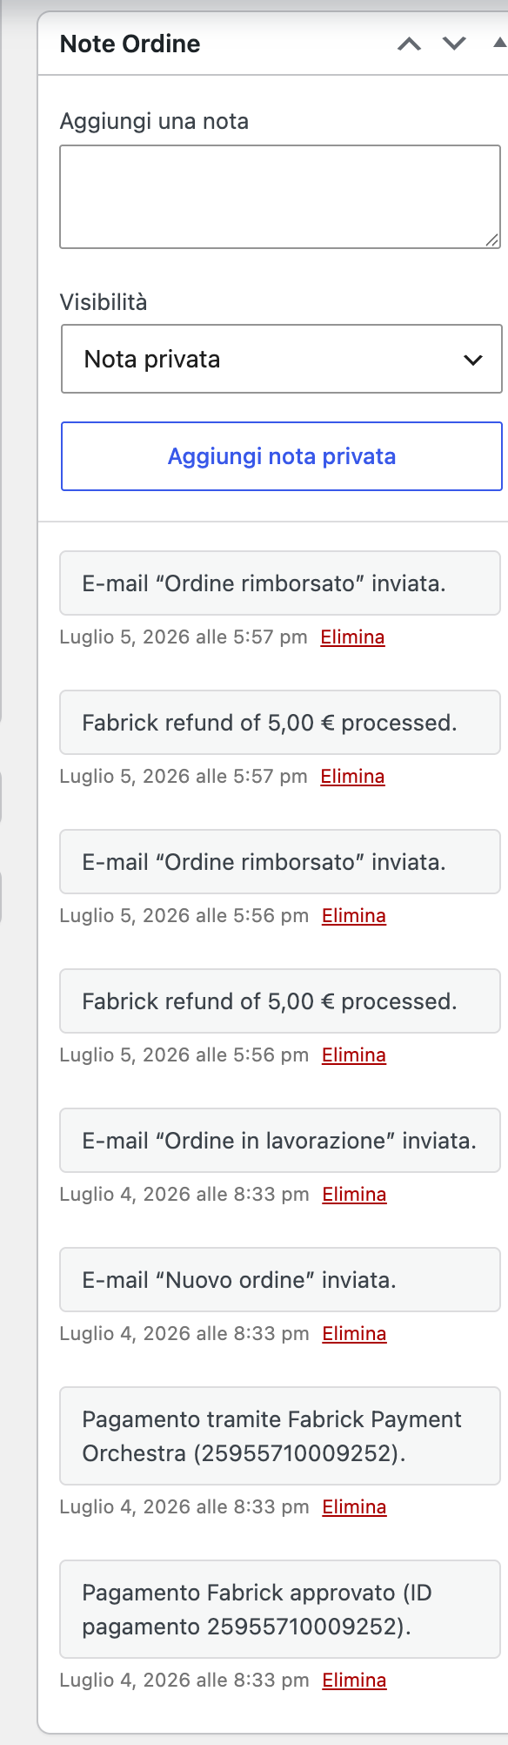
The note with the amount processed confirms that the platform has accepted the chargeback.

- To cancel altogether, change the status to Canceled. If the payment is stuck at an authorization and you want to free it without going through the refund fields, turn the order status to Canceled and save: the plugin checks the transaction and, if it has not yet been collected, sends the cancellation and adds the corresponding note. If, on the other hand, the money had already been collected, it does not cancel anything and notifies you with the note Order canceled in WooCommerce, but the Fabrick payment had already been accounted for. If necessary, issue a manual refund from the order screen.

Expected outcome
What the plugin can do depends on the state the platform holds the transaction in at the time you press the button, not the method by which the customer paid. A card and a digital wallet follow the same rules: only the state they are in changes.

Transaction status on the platform | Full refund | Partial refund | Recorded note about the order
Authorized (AUT code): Amount blocked on the customer's card but not yet  recessed | Cancellation of authorization, the block on the card is released | Out of stock | Fabrick payment authorization canceled.
Cashed out (MOV code): money accounted for | Cancellation of the entire remaining amount | Cancellation of any amount up to the remaining amount | Fabrick refund of ... processed.
Partially reversed (STO code): at least one refund already  executed | Reversal of what remains | Cancellation until the remaining amount is still available | Fabrick refund of ... processed.
Cancelled (code  CAN): authorization already released | Rejected | Rejected | None: the operation does not start

When the operation fails, WooCommerce cancels the refund it had just registered and shows you the message of the platform. The order totals therefore remain consistent: you do not find a refund accounted for for money that was never returned.
The only exception is the cancellation of an authorization: there WooCommerce records a refund equal to the amount, even if nothing had actually been cashed out. It's how WooCommerce represents the closing of the order and applies to all gateways that work with authorizations, it's not a plugin error.

Notes and constraints
  - A partial refund requires a payment that has already been collected. As long as the platform only keeps the authorization, the only possible operation is to release it in full. If you try to refund a part, you will receive the message Partial refund is not available: Fabrick still only has one authorization (payment not collected). This applies to any payment method, not just cards. To cancel the authorization and unblock the customer's card, refund the entire remaining amount (...). To refund only a part of the order, first collect the payment on Fabrick. The message shows the exact amount to be indicated for cancellation.
  - The collection of the authorization is managed on the Fabrick platform. The plugin does not offer a command to account for an authorization from WooCommerce. If transactions

of your store remain authorized and you want to be able to collect at a later time or refund partial amounts, the mode must be seen on the terminal: there is no default behavior that is the same for everyone, it depends on the contract and is configured from the Fabrick backoffice. Check it with your Fabrick representative.
  - The refund limit is the lower of the two residuals. The plugin compares the refundable remainder of the WooCommerce order with the one that is still available on the Fabrick transaction and accepts at most the lesser of the two. It is used in cases where the two systems are not aligned, for example after a refund performed directly from the platform's backoffice.
  - Multiple partial refunds on the same order are allowed. You can repeat the operation until the remainder is exhausted, even with identical amounts: each WooCommerce refund is treated as a separate operation and sent to the platform.
  - One order at a time. Refund, cancellation, and payment confirmations share the same block on the order: no two operations can overlap. If you receive the notification that the operation is in progress, please wait a few seconds and try again.
  - The reason for the refund remains internal. It is cleaned up, limited in length and written in the order note; only the payment ID, the amount and the currency are sent to the platform. Do not enter personal data of the customer: the note is visible to those who manage the orders.
  - The refund button via Fabrick may not appear. It is missing on orders paid with other methods and on those without registered payment identification, for example an order created by hand or left on hold. In those cases, only the manual refund remains, which does not move money.
  - The automatic cancellation is triggered even without your intervention. If WooCommerce cancels an order on its own, for example after the stock reserve period has expired, the plugin applies the same rules. However, it does not affect orders that do not yet have a verified payment outcome: an attempt that has never been completed does not result in a call to the platform.
  - Changing status by hand does not return money. Moving an order to Refunded from the status menu only updates WooCommerce. To return the collection, you always need the button that names the gateway, or an operation performed in the Fabrick backoffice.

Special cases and errors
  - The refund amount exceeds the remaining refundable balance on Fabrick. The transaction has less residual than WooCommerce thinks: usually because a refund has already been made from the platform's backoffice. Check the transaction with the order ID and try again with the amount actually still available.
  - There is no refundable amount left on this Fabrick payment. The entire collection has already been reversed. If the WooCommerce order is still to be refunded, align it with the manual refund.
  - This Fabrick payment has already been cancelled. The authorisation has already been released, either from your previous operation or from the order being switched to Cancelled. There is nothing to return to the customer.
  - Refund is not available for payment status... The transaction is in a state that cannot be traded, typically a payment that has not been completed or is still awaiting confirmation. Wait for the outcome to consolidate and double-check the order notes.

  - This Fabrick payment cannot be refunded or canceled in its current state. It is the platform that rejects the operation. Please check the status of the transaction in the Fabrick backoffice before trying again.
  - Fabrick has rejected the refund amount for this payment status. The amount is not compatible with what appears on the platform: try again with the full remainder or check the amounts already reversed.
  - The Fabrick payment service is temporarily unavailable. Please try again later. The plugin has suspended calls after a series of consecutive errors, so as not to insist on an unresponsive service. No refund has been sent: repeat the operation later.
  - The Fabrick Orchestra credentials are not configured. The credential pair for the active environment is missing. Complete the gateway settings and reclaim.
  - Fabrick could not complete the payment operation. Check the WooCommerce logs for details. Generic message for a communication error or an unexpected response. Activate the log from the gateway settings and try again - the technical detail of the operation ends there.
  - The refund disappears from the totals after saving. It's not a glitch on the screen: it means that the platform declined the operation and WooCommerce removed the refund you just recorded. The error message shown at the top of the refund area explains why.
  - The customer does not see the credit immediately. The plugin records the transaction when the platform accepts it, but the time it takes to re-credit the account or card depends on the customer's circuit and bank. For a canceled authorization, the block can remain visible for a few days before disappearing from the statement.

Frequently Asked Questions

Why can't I refund only part of an order paid by card?
Because that transaction is only authorized: the amount is blocked on the customer's card but has not yet been cashed out, and only an authorization can be acted on in full. It does not depend on the card or the circuit. Refund the remaining amount indicated in the message to release the authorization; if you need to return only a part, the collection must be done first on the platform.

What is the difference between the manual refund button and the one that Fabrick mentions?
The button that names the gateway sends the operation to the platform and returns the money to the customer. The manual refund only writes a refund line in WooCommerce accounting and does not contact Fabrick: after using it, the customer has not received anything. Use it only to post a refund that you have already made in other ways.

Can I cash out an authorization directly from WooCommerce?
No, the plugin does not have a command to do this. The moment when a transaction goes from authorized to cashed out is a feature of the terminal and does not have a default value that is the same for everyone: it is defined in the contract and set from the Fabrick backoffice. If your store needs to work with deferred collections or partial refunds on cards, talk to the Fabrick contact person.

If I place an order on Cancelled, does the customer get the money back?
Only if the payment was stopped at an authorization: in that case the plugin frees it and writes it in the notes. If, on the other hand, the collection had already taken place, it does not cancel anything and notifies you with a note inviting you to proceed with a refund from the order screen. Always check the notes after canceling.

I have already refunded from the Fabrick backoffice: do I need to do anything in WooCommerce?
Yes, otherwise the order remains unreimbursed in the accounts. Record the amount with the manual refund, so the order totals come back correct without sending a second operation. If you mistakenly use the gateway button for more than what is still available, the operation is rejected with the remaining balance warning.

Can I make two partial refunds of the same amount on the same order?
Yes. Each refund created in WooCommerce is sent to the platform as a separate operation, so two 10 euro chargebacks on the same order are both executed, until the available residue is exhausted. You find a separate note for each.

Debug e log
When a payment fails and the message on the screen is not enough to understand why, the plugin can record the technical events of the exchange with the Fabrick platform: the creation of the payment session, the return of the outcome notification, the errors returned by the API. This is the information you need to orient yourself and Fabrick assistance to understand where an operation has stopped.
Logging is governed by a single switch, in the Debug pane of the gateway tab. From there you consult the most recent entries without leaving the page, download them in a file to be analyzed or attached to a report and reach the complete archive of WooCommerce logs. The Debug pane also hosts, only on sites configured for development, the link that restarts the configuration wizard.
Before you turn it on, keep in mind the trade-off it entails: with debugging on, the payment request records also include the customer's billing information and email address. This is why the switch is born off and why it should be turned back to off as soon as you're done investigating.

What is recorded and when
The plugin distinguishes four event levels and does not treat them in the same way. Informational events, i.e. the step-by-step story of the flow, are written only with debugging active; anomalies are always recorded, even when the debug is off, so a repeated error leaves a trace without the need for any prior configuration.
Event levels and logging conditions

Level | What's in it | When it is written
Debugging and information | The normal course of operations: opening the payment session, content of the request sent, checking the outcome, processing the notification, sending a payment link, renewing a subscription. | Only with debug mode active. With the switch off, these events are not produced.
Warning | Situations handled but not  Normal: Authentication refused by the platform, response with error code, unrecoverable method list resulting in the use of the | Always, Regardless  from the switch.

 | reserve, deletion of a saved card failed.
Error | Operations interrupted: Fabrick server unreachable from the site, subscription renewal failed. | Always, regardless of the switch.

All entries end up in the WooCommerce logs under a single source,
fabrick-payment-orchestra: this is the keyword with which you isolate the plugin from all the logs on the site. The messages are technical and in English, because they are designed for diagnosis: it is not a translation defect.

Procedure
- Open WooCommerce → Settings → Payments → Fabrick Payment Orchestra and scroll to the last pane of the page, titled Debug. The description under the title already resembles the perimeter of what is being logged: technical events for diagnostic purposes, no card number and no security code, no API tokens (Figure 1).
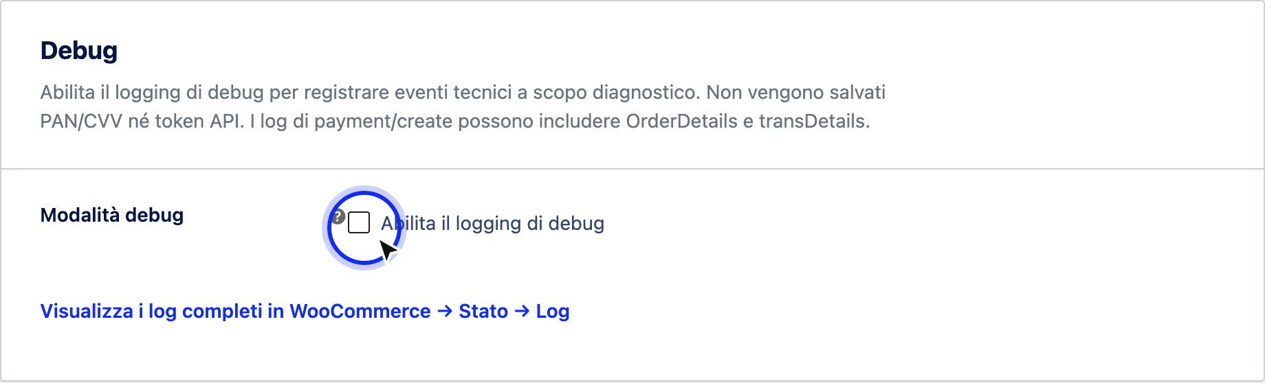
Figure 1. The Debug pane with the switch in its default condition, i.e., off.
- Check the Enable debugging logging box in the Debug Mode field, then press Save Changes at the bottom of the page. The button is unique for the entire tab: until you save, the recording doesn't start.
- Reproduce the issue. If you're investigating a payment, complete a sandboxed test order with test cards; if the case involves a refund or payment link, repeat that specific step. Events are logged as they happen, so debugging should be triggered before the attempt you want to investigate, not after.
- Return to the gateway tab. With debugging enabled, the Recent Log (last 100 entries) pane appears below the switch, listing the events from newest to oldest in a table with Date/Time, Level, and Message columns. Below each message, when it exists, is the context data of the event, such as the order number, the environment in use, and the status code returned by the platform. Above the table, when the log contains at least one entry, you will find three buttons: Export CSV, Export Markdown, and Empty Log (Figure 2).

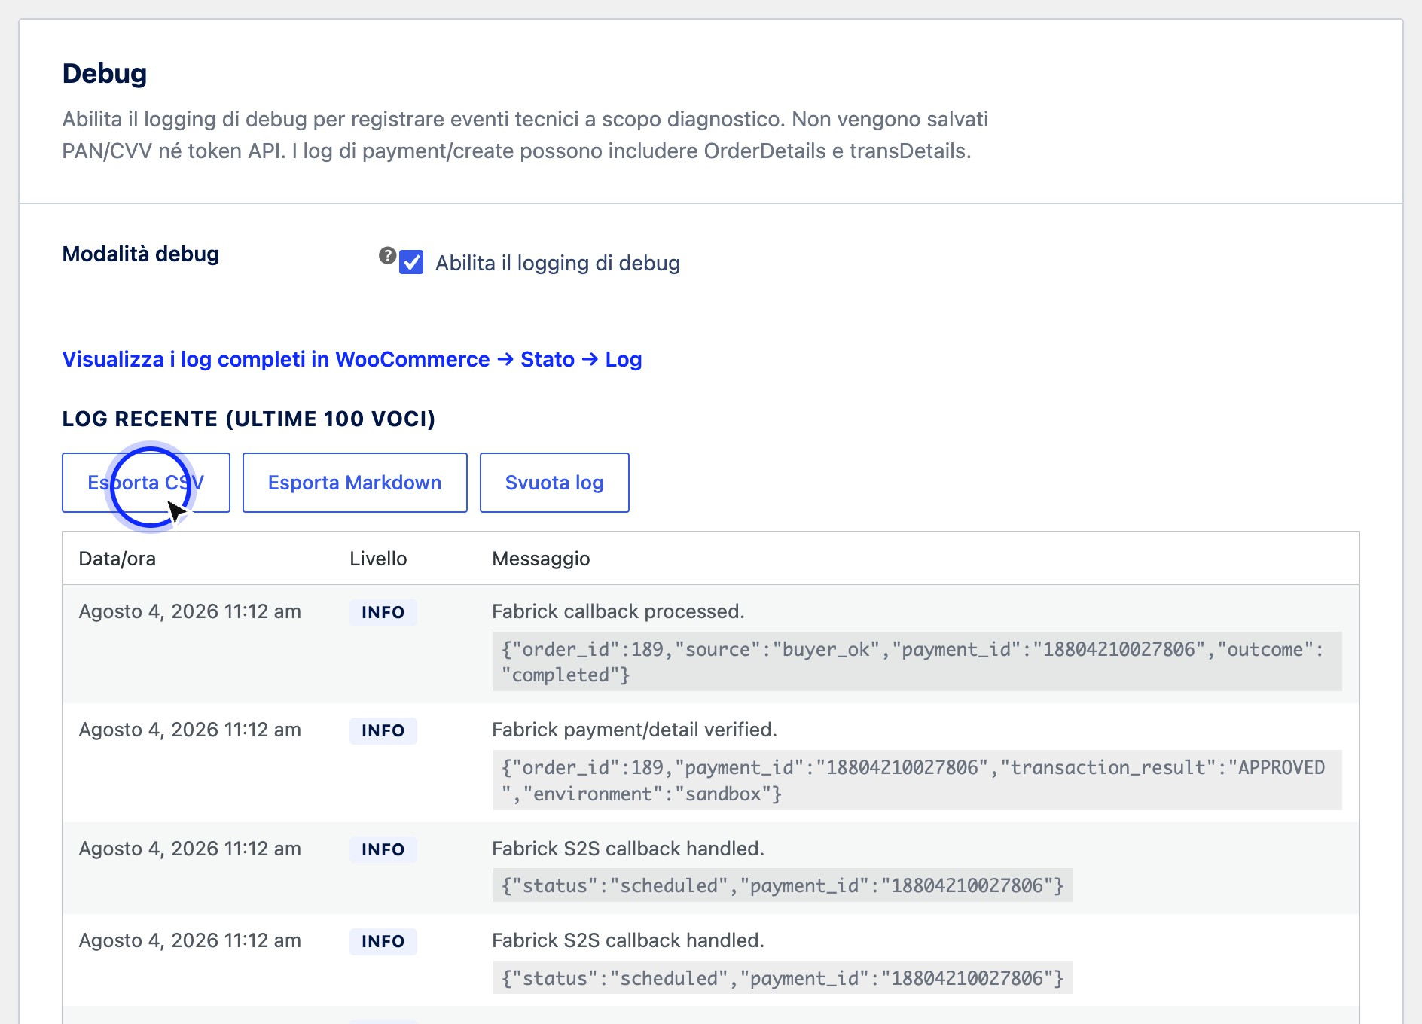

Figure 2. With debug mode active, the page shows the most recent entries, with buttons to export them or empty the list.
- If the entries on the screen are enough for your analysis but you need to keep or share them, export them with one of the two buttons. Export CSV downloads the log into a file to be opened with a spreadsheet, one row per event with date and time, level, message and context data: it is the right format to filter and sort many entries. Export Markdown downloads the same entries as a readable text document, one event per section with the context already formatted: it is the suitable format to attach to a report or to paste into a ticket. In both cases the file contains only the recent log shown on the page, with the same masks, and the name shows the date and time of the download.
- For the complete history, follow the link View full logs in WooCommerce → → Log Status, which is always present in the pane even when debugging is off.
On the WooCommerce logs page, look for source entries
fabrick-payment-orchestra: they are collected in dated files whose name begins with the same text. From here you can open the content and, if needed for support, download it (Figure 3).

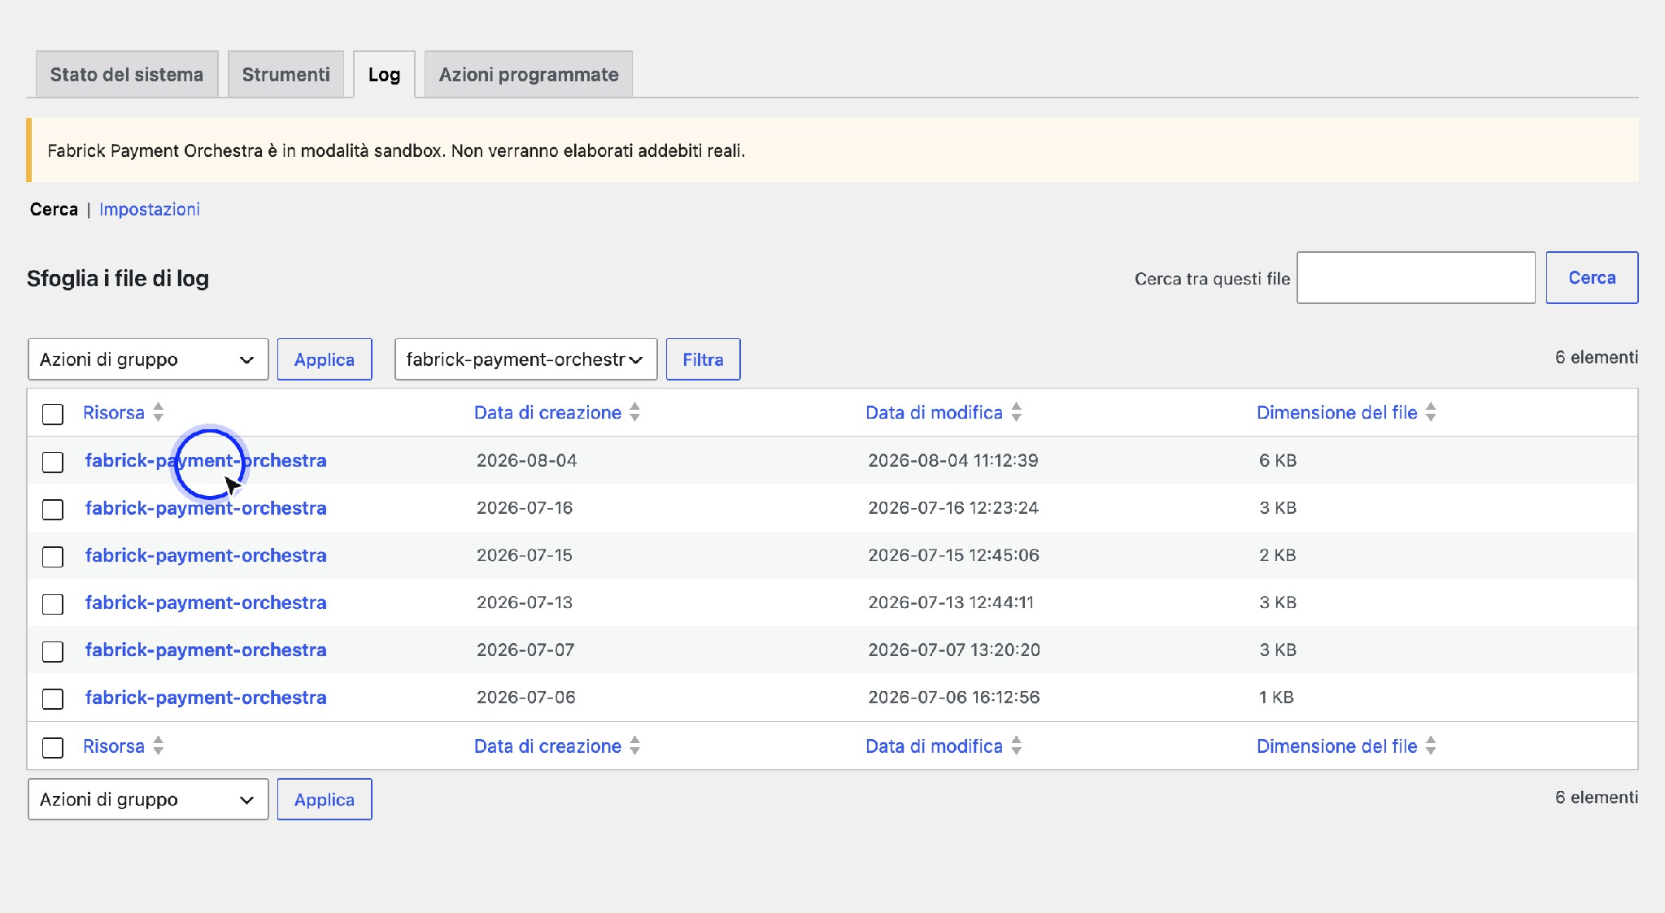
Figure 3. In the WooCommerce logs, the plugin entries are grouped under the fabrick-payment-orchestra source.
- When the investigation is closed, uncheck Enable debug logging and save again. If you want to clean up the list shown on the page as well, press Clear log before disable: The confirmation Debug log emptied. appears at the top of the tab.

Expected outcome
During the investigation, the gateway card shows the log of the last hundred operations, with time, level and message of each, downloadable in CSV or Markdown with the buttons above the table, and the WooCommerce logs contain the complete trace of the plugin source, ready to be attached to a report. At the end, with the switch set back to off, the store stops producing informative events and continues to record only warnings and errors. The Recent log pane disappears from the page along with the deactivation, while the files already written in the WooCommerce logs remain available for consultation.

Notes and constraints
  - With active debugging, personal data is logged. Payment request logging includes OrderDetails and transDetails blocks, which carry the customer's billing address and email. On a production store that doesn't need to keep this data in logs, the switch should only be kept off and on for as long as necessary to reproduce a problem.
  - Card numbers and keys are never written. The card number and security code don't pass through your server, so they can't end up in any logs. The API key, authorization headers, and payment tokens are masked before writing, both on the page and in WooCommerce files.
  - The log on the page is deliberately short. It keeps a maximum of one hundred entries: when new ones arrive, the oldest ones come out. For a longer period of time analysis, the reference is the WooCommerce logs, not the box in the tab.

  - Clear log only acts on the list on the screen. It cleans up the recent log shown on the page and does not touch the WooCommerce log files, which remain available and must be deleted from their page.
  - The export concerns only the recent log. The files downloaded with Export CSV and Export Markdown contain a maximum of one hundred entries shown on the page, already masked. For the complete history, the reference remains the WooCommerce log files.
  - The two lists do not match. On the page you only see what was recorded while debugging was active; in the WooCommerce logs you also find the warnings and errors collected during the periods when it was turned off.
  - The switch applies to the entire store. You can't turn on debugging for just one order or one customer: once you turn it on, it records all traffic to the platform until you turn it off.
  - Who can export or empty the registry. Both actions require store management permissions and a link generated by the page itself: opening such an address by hand has no effect.
  - Debugging does not change the behavior of payments. Enabling or disabling it does not change outcomes, order statuses, or methods available at checkout: it only affects what is written to the registers.

Special cases and errors
  - The Recent Log pane does not appear. Debug mode is not active or the check has not been saved. Put the check back on, press Save Changes, and reload the page.
  - "No log entries at this time." Debugging is active but no events have passed since activation. Reproduce the operation you want to analyze, for example a sandboxed test order, then return to the tab.
  - The Export CSV, Export Markdown, and Empty Log buttons are not there. They only appear when the log contains at least one entry. With the empty list, they are not needed, because there is nothing to download or remove.
  - "Invalid export link. Please try again from the Debug card." The download link has expired, for example because the page was open for a long time or saved to your favorites. Reload the gateway card and press the export button again.
  - In the WooCommerce logs, you can't find the source of the plugin. It means that the store has not yet produced events for this gateway: with debugging turned off, only warnings and errors are written, so a period without anomalies leaves no files. Activate debugging and repeat the operation.
  - You see warning entries even though you have debugging turned off. This is the expected behavior: warnings and errors are always logged, so a rejected authentication or a failed call remains tracked even without prior configurations.
  - A value appears shortened or covered. It's not accidental truncation: keys, permissions, and tokens are purposely masked before they're written. To verify a credential, use the connection test in the credentials pane, not the logs.
  - The log fills up with repeated entries. The plugin writes a line for each step of the flow, so a store with many orders quickly runs out of the hundred available entries. In these cases, it works on WooCommerce log files, where the history is not overwritten.

Frequently Asked Questions

Can I leave debugging always on the production store?
We don't recommend it. With debugging turned on, payment request records contain the customer's billing address and email, which remain in the site logs until the files are deleted. Turn it on to reproduce an issue and turn it off again immediately afterward—warnings and errors continue to be logged even with the switch off.

Can the customer's card number end up in the logs?
No. Card information is entered into the Fabrick payment page and does not pass through your server, so it does not exist in the site's logs. The API key, authorization headers, and payment tokens are also masked before writing, both in the log shown in the tab and in WooCommerce files.

What's the difference between the log in the tab and the WooCommerce logs?
The log in the tab is a quick view of the last hundred entries collected while debugging was active, convenient for immediate control without changing pages. WooCommerce logs are the complete archive, organized in dated files under the fabrick-payment-orchestra source, and also include warnings and errors of periods with debugging turned off. For a support report, use the latter.

What should I send to support when I open a report?
The fabrick-payment-orchestra source log file for the day of the problem, together with the order number and the Fabrick transaction identifier that you can find in the order card. If the problem has just happened and the entries are still in the recent log, the quickest way is to Export Markdown: it produces a readable document ready to be attached. It also indicates the environment in which it happened, sandbox or production, and the time of the attempt: these are the references that allow you to find the same operation on the platform.

What is the difference between Export CSV and Export Markdown?
The content is the same, the use changes. The CSV opens with a spreadsheet and is used to analyze the entries, filter them and sort them; the Markdown is a readable text document, with one event per section, designed to be attached to a report or pasted into a ticket. Both contain only the recent log shown on the page, with keys and tokens already masked.

Do I lose my service information when I clear my log?
Only those shown on the gateway tab. Clear Logs cleans up the on-screen list and doesn't touch the WooCommerce log files, which remain available on the logs page. If you need to keep a trace of the on-screen list, press Export CSV or Export Markdown before emptying it.

Migrating from the GestPay plugin
If your store already collects with GestPay for WooCommerce, switching to Fabrick Payment Orchestra does not require you to redo the configuration from scratch and does not touch the order history. The two plugins remain separate entities within WooCommerce: they coexist without overlapping, each have its own entry among the payment methods and turn off one at a time. The migration, therefore, is a sequence of controlled steps that you decide, not an automatic operation that starts at activation.
This chapter describes what the new plugin recovers from the previous one, what remains as before and what needs to be redone. The three things to focus on before starting are: credentials can be retrieved with a dedicated command, historical orders remain readable but do not become workable by the new gateway, and cards saved by customers with the old plugin are not transferred.

Prerequisites
  - Fabrick Payment Orchestra plugin installed and active, with the configuration wizard still to be completed or stop on the Account step: the credential recovery is there.
  - GestPay for WooCommerce plugin still present on the site with its settings saved. The recovery reads the values stored by the old plugin: if you have already uninstalled it by deleting its data, there is nothing left to recover.
  - WordPress user with permission to manage WooCommerce. Without that permission, the fetch command is not executed.
  - Merchant account credentials at hand anyway: they are used for connection testing and, if your production contract uses different values than the old plugin, to complete the configuration.
  - Back up the site and database before starting, as with any change that affects revenues. The transition is made when the store is open, but it is better to choose a quiet time.
  - List of still open orders paid with the old plugin, i.e. those on which you may have to make a refund or cancellation in the following days.

Procedure

Open the Account step of the OOBE. Go to
wp-admin/admin.php?page=fabrick-orch-setup and continue to the Connect your Fabrick account screen. If the plugin finds the credentials of the old GestPay and has not already retrieved them, the information box We found credentials from the legacy plugin GestPay for WooCommerce appears above the fields. You can import them in this configuration with the Import legacy credentials button. If the box is not there, the retrieval is not available and the fields must be filled in by hand.

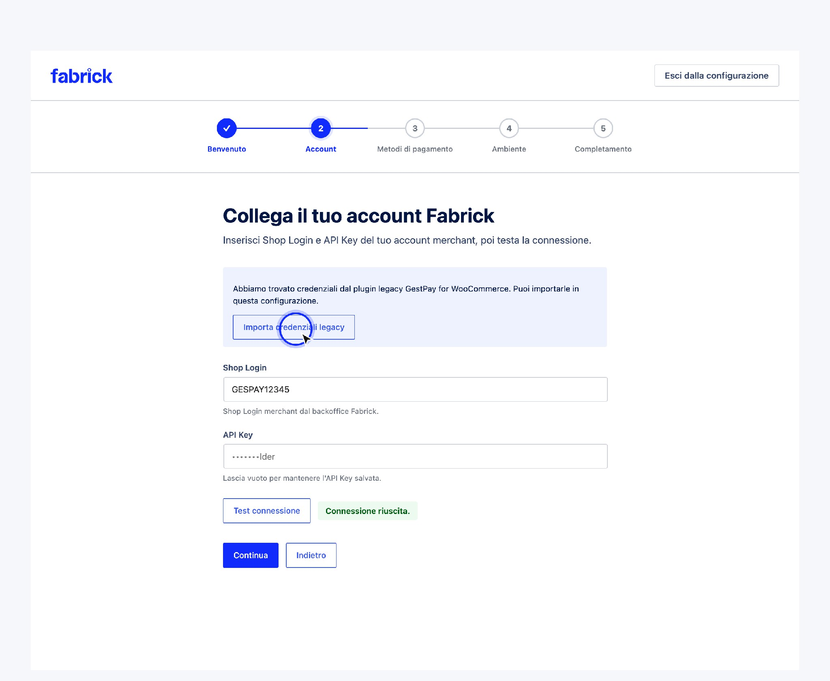
The credential recovery appears in the Account step only if the old plugin still has its data on the site.
- Retrieve Shop Login and API Key. Press Import legacy credentials: the plugin copies the store identifier and key found in the old plugin into its fields and confirms with Imported GestPay legacy credentials. Run a connection test before continuing. The operation is a one-shot operation: once executed the box never returns, even if you later change the credentials by hand. If the old plugin used a second terminal for recurring payments, the first valid value is taken, with precedence to the main terminal.

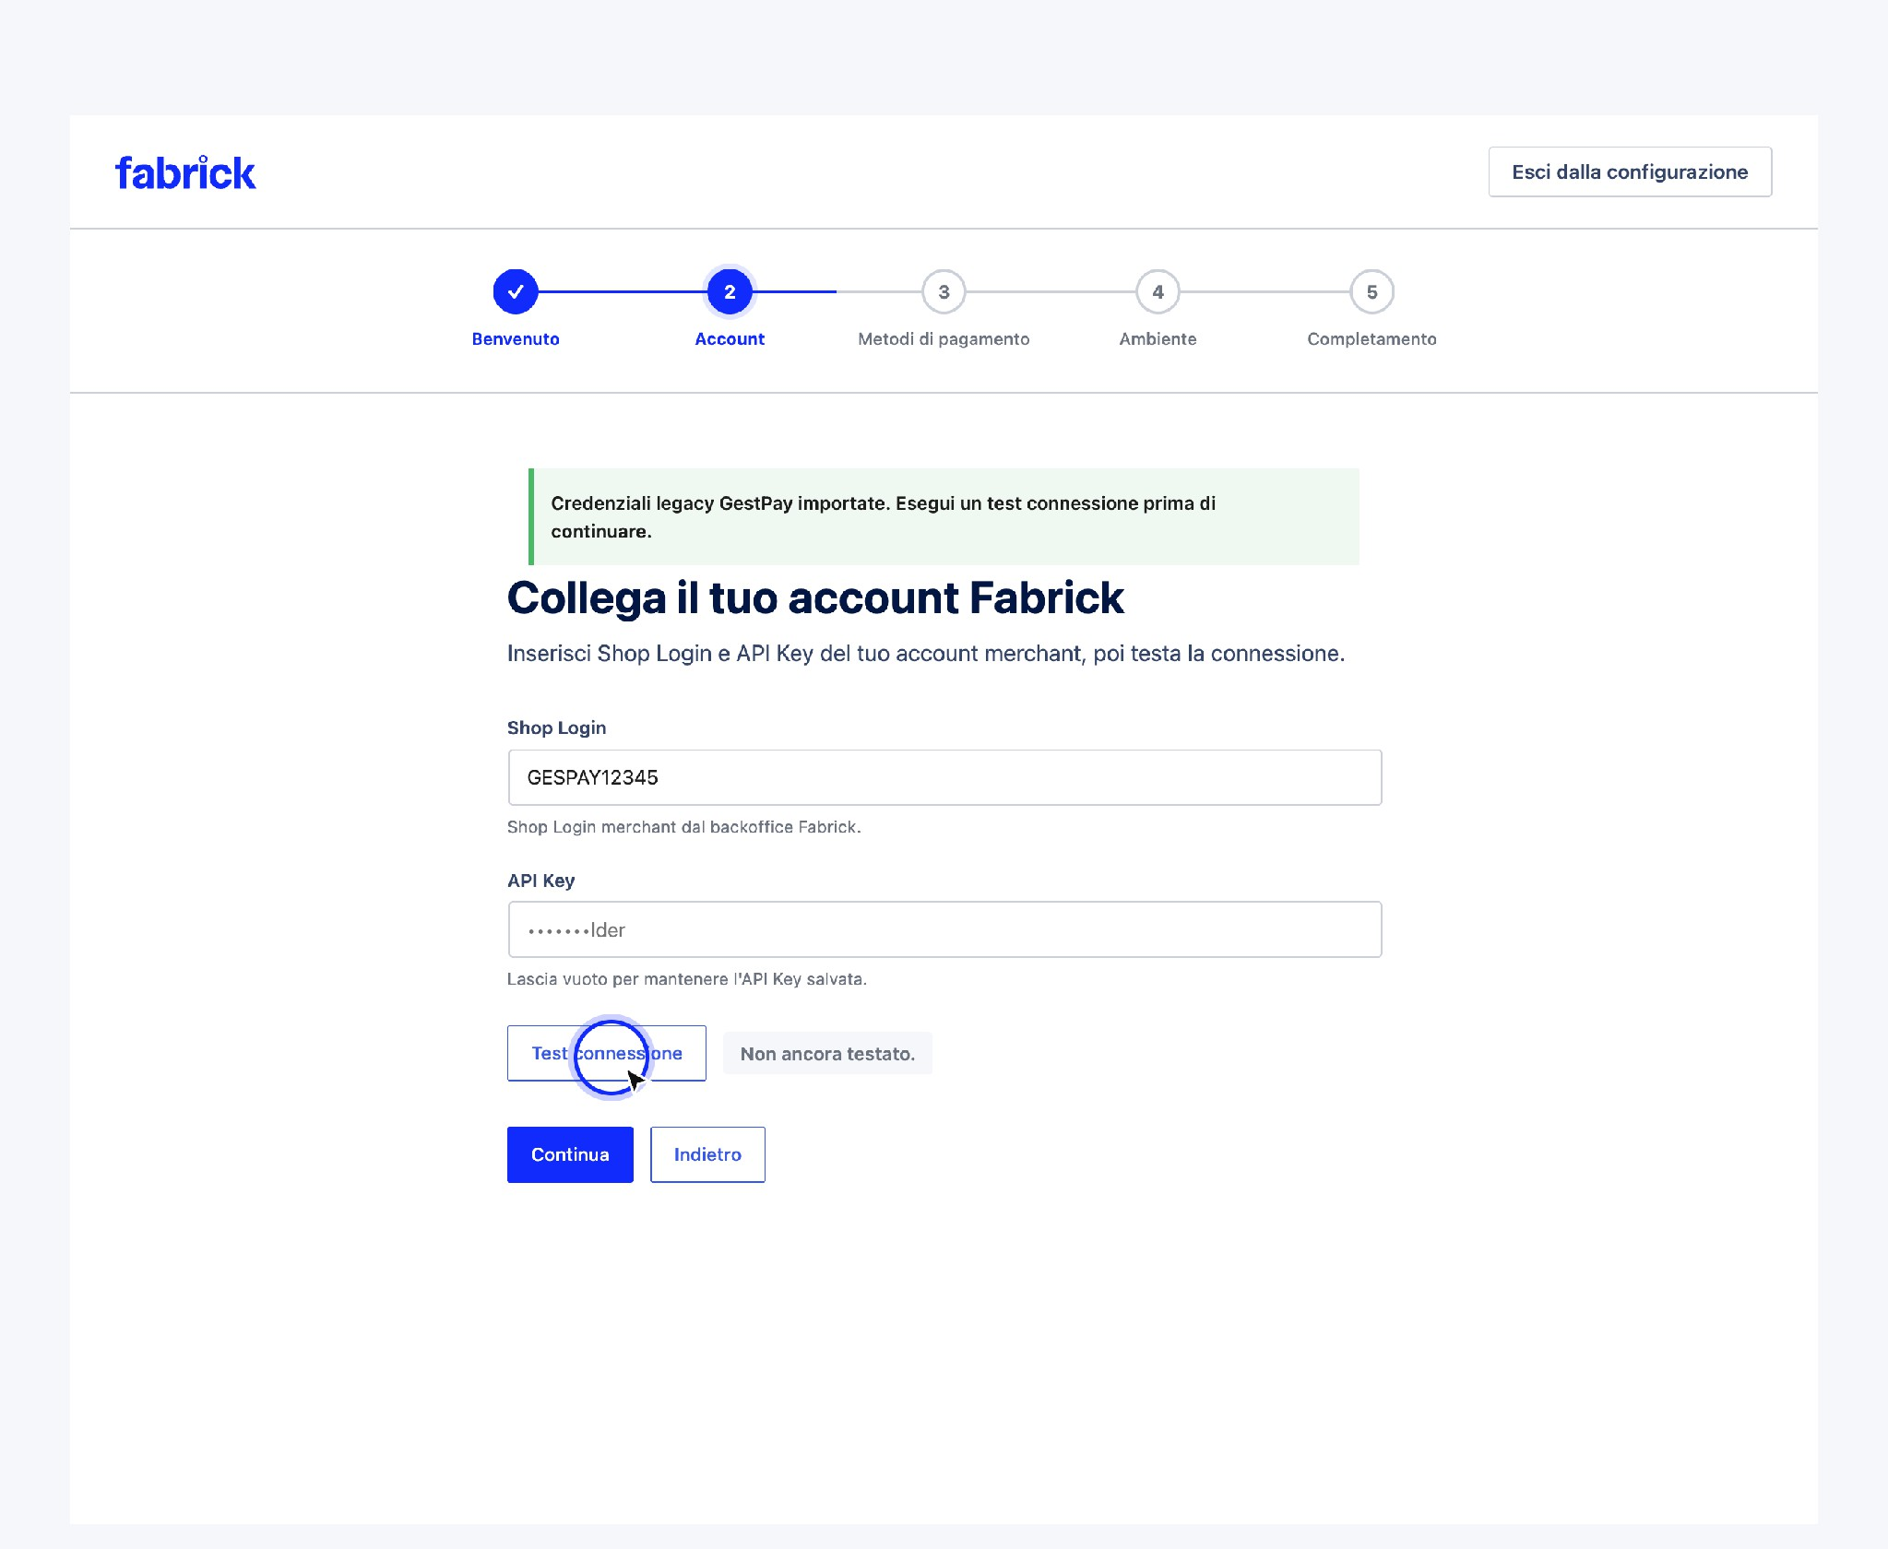
After retrieval, the plugin explicitly asks you to verify the connection before continuing.
- Verify the retrieved credentials. Press Test connection and wait for the result. The retrieval does not validate anything on its own: just copy the values. If the test fails, correct the fields by hand with the data taken from the Fabrick backoffice. Remember that the credentials of the old plugin may refer to a different environment than the one you want to use now: when you continue to production mode, the plugin repeats the check on the chosen environment.
- Complete the configuration and test a sandboxed payment. Continue with the choice of payment methods and environment, then complete the procedure. Before turning off the old gateway, perform at least one full sandbox test order with the new plugin: it is the quickest way to notice a method that is not active on the terminal or a theme customization that intercepts the checkout.
- Turn off the old gateway without uninstalling it. Go to WooCommerce → Settings → Payments: here you see both the Fabrick Payment Orchestra item and those of the old plugin. Deactivate the GestPay items and activate the new one: from now on, customers pay with the new gateway, while the old plugin remains installed to manage the history. Do not keep both on except for a short and voluntary support: two payment methods of the same platform confuse the customer and make it more difficult to read sales data.

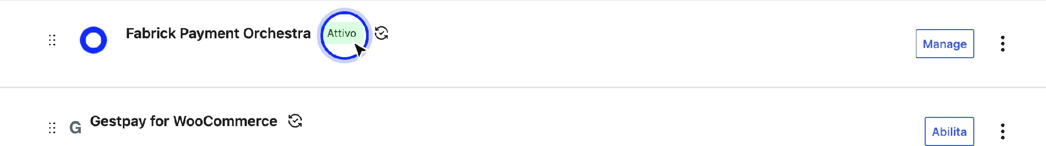

The two plugins remain separate entries among WooCommerce payment methods.
- Close the still open orders of the old plugin. Refunds, cancellations and unlocks of orders collected with GestPay continue to go through the old plugin, as long as it is installed and configured, or from the Fabrick backoffice. The new gateway does not take care of them. When you no longer have historical orders to handle, you can consider uninstalling the old plugin.
- Notify customers that they were saving the card. If you offered payment with a stored card, customers find the card list empty on the first transaction with the new plugin and have to re-enter the data. It's worth writing this down on the payment information page or in a communication – it reduces support requests in the first few days.

Expected outcome
Once the migration is complete, the store collects with the new gateway using the merchant account you already had, the order history remains available as usual and the old plugin is turned off or removed. The table summarizes what is transferred and what is not.

Item | What happens when you migrate
Shop Login e API Key | Recoverable with the dedicated command in the Account step, then to be verified with the connection test
Historical orders paid with GestPay | They stay in WooCommerce with their statuses, notes, and transaction references. The new plugin doesn't reprocess and refund them
Transaction reference on new orders | Also written in the format used by the old plugin,  so extractions and personalizations that read that data continue to find it
Cards saved by customers | They are not transferred: the card must be reinserted at the  First payment with the new plugin
Subscriptions already active with WooCommerce Subscriptions | Renewals cannot start from the new gateway until the customer re-authorizes a card
Gateway settings (title, description, methods, statuses) | They are not read by the old plugin: they are configured in the new gateway tab
Reply-to addresses and IP address registered in the back office | No longer needed: the new plugin communicates the store addresses to the platform at each time  Payment

Notes and constraints
  - Credential recovery is a help, not an automatic configuration. It copies two values into the procedure fields and asks you to verify them. Everything else in the configuration, including methods, is set up as if you were in a new store.
  - The retrieved credentials end up in the account form. They are the same account that the plugin then uses in production when you choose live mode. If your contract has different credentials for production, enter them before moving to the live environment.
  - The recovery box appears under precise conditions. You need both values stored by the old plugin, a key that is not a dummy value, and no

Retrieving has already been performed previously. If even one condition is missing, the tile does not appear.
  - The old plugin is not deactivated by the new one. No step of the configuration turns it off, modifies it or deletes its data: the two configurations remain independent and the choice of which gateway to activate remains yours.
  - Historical orders do not become workable by the new gateway. The refund button of the new plugin only acts on orders that the new gateway has actually cashed. On an order of the old plugin the attempt stops with This order has not been paid with Fabrick Payment Orchestra.
  - Maps saved with the old plugin are not migrated. There is no setting to activate to retrieve them and this version does not provide for the operation. If the continuity of the stored maps is a requirement of your project, talk about it with the Fabrick contact person before planning the switch.
  - The sub-methods become one. Where the old plugin added separate items to the checkout for individual alternative circuits, the new one exposes a single payment method and shows the alternatives available within it. The chapter on payment methods explains how to govern them.
  - The customizations made on the old plugin need to be reviewed. The new plugin has its own set of attachment points for developers, with some compatibility references to the names of the old one. The detail is in the appendix for developers and integrators.

Special cases and errors
  - "No legacy GestPay credentials found to import." The old plugin no longer has the data on the site, or the retrieval has already been done once. Fill in the Shop Login and API Key by hand with the values from the Fabrick backoffice.
  - "Unable to import Shop Login from legacy plugin." or "Unable to import API Key from legacy plugin." The value read did not pass the format checks of the new plugin: it happens with identifiers that are too long or with remnants of incomplete configurations. Enter the data by hand and continue with the connection test.
  - The recovery pane does not appear. Check that the old plugin is still installed and that its settings really contain the store identifier and key. If the recovery has already taken place in a previous attempt, the operation does not repeat itself: update the fields by hand.
  - The connection test fails with the retrieved credentials. Almost always these are credentials from a different environment than the one selected. Check in the Fabrick backoffice which values are valid for the environment in use and, if the doubt remains, ask the Fabrick contact person for confirmation before forcing the configuration.
  - A customer no longer finds the card they had stored. This is the expected behavior: cards saved with the old plugin are not available in the new one. Invite the customer to complete the payment by re-entering the data and, if the feature is active, to save it again.
  - A subscription renewal fails after migration. The subscription born with the old plugin does not have an authorized card for the new gateway, so the automatic renewal does not start. The customer must update the subscription payment method with a new authorization: the chapter on subscriptions describes the path.

You have to refund a historical order after uninstalling the old plugin.
The operation is performed from the Fabrick backoffice on the original transaction. On the order

WooCommerce can then record the refund manually, remembering that that step only updates the store's accounting and does not move money.
  - Both gateways appear at checkout. The old gateway has remained active. Deactivate it from the WooCommerce list of payment methods: the two plugins are not automatically mutually exclusive.

Frequently Asked Questions

Do I need to uninstall GestPay before installing the new plugin?
No, and it is not worth doing so. Credential retrieval reads the data of the old plugin, so it still has to find it on the site. Keep it installed even after the new gateway starts, at least as long as you have historical orders that you may have to refund or cancel.

Does credential recovery delete or change anything in the old plugin?
No. The operation reads the two values and copies them into the fields of the new configuration, without touching the GestPay settings. You can perform it when the store is open: until you activate the new gateway, customers continue to pay as before.

Orders paid for with the old plugin remain visible and refundable?
They remain visible in WooCommerce exactly as before, with statuses, notes and transaction references. However, they are not workable by the new gateway: to refund them use the old plugin as long as it is installed, otherwise the Fabrick backoffice.

Are the cards that my customers had saved transferred?
No, and there is no setting that allows this in this version. The first time you pay with the new plugin, the customer re-enters the card and, if you have saved it activated, can store it again. It is advisable to notify them in advance to avoid abandoned carts.

Do I have to check the reply addresses and IP address I had configured for the old plugin in the Fabrick backoffice?
You don't need them for the new plugin: the notification and return addresses are transmitted to the platform together with each payment request. If the old plugin remains active for the history, leave its configuration where it is until you decommission it.

Can I keep the two plugins active at the same time for a trial period?
Technically, yes, because they are distinct and independent gateways. In practice, it is advisable to limit the support to a few days and to a single gateway visible to the customer: the choice is made from the list of WooCommerce payment methods, activating the new one and deactivating the old one.

Troubleshooting
Almost all cases that seem to be a malfunction of the plugin fall into three families: something is not configured in the store, something is not active on the Fabrick terminal, or the site server cannot communicate with the platform. Recognizing the right family at the first try is what makes the difference between a two-minute correction and an open report to the wrong channel.
This chapter collects the diagnosis method, the checks on infrastructure and platform, a table that connects the symptoms to the checks to be done, the messages that the plugin really shows and the procedure to open a support report by attaching debug logs. It does not replace specific chapters: when the cause is clear, the reference takes you to where the procedure is explained in full.

Prerequisites
  - WordPress login with a user who can manage WooCommerce: you need gateway settings, the order screen, and WooCommerce → → Log Status.
  - The certainty of which environment is selected, sandbox or live. Most of the wrong diagnoses arise from the comparison between an observation made in sandbox and a production configuration, or vice versa.
  - The reference of the order involved: order number, date, amount and, if any, the Fabrick transaction identifier recorded on the order.
  - The contact of your Fabrick sales representative and the possibility of accessing the platform's back office, to compare what the store sees with what Fabrick sees.
  - A channel to those who manage the site or hosting, for the checks that are not done by WordPress: public reachability in HTTPS, outgoing connections, execution of scheduled processes.

Procedure
- Establish where the flow stopped. A payment goes through four distinct moments: the gateway appears at checkout, the secure Fabrick page shows the form, the customer concludes the payment, the store receives and verifies the outcome. Identify the last successful moment, because each moment has different causes and remedies. If the gateway does not appear, there is no need to investigate callbacks; if the order is stopped after a successful payment, there is no need to touch the payment methods.
- Test configuration and connection. Open WooCommerce → Settings → Payments → Fabrick Payment Orchestra, check the selected environment, and run Test connection. It's the cheapest check and discards wrong credentials, wrong environment, and blocked outbound connections in one fell swoop. If next to the button read Credentials have changed since the last test. Run the test again. or The last test was run in another environment. Run the test again. , the result you see is no longer reliable: repeat it before drawing conclusions.
- Read the order notes. On the order card, in the Order Notes box, the plugin writes the waiting for the payment and then the outcome verified with the platform, with the payment identifier and, in case of refusal, the code returned by Fabrick. The absence of an outcome note is itself information: it means that the store has not yet received any verified confirmation, so the problem lies in the notification channel and not in the collection.

- Look at the technical log. In the Debug tab of the gateway settings, you'll find Recent Log with the latest recorded entries and the View full logs in WooCommerce link → → Log Status, where entries are collected under the source
fabrick-payment-orchestra. Errors and warnings are logged even with Debug Mode turned off; the platform dialogue detail and the on-page table, on the other hand, require active debugging. If you're investigating a case that repeats itself, turn on debugging, reproduce the issue, and turn it off immediately after (Figure 1).
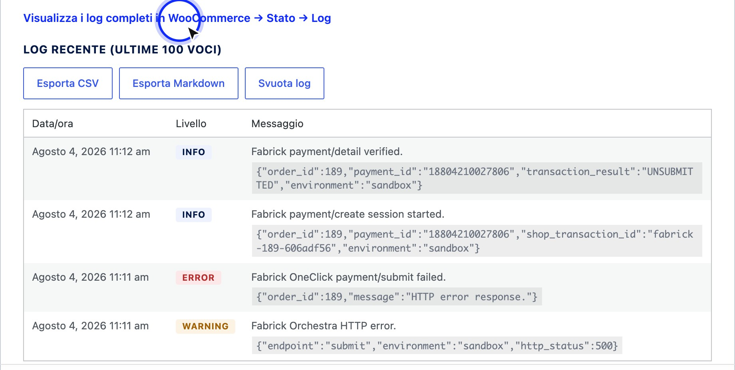
Figure 1. The recent log in the Debug tab is the starting point for figuring out if the store has really talked to the platform.
- Compare with the Fabrick backoffice. Search for the transaction with the identifier shown in the note and see what status it is in on the platform. The comparison between the two sides resolves the most frequent ambiguity: a collection that exists on Fabrick and not on WooCommerce is a notification problem towards the store, a collection that does not exist anywhere is a payment that the customer has not concluded.
- Play in sandbox before changing production. If the case is repeatable, sandbox on a test environment and repeat the scenario with test data. Avoid experimenting on live store settings while you're accepting real payments: some changes, such as shutting down a method or changing environments, take effect immediately on customers who are paying at that time.
- If necessary, open the report to the right channel. Follow the How to open a support case section further on: activate debugging, reproduce the case, attach logs and use the plugin sheet or Fabrick support depending on the type of problem. A complete request on the first submission shortens the time much more than any description in words.

Symptoms and what to check for
From the symptom observed to the checks to be done, in order of probability

Symptom | What to check
The Fabrick gateway does not appear among the payment methods at checkout. | The activation wizard is complete and the gateway is enabled in the settings: until the initial configuration is closed, the method remains invisible to customers, and at the end of the procedure the gateway must be turned on manually. Also make sure that you are looking at the checkout as a customer, not on a cached page.

The gateway is there in the classic checkout but not in a block checkout. | If the notice about the Fabrick integration for the Blocks checkout not present in the installation appears on the WooCommerce screens, the plugin package is incomplete: reinstall the plugin from the official version. The classic checkout is not affected.
A payment method does not appear on the Fabrick payment page. | The method must be active on the terminal and selected in the Payment methods tab: the intersection between the two applies. Press Update methods, check that you are in the right environment and check that the method is not among those removed from the terminal. Activation on the terminal is requested from the Fabrick sales representative.
The connection test fails. | Shop Login and API Key of the selected environment, with no spaces pasted in; key not regenerated in the meantime; outgoing HTTPS connections allowed by the server. The chapter on credentials lists the messages of  error one by one.
The customer arrives on the payment page but the form does not appear or remains to load. | The payment module is served by Fabrick and is loaded by the customer's browser: check that the store is in HTTPS with a valid certificate and that nothing blocks external scripts of the platform, for example browser extensions or restrictive site rules. If the delay is repeated, check the log if the payment session has been created.
The order is awaiting payment and has no outcome notes. | The store has not received any confirmation: site reachable from the outside in HTTPS, outgoing calls allowed, queue of WooCommerce scheduled actions does not stop. An order like this is often only  an attempt that the customer did not complete.
The order is Pending with the payment note awaiting confirmation. | This is the expected behavior for methods that confirm collection in a deferred way. Do not ship and do not force status: the order is updated when the confirmation arrives. If the wait exceeds the typical time of the method, compare the transaction in the Fabrick backoffice.
The customer says they saw an unconfirmed payment message. | The browser re-entered before the platform had an outcome to communicate. The store explicitly invites you not to pay again. Check the notes again after a few minutes: if the confirmation has arrived, the order is already updated.
A refund is not available or a partial refund is declined. | It depends on the status of the transaction on Fabrick: on a simple authorization not yet collected, you can only cancel the entire remaining amount. Accounting is managed on the Fabrick backoffice according to the  contract. The chapter on refunds goes into detail.
The payment link does not reach the customer. | The order must have a valid billing email address and be in a state that allows payment; the submission uses emails from your store, so a site mail issue also blocks this message.  After fixing the sending, repeat the Send Fabrick payment link action: the new link invalidates the previous ones.
Saved cards are not offered to the customer. | The Saved Cards setting must be active on the gateway, and the customer must be registered and authenticated. Cards are saved during the  payment, not from the account's payment methods page.
Subscription renewals are not charged. | You need active saved cards and a card stored on the subscription; if the reference of the first authentication is missing, the customer must remake an authenticated payment. Also check that WooCommerce's scheduled processes run regularly.
A test order resulted in a real charge. | The environment you selected was Live. Refund the operation from the order card, then go back to the sandbox for testing and double-check the environment  before each test session.
There is nothing useful in the register. | Detail entries appear only with Debug Mode on. Turn it on, replay the problem, read the log, and turn it off: with debugging off, only errors and warnings are logged.

Infrastructure and platform issues
Before opening a report, check these points: often the plugin works, but the dialogue with Fabrick or the store server is interrupted upstream.
Controls on configuration, Fabrick platform and hosting

Area | What to check

API Key and Shop Login Configuration | Credentials of the selected environment (sandbox or live), without extra spaces and without mixing the two environments. After each change, run Test connection. If the key has been regenerated on the Fabrick backoffice, update it immediately in the plugin.
IP blocking on the Fabrick platform | Some terminals only accept calls from authorized IP addresses. If the connection test or payments fail with authentication or login errors, ask the Fabrick contact person if you need to enable the outgoing IP of your hosting and provide it to those who manage the site.
SSL/HTTPS certificate | In production, the store must be reachable in HTTPS with a valid, non-expired certificate. An incorrect, expired, or domain-mismatched certificate blocks checkout pages and notifications  to the site.
Enabling payment systems | Card and alternative methods must be active on the Fabrick terminal and selected in the Payment methods tab of the plugin. Activation on the terminal is requested from the sales representative; the plugin alone does not enable a circuit on the contract.
Firewall o WAF dell'hosting | Rules that are too restrictive can block outgoing calls to Fabrick or incoming notifications to the store. Check with the hosting that HTTPS connections to the platform are allowed and that the  The plugin's reply URLs are not filtered.
Disk space and hosting resources | Running out of space, full database quota, or CPU/memory limits can prevent you from writing logs, executing scheduled actions, and saving orders. Check the space status and error messages of the hosting panel.
Scheduled jobs (cron) | WooCommerce uses scheduled actions to complete verifications and renewals. If the queue is stopped, the results can remain on hold even when Fabrick has already confirmed. Check with site managers that scheduled processes  turn regularly.

How to open a support case
When the previous checks aren't enough, open a complete request to the right channel and attach the debug logs produced after reproducing the issue. Reporting with the right data reduces round-trips.
- Turn on debugging before reproducing the case. Open WooCommerce → Settings
→ Payments → Fabrick Payment Orchestra, go to the Debug tab, turn on Debug Mode / Enable Debug Logging, and save. Debugging should only be turned on for the time of the diagnosis.
- Repeat the operations that fail. Run the connection test again and, if necessary, one or more test transactions (preferably sandboxed) until the error is reproduced. Without these operations, the logs remain empty or of little use.
- Collect debug logs. In the same Debug tab, open Recent Log and download the newly logged entries with Export Markdown (readable document to attach as-is) or Export CSV (to analyze them in a spreadsheet). If the issue is from previous days or you need more than the last hundred entries, go to WooCommerce → → Log Status, select the source fabrick-payment-orchestra, and copy or download the issue timeline entries. Attach this copy to the report (Figure 2).

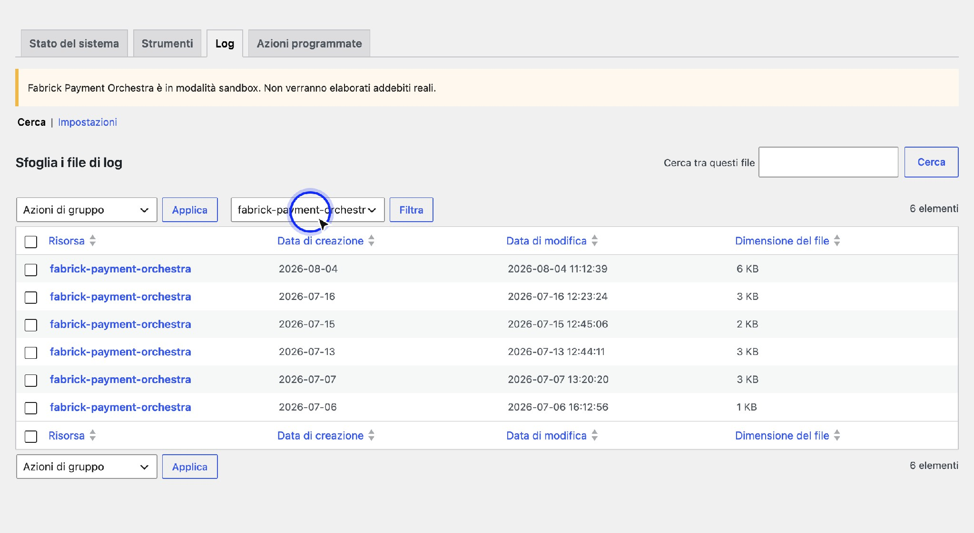
Figure 2. The full logs under the fabrick-payment-orchestra source are the material to be attached to the support report.
- Write to support from the plugin tab. Go to Plugins → Installed plugins and locate Fabrick Payment Orchestra: under the description you will find the links of the plugin row, including Visit the plugin site; for installations from the WordPress.org catalog there is also the View details item with the dedicated support channel, from which you can open the ticket and describe the problem. For platform, terminal or individual transaction issues, also contact your Fabrick sales representative or Fabrick ecommerce support (ecommerce@sella.it) (Figure 3).
Figure 3. From the plugin row under Installed Plugins, navigate to the plugin tab and support channel.
- Attach the minimum context. In the request, indicate: plugin version, WordPress and WooCommerce version, environment (sandbox or live), Shop Login (never the API Key), order number, date and time, amount, payment identifier if any, error message seen on the screen and copy of the debug logs produced in step 3.
- Turn off debugging when you're done diagnosing. When you have the necessary logs, turn off Debug Mode and save. On a production store, don't leave it on permanently.

What logs do (and do not contain)
  - No full card number (PAN), security code (CVV), password, API Key and payment tokens are saved in plain text: the plugin masks them or does not register them at all.
  - Technical events of the flow (session creation, callbacks, API errors) are recorded to help you understand where the dialogue with Fabrick left off.

  - With debugging enabled , the payment creation logs can include the customer's billing address and email address (technical order data). Therefore, debugging should only be used for the time of the diagnosis and then deactivated.

Who to contact
The plugin governs what happens in your WooCommerce store. Everything related to the contract, the terminal, and individual transactions on the platform goes through Fabrick, and there is no plugin setting that can replace those decisions.
Correct channel for request type

Type of request | Channel | What to prepare
Activation of a payment method, economic conditions, circuit requirements, opening a new store on the platform. | Fabrick sales representative. | Shop login, environment, required method and markets served.
Production credentials, permissions on the back office, API Key to be regenerated, possible outgoing IP enablement of the store. | Fabrick sales representative, then backoffice of the platform. | Name of the store on the platform, the user you log in with and, if required, the public IP of the server.
Paper behavior after  authorization, accounting, handling managed outside the store. | Backoffice Fabrick per  the operation, commercial contact for the configuration of the terminal. | Payment ID, and  current configuration of the terminal.
The outcome of a single transaction, the reason for a recurring refusal, a collection that you cannot find. | Fabrick ecommerce assistance (ecommerce@sella.it) or sales representative. | Payment ID, date and time, amount, shop login, environment, error code in order notes and copy of the  debug.
WooCommerce plugin behavior, screenshots, messages, installation. | Support channel from the plugin tab in Plugins → Installed Plugins (plugin details / Support). | Plugin versions, WordPress and WooCommerce, steps to reproduce and copy of fabrick-payment-orchestra logs.
Site not reachable from the outside, HTTPS certificate, firewall, disk space, blocked outbound connections,  Planned processes stopped. | Who runs the site or hosting service. | Store address, date and time of the attempt, log entries with the connection error.
Customization of texts, data sent to the platform, integration with other systems. | Who develops or maintains your site, with the appendix for developers and integrators of this manual. | A description of the desired behavior and the point in the flow where it should take place.

Expected outcome
At the end of the process, the problem is located in one of the three initial families and you know what to do with it: if it is the configuration of the store, you correct it from the settings, if it is terminal or contracted, the request goes to Fabrick, if it is the infrastructure of the site, it is forwarded to those who manage it. In the orders involved, the trace of what happened remains, so the same verification can be repeated after days without having to reconstruct anything from memory.
An equally valid result is to exclude the malfunction: many situations that seem to be errors are deliberate behaviors, such as the pending order of a deferred method, the method hidden because not selected, or the partial refund not available on a simple authorization.

Notes and constraints
  - The store does not decide the outcome. The status of an order always derives from the verification made with the platform. Changing the status by hand does not collect and does not refund anything: it only serves to lose the correspondence between WooCommerce and Fabrick.
  - Debugging is a diagnostic tool, not a permanent configuration. Activate it only to reproduce the problem and attach the logs to the report, then turn it off. No card number, security code, password, API Key or clear token are saved in the logs. With active debugging, the customer's billing address and email may appear: for this reason, it should not be left on in production.
  - Only one connection test at a time. After a few quick attempts, the plugin asks you to wait: it's a protection, not a configuration error. Retrieve the correct values and try again after a few minutes.
  - The sandbox does not reproduce everything. Some alternative methods do not complete themselves in the test environment, because they require a dedicated application, a test account issued by the circuit or a specific activation on the terminal. A payment that does not close in sandbox is not necessarily a problem of the store.
  - Customizations do not go through the settings. Changing the data sent to the platform, the texts of the emails or the behavior after an outcome requires interventions via code: they are documented in the appendix for developers and integrators of this manual, to be delivered to those who maintain the site.
  - Update before reporting. Check that you are on the latest available version of the plugin and read the release notes: an already corrected problem is solved with an update, without opening any request.

Special cases and errors
  - "Fabrick Payment Orchestra is not yet configured. Please complete the configuration." The store tried to initiate a payment with no usable credentials. Complete the activation wizard and run a successful connection test.
  - "Complete the Fabrick configuration before enabling this gateway." You are trying to turn on the gateway with the configuration incomplete. Close the wizard first: the gateway remains disabled until you enable it, and this is intentional.
  - "This payment session is no longer valid. Please go back to checkout and try again." or "This payment session has expired. Please try again." The customer has reopened an old link to the payment page or waited too long. A new attempt must be created from the checkout; the previous order is on hold and you can cancel it.
  - "The payment module is taking longer than expected." The component served by Fabrick did not load in the customer's browser. The message invites you to reload the page or try with another browser; if it happens systematically, check HTTPS and block external scripts of the platform.
  - "We were unable to start the payment. Please try again or choose another payment method." The platform has rejected the creation of the session. In the log you will find the cause: the most frequent is a selection of methods that contains only codes that are no longer active on the terminal, which Fabrick rejects with the code 1403. Press Update methods, correct the selection and save.

  - "Another Fabrick payment transaction is in progress for this order. Please try again in a few moments." Two operations on the same order overlapped, for example a refund launched while a confirmation arrived. Wait a few seconds and repeat: no action is necessary.
  - "The Fabrick payment service is temporarily unavailable. Please try again later." The platform has not responded to the requested operation. The plugin does not change the status of the order: try again later and, if the unavailability is prolonged, report it to Fabrick support with the date, time and payment ID.
  - "Fabrick could not complete the payment transaction. Check the WooCommerce logs for details." It's the generic message of refunds and cancellations – the precise reason is in the log under the fabrick-payment-orchestra source.
  - "Security check failed. Please reload the page and try again." The admin page has been open for too long and the security check has expired. Please reload and try again.
  - "You don't have permissions to perform this action." The user you are working with cannot manage WooCommerce. Ask for the appropriate role from the site administrator: Gateway functions require store management permissions.
  - "This card cannot be deleted because it is used by an active subscription." First you have to change the payment method of the subscription, then the card can be removed. It is a protection against renewals that would remain without a card.
  - The register shows a notification with no corresponding order. The reference that arrived cannot be linked to any order in the store: it happens with notifications from another site that shares the same Fabrick account or after the permanent deletion of a test order. No order is modified.

Frequently Asked Questions

What data do I need to collect before opening a report?
Shop login and environment (never the API Key), WooCommerce order number, payment ID and error code in the notes, date and time, amount, plugin / WordPress / WooCommerce versions and a copy of the debug logs produced after reproducing the problem. With these elements the case is found without further exchange.

How do I attach logs without exposing sensitive data?
Activate debugging, repeat the attempt, export the entries of the fabrick-payment-orchestra source and immediately turn off debugging. No paper, CVV, password, API Key or unencrypted token appear in the logs. If there are billing addresses or emails in the time window, you can obscure them before sending them if your internal policy requires it: date, time, error message and technical identifiers remain useful.

Can I enable debugging on a store in production?
Yes, but only for the time strictly necessary to reproduce the case and copy the logs. Then deactivate it. Card number, security code, password and credentials are not saved in the logs; with active debugging, however, billing address and email may appear.

Where do I open the plugin support ticket from?
From Installed Plugins → Plugins open the details of Fabrick Payment Orchestra and use the support link indicated in the plugin tab. For terminal issues,

contract or individual transactions on the platform, contact the Fabrick contact person or ecommerce support (ecommerce@sella.it).

The customer says he has paid but the order is not paid: where do I start from?
From the order notes. If there is no outcome note, the store has not received confirmations and the problem is in the notification channel: check reachability in HTTPS, outgoing connections and queue of scheduled actions. If the note is there but reports a rejection, the collection has not taken place and the code reported tells you the reason. In both cases, compare the transaction in the Fabrick backoffice before intervening on the order.
A method disappeared from the checkout after a list update: is it a failure? Normally no: the plugin only shows the methods that are active on the terminal and that you have selected, so the disappearance reflects a change on the platform side. Open the Methods tab
of payment, press Update methods and see if the method is marked among those
removed: if it is, ask the Fabrick sales representative why it is no longer exposed by the terminal.

I need to edit a text or data sent to the platform: can this be done from the settings?
No, the settings cover the environment, credentials, methods, saved cards, appearance at checkout, and debugging. To change the data transmitted, the text of the emails, or the behavior after an outcome, you need the developer connections described in the appendix of this manual: pass it on to the maintainers of your site, along with a description of what you need.

How do I distinguish a problem in my store from a test environment boundary?
See if the payment has been created on the platform: if the session starts and the store receives an outcome, the plugin flow works and what is missing is the conclusion on the circuit side. Several alternative methods cannot be completed independently in sandbox, because they require a dedicated application, a circuit test account or a specific activation on the terminal: in those cases the final test is done with Fabrick.

