

Fabrick Payment Orchestra for WooCommerce

Introduction

Fabrick Checkout integra i pagamenti Fabrick Payment Orchestra in Woocommerce tramite REST API e Web Component <fbk-checkout>.
Key features:
- Standard payment (card and APM methods enabled on the shopLogin)
- Checkout on dedicated page
- Pay by Link (optional)
- Paper Saving
- Notifiche server-to-server e callback buyer
- Reconciliation cron (e.g. Pay by Bank)
- Cancellation and refunds tool
- Subscription (compatible with add-on plugin)

Introduction and requirements

Fabrick Payment Orchestra is the payment gateway that connects your WooCommerce store to the Fabrick Payment Orchestra platform. Once configured, the plugin creates the payment session on the platform, shows the customer the payment module hosted by Fabrick, receives confirmation of the outcome and updates the WooCommerce order status without manual intervention.

Figure 1. The plugin in the list of installed WordPress plugins, with the version you are using.

Requirements
Before installing the plugin, check that the store environment complies with the minimum requirements shown in the table. The versions indicated are those declared by the plugin: below PHP 8.0 or WooCommerce 9.0 the gateway does not start and shows a warning on the dashboard.
Technical requirements of the plugin

Requirement | Value | Why you need it
WordPress | 6.4 or higher (verified up to 7.0) | Minimum version supported by the plugin.
PHP | 8.0 or higher | With previous versions the plugin  stops and signals the requirement.
WooCommerce | 9.0 or higher (verified up to 10.0) | The gateway registers among WooCommerce payment methods.
Order storage | Compatible with HPOS, high order storage  performance, and with classic storage | The plugin declares HPOS compatibility, so you can activate it without losing payment information on orders.
SSL certificate | HTTPS valid throughout the site,  Mandatory in production | The customer's return from payment and platform notifications reach your store addresses: they must be served in HTTPS.
Connection to Fabrick | Outbound HTTPS calls from the server to the Fabrick platform | Creation of the payment session, verification of the outcome, refunds and reading of active methods pass through the Fabrick APIs.
Fabrick Contract | Shop Login and API Keys for sandbox and production | These are the credentials with which the plugin communicates with the platform.
WooCommerce Subscriptions | Optional | This is only for subscription products and auto-renewals.

Check the requirements on the standard WordPress and WooCommerce screens – it only takes a few minutes and saves you from an installation that crashes at the first warning.
- Open Tools → Site Health → About and expand Server to read the PHP version, then WordPress for the CMS version.
- Open WooCommerce → Status and check the Environment section for the WooCommerce version and site addresses, which in production must start with https://.
- If you want to work with high-performance order storage, open WooCommerce → Settings → Advanced → Features and check the order storage option.
- Retrieve the Shop Login and the API Key of the sandbox environment from the Fabrick backoffice: you need them immediately after installation, when the store runs the activation wizard.

Installation

- Open Plugins → Installed Plugins and verify that WooCommerce is present and in the active state. If it is not, install and activate it before continuing.
- Open Plugins → Add New Plugin.
- Install from the plugin directory. Type Fabrick Payment Orchestra in the search field, locate the plugin tab and press Install Now. When the installation finishes the button changes to Active.
- As an alternative to step 3, you can proceed with the installation from the zip file. Press Upload Plugin at the top, choose the .zip file you received, and press Install Now. WordPress unpacks the package and shows the result with the Activate Plugin link (Figure 2).

Figure 2. The Upload Plugins panel, used when the package arrives as a zip file.

- Press Activate (or Activate plugin if you arrive from the loading screen). WordPress confirms the activation and the plugin appears in the list of Installed Plugins → Plugins with the version number (Figure 3).
Figure 3. The installed plugin is waiting to be activated in the list of WordPress plugins.
- Immediately after activation, the store takes you to the configuration wizard. If, on the other hand, you remain on the plugins screen, open any WooCommerce page: at the top appears the notice Fabrick Payment Orchestra requires configuration before accepting payments. with the Complete configuration link →.
The alert that invokes the configuration, with the direct link to the wizard.

Expected outcome
The plugin is active in the list of plugins and the store opens the first screen of the configuration wizard, which asks for your Fabrick account credentials. The gateway is registered in WooCommerce → Settings → Payments but remains deactivated; therefore, no customers see it at checkout.
Until the configuration is completed, opening the gateway settings automatically takes you back to the wizard: this is the path provided so that you don't leave the credentials halfway through. The configuration wizard is described in the dedicated chapter.

Obtaining credentials on the Fabrick platform
The plugin communicates with the Fabrick platform through two pieces of data that identify and authenticate your store: the Shop Login, i.e. the store code on the platform, and the API Key, the secret key that authorizes calls. Without this pair, the gateway cannot create the payment session, verify the outcome of a transaction, read the methods active on the terminal or send a refund.

Back-office merchant Fabrick

In the merchant back-office made available by Fabrick, it is possible to retrieve the credentials (Shop Login and API Key) to be used in the configuration of the module in PrestaShop.

Creating and copying the API Key
      - Go to Configuration -> Security -> APIKEY and create the required value.

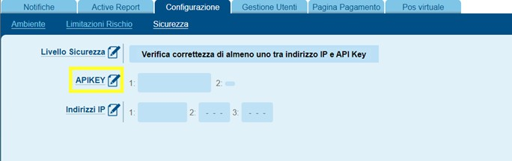
Back-office Fabrick - Configuration > Security, APIKEY section

      - Press Add Key.
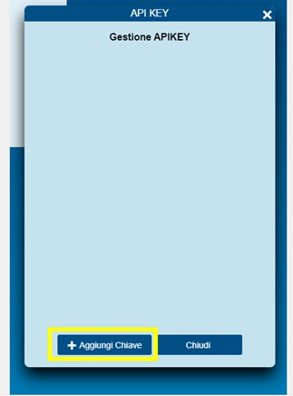
Back-office Fabrick - APIKEY Management, Add Key

      - Use the copy icon (highlighted in the screenshot) to copy the key to your clipboard and paste it into the API Key field of the PrestaShop module.

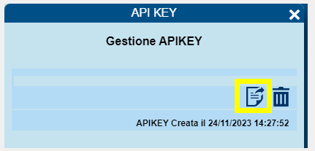
Back-office Fabrick - copia API Key

Response Parameters (Checkout Page)
In Payment Page -> Fields & Parameters enable the PaymentMethod, Token, ExpiryMonth Token, and ExpiryYear Token parameters on both pages. Below is the example with PaymentMethod; the others follow the same logic.
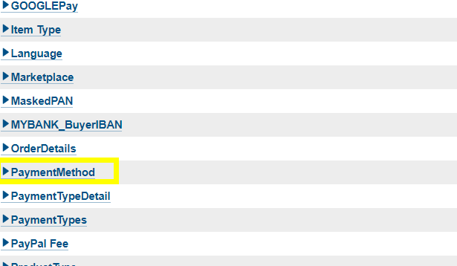
Back-office Fabrick - elenco parametri, PaymentMethod

On the parameter tab, flag the Response and Web Service Response items, then save.

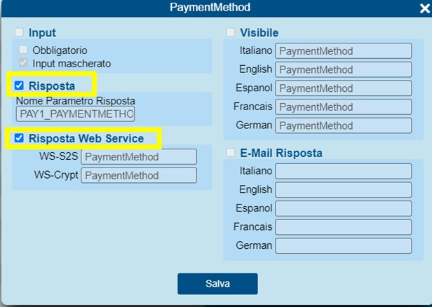
Back-office Fabrick - PaymentMethod: Response and Response

5-step activation wizard
Immediately after activating the plugin, WordPress opens the configuration wizard: five steps that connect the store to your Fabrick account, verify that the credentials work, define which payment methods to offer and determine whether the store should communicate with the sandbox or production environment. Until the procedure is completed, the gateway cannot accept payments, so it is advisable to complete it in a single session.
The procedure is located at wp-admin/admin.php?page=fabrick-orch-setup and occupies the entire browser window. The page does not appear in the administration menus: you can get there with the automatic reference after activation, with the Complete configuration link → of the Fabrick Payment Orchestra notice requires configuration before accepting payments, or by opening the gateway tab in WooCommerce → Settings → Payments: until the configuration is incomplete, that tab refers to the wizard.

Procedure
At the top, the progress indicator with the five steps Welcome, Account, Payment Methods, Environment and Completion is always visible. From the second step onwards, the Back button returns to the previous step without saving the current one, while Exit configuration at the top right returns to the list of WooCommerce payment methods. If you exit before the end, when you reopen the procedure starts again from the step you had reached.

- Welcome. The Welcome to Fabrick Payment Orchestra screen lists the technical requirements on which the plugin rests: the minimum PHP version, the minimum WooCommerce version, and compatibility with high-performance order storage. There are no fields to fill in: press Start.

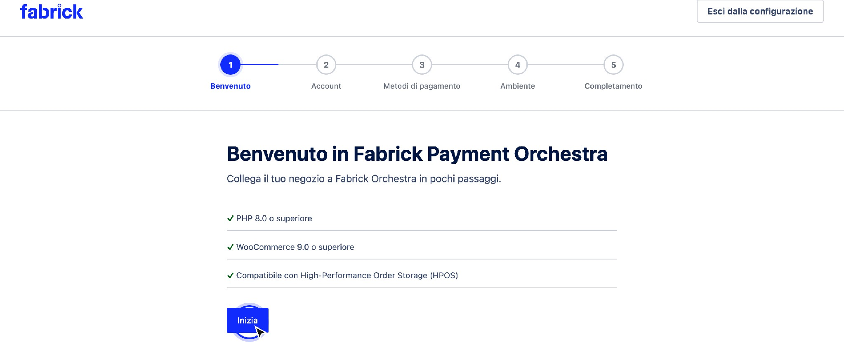

The first step summarizes the technical requirements and shows the progress indicator of the five steps.
- Account. On the Connect your account screen, Fabrick fills in Shop Login with the identifier of your store on the platform, up to 64 characters, and API Key with the associated key. The key field is masked and never repeats the value already stored: if a key is already saved, the field shows a fictitious value and the suggestion Leave blank to keep the API Key saved.

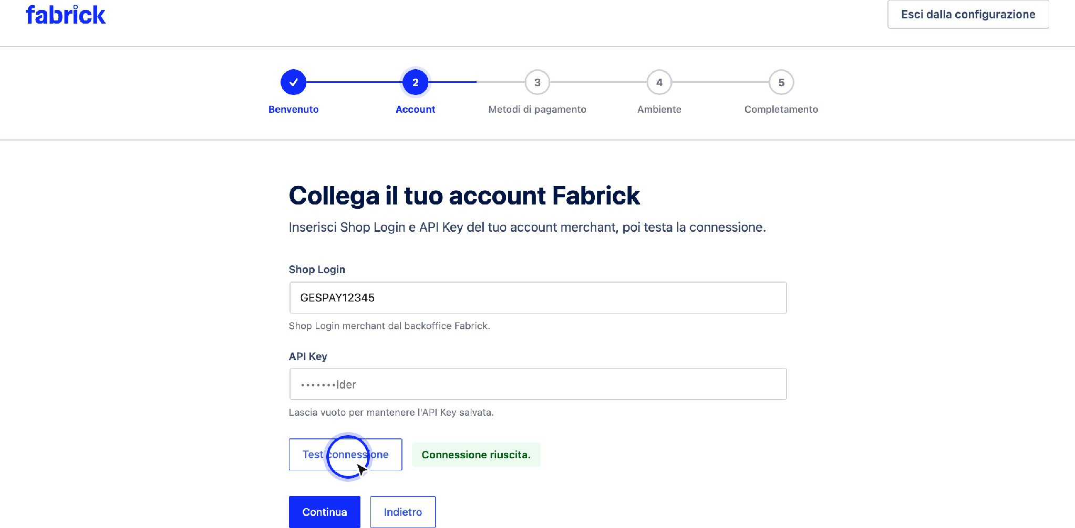

The Account step collects Shop Login and API Key and provides the connection test.
- Credential verification. Press Test connection: the plugin sends the values typed to its server, which queries the Fabrick platform with the indicated account. The label next to the button changes from Not yet tested to Test connection in progress and finally to Connection successful. The key is never returned to the browser or shown in plain text. When the result is positive, press Continue: without a successful test, the procedure remains on track and reports Run a successful connection test before continuing.
- Credentials from the GestPay plugin. If the credentials from the previous GestPay for WooCommerce plugin are still present on the site and have not already been retrieved, the We found credentials from the legacy GestPay for WooCommerce plugin box appears above the fields with the Import legacy credentials button. By pressing it, Shop Login and API Key are copied into the fields of this procedure and the plugin notifies you with Legacy GestPay credentials imported. Run a connection test before continuing. The operation is available only once: after importing, the tile never returns.
- Payment methods. The Choose which alternative payment methods to offer at checkout screen lists the methods with a switch for each, starting with Card (+ wallet if enabled). After a successful test, the list reflects the methods that the platform returns for your account; the items marked as New are those that have appeared compared to the plugin's default list. Some lines may be blocked with the indication Always enabled: these are methods managed by the platform, to be dealt with the Fabrick backoffice or with your sales representative. Turn off what you don't want to propose and press Continue.

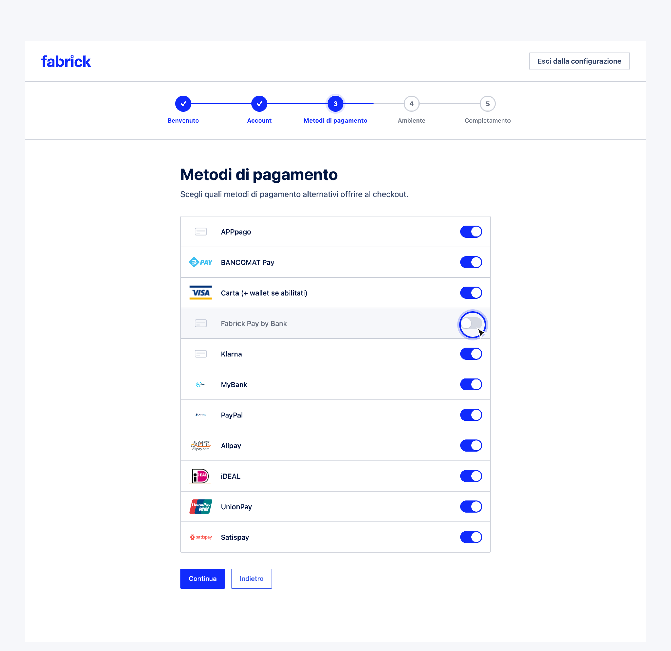
Each method has its own switch; locked rows remain active at all times.
- Environment. The Choose payment environment screen shows the linked account and two options. Sandbox is listed as Recommended during testing. No real charges. Live corresponds to Production Mode. Real payments use the Live Orchestra API: Selecting it displays the real payments warning and the I understand that Live Mode will process real payments box, which you must check to continue. The plugin uses the same account entered in the Account step for production as well and repeats the connection check on the chosen environment before advancing the procedure. Press Continue.

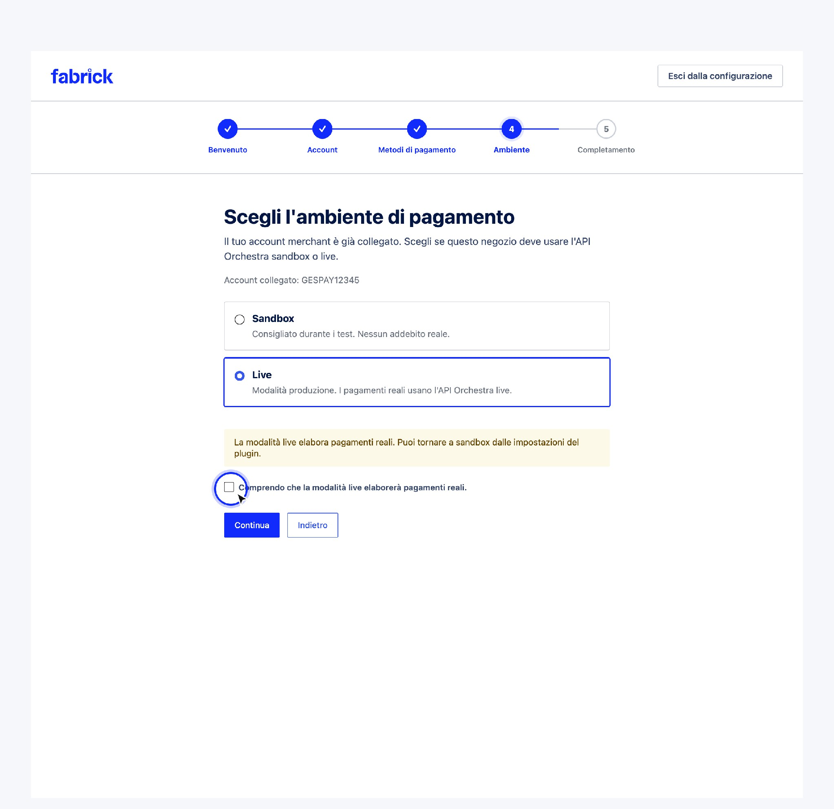
Choosing the live mode requires explicit confirmation before continuing.
- Completion. The You're Almost There screen summarizes Connected merchant account, Connection test passed, and the selected environment, and warns that the gateway will remain disabled until you manually enable it. Press Complete configuration: the plugin records the configuration as completed and takes you to the gateway tab in WooCommerce → Settings → Payments.

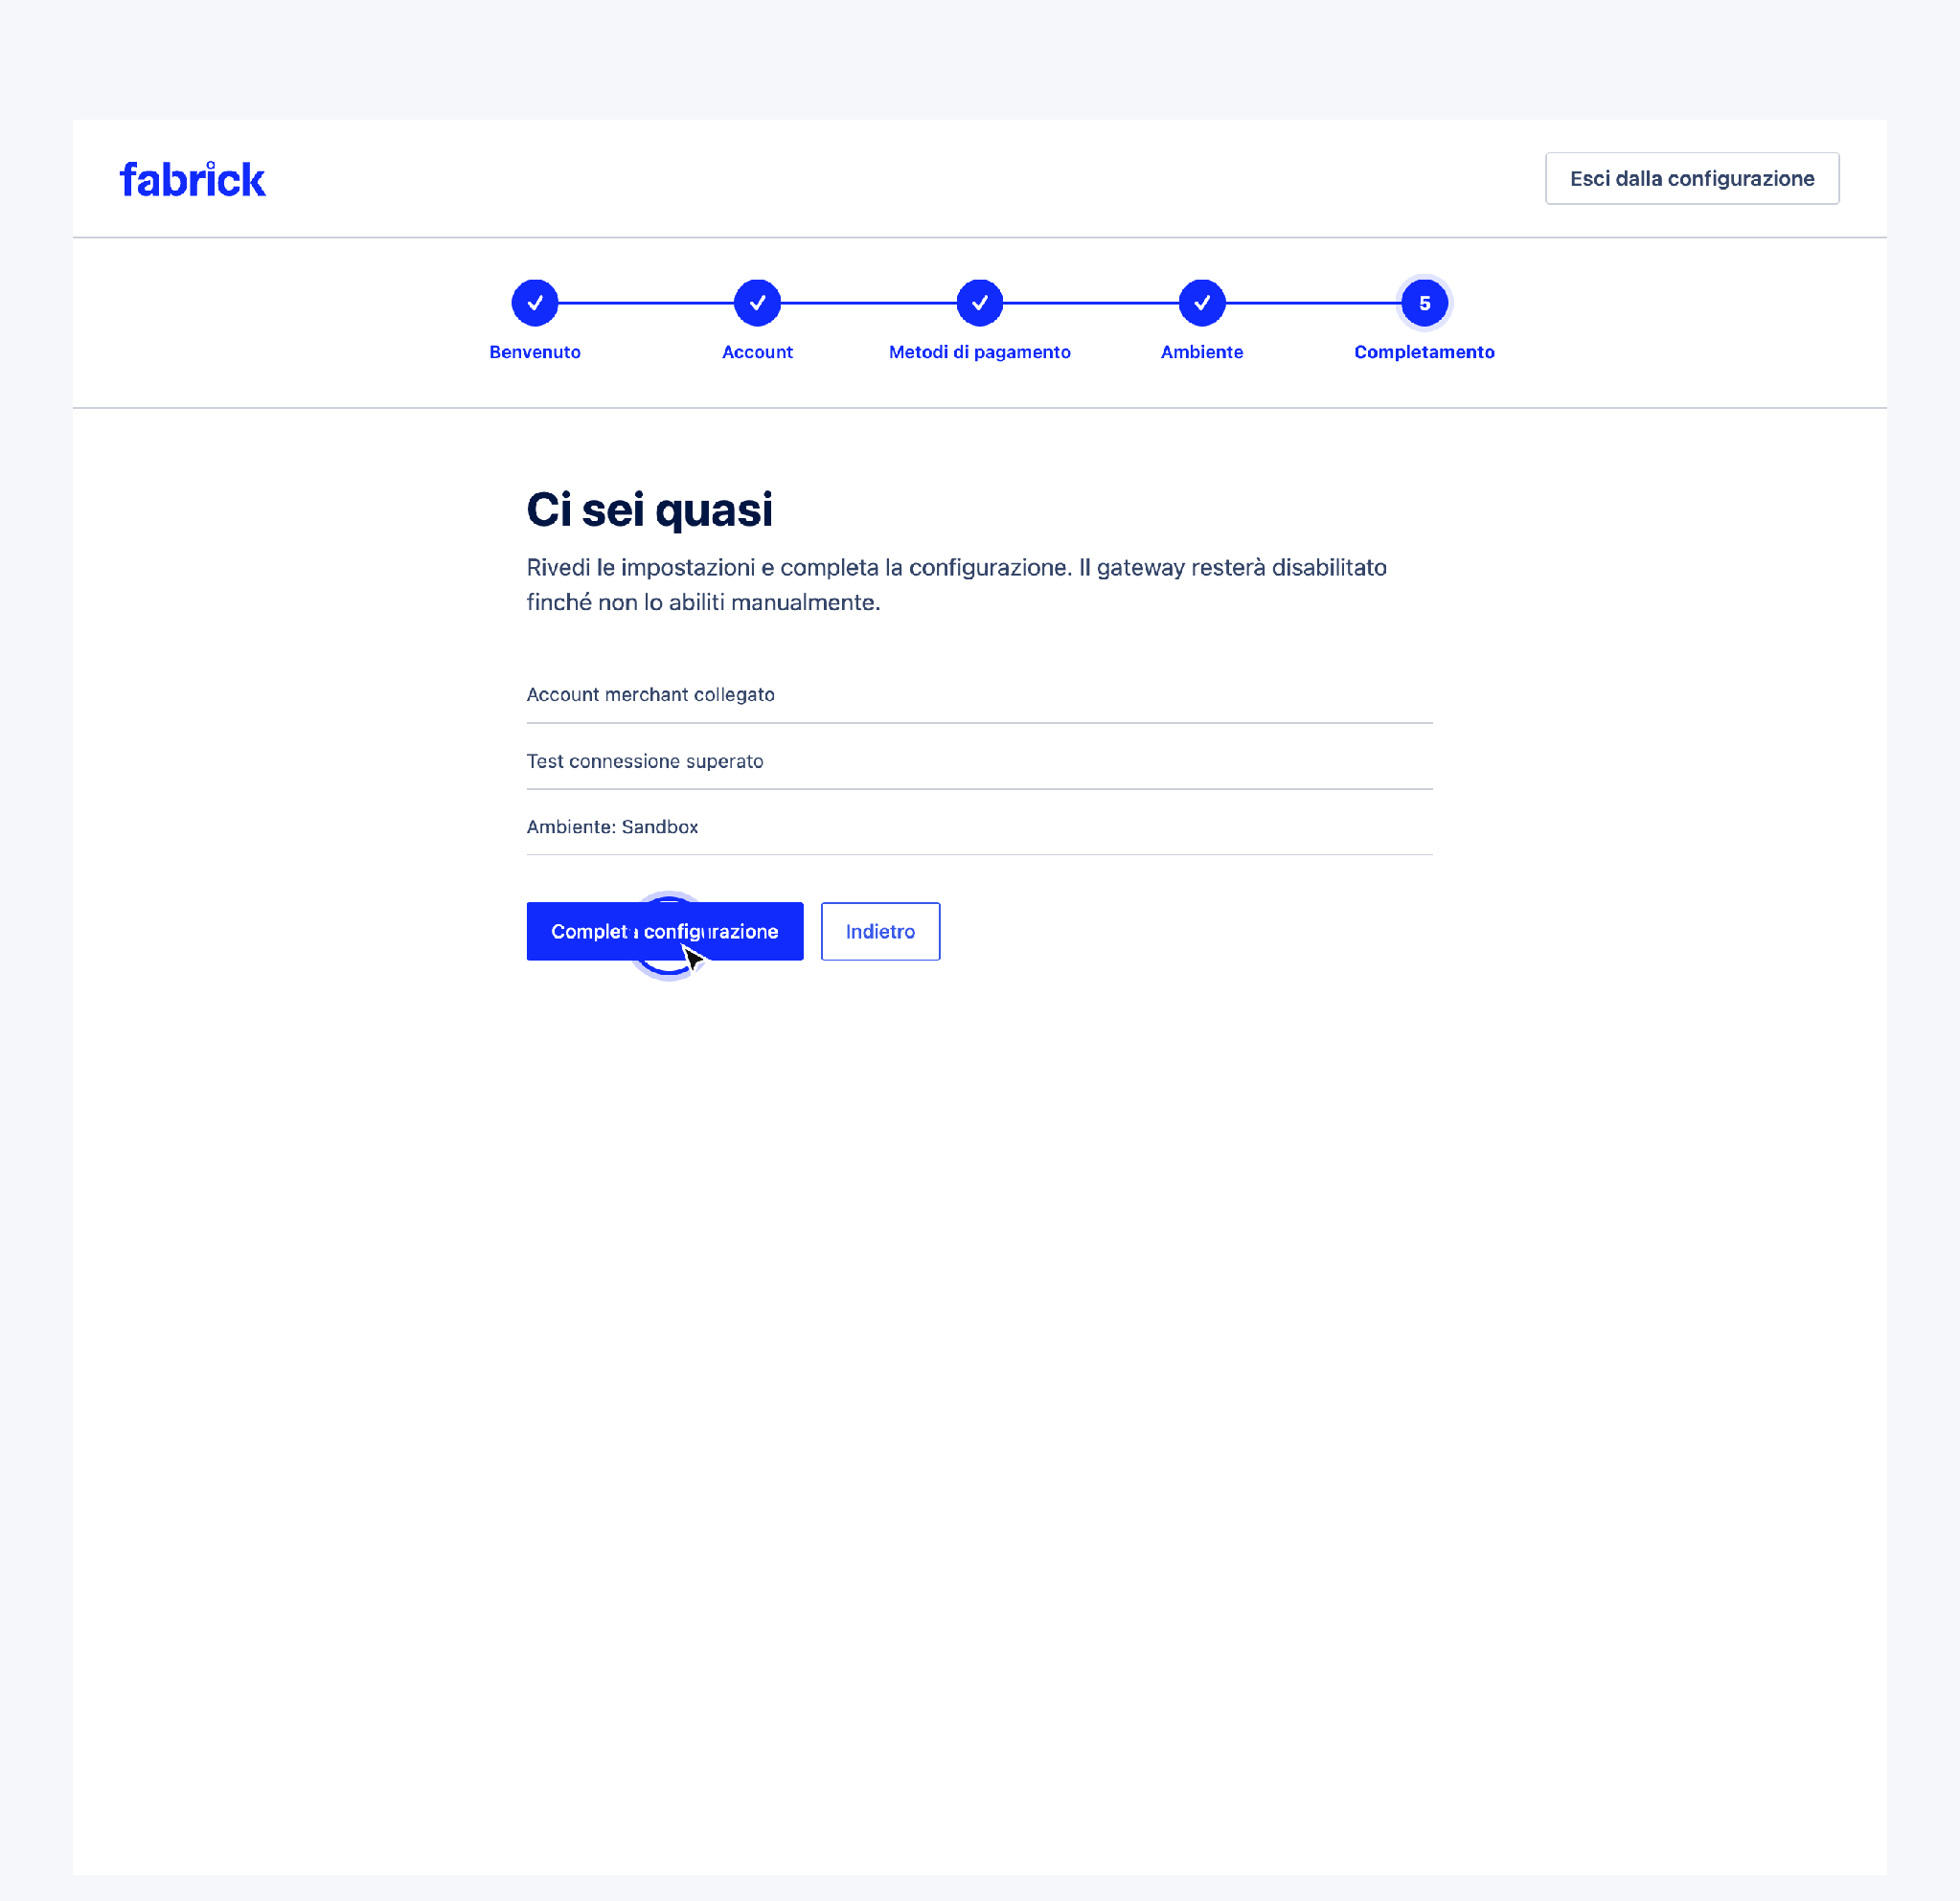
The final summary anticipates that the gateway remains deactivated until it is manually activated.

Gateway settings
Once the configuration wizard is complete, everything related to the daily operation of the payment method is governed from a single screen: the gateway tab in WooCommerce → Settings → Payments → Fabrick Payment Orchestra. Here the gateway turns on, takes the name that customers read at checkout and shows the credentials with which the store talks to the platform.
The screen corresponds to the address
wp-admin/admin.php?page=wc-settings&tab=checkout&section=fabrick_orchestra and can also be reached by clicking on the method name in the WooCommerce list → Settings → Payments. At the top, next to the Fabrick Payment Orchestra title, the Back to Payments link takes you back to the full list of methods.
The content is organized in five boxes, in order: the box with the Fabrick logo that collects Payment Environment and Credentials, then Checkout View, Payment Methods, Saved Cards and Debug. At the bottom of the page there is only one Save Changes button: it applies to all the boxes together.

Prerequisites
  - Setup Wizard complete. If it is not, opening this tab returns to the wizard and the tiles are not shown.
  - WordPress user with permission to manage WooCommerce.
  - Shop Login and API Key already verified with a successful connection test on the active environment.
  - Decision made on how to call the method at checkout, if the default name isn't the one you want to show to customers.

Procedure
- Open WooCommerce → Settings → Payments and click on Fabrick Payment Orchestra. The page opens on the five panes, with the account one at the top (Figure 1)
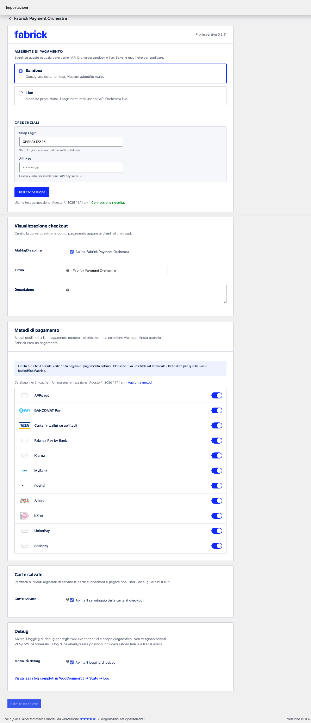
Figure 1. The gateway card collects accounts, checkout appearance, methods, saved cards, and diagnostics on a single page.

- In the Checkout View pane, check Enable Fabrick Payment Orchestra. It is the switch that makes the method visible to customers: the configuration wizard deliberately leaves it off; therefore, until you check it here, no one can pay with Fabrick (Figure 2).
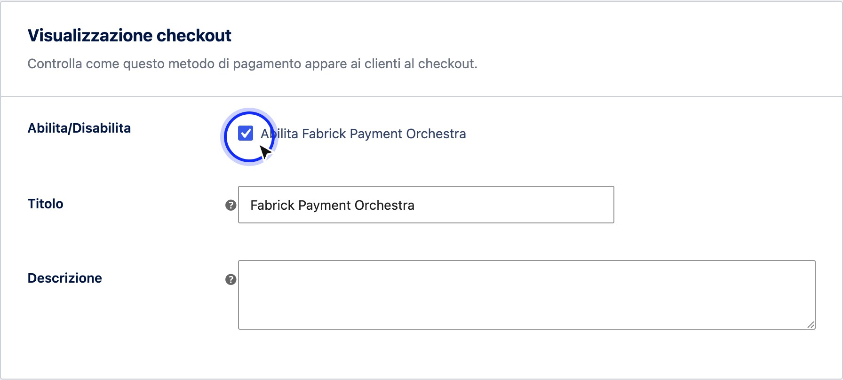
Figure 2. Enabling the gateway is an explicit check in the Checkout View pane.
- In the same box, check Title and Description: these are the two texts that the customer sees next to the payment method. The default title is Fabrick Payment Orchestra, the description is empty.
Checkout Display pane

Field | Description
Enable/Disable | Enable Fabrick Payment Orchestra box. Off at installation: as long as it remains off, the method does not appear at checkout. By turning it on, the method enters the store's payment choices.
Title | The name of the method shown to customers at checkout. Default value Fabrick Payment Orchestra: You can replace it with a formula that is more recognizable to your customers, such as Credit Card and others  methods.
Description | Optional text shown below the title at checkout. Blank by default. Useful for anticipating that the payment is completed on a secure page.

- Go up to the box with the Fabrick logo and verify the account. The Payment environment section shows which of the two environments is active, the Credentials section contains Shop Login and API Key, and below the fields the Test connection button with the status line Last connection test. The key field is masked: if a key is already saved it shows a dummy value and the suggestion Leave blank to keep the API Key saved (Figure 3).

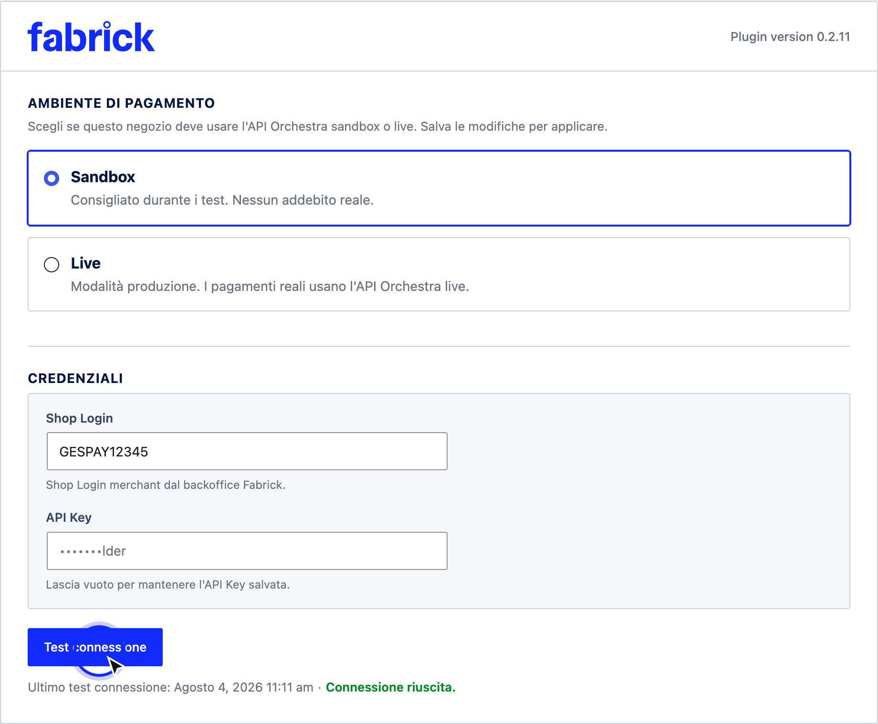
Figure 3. The account tile summarizes the environment, credentials, and date of the last connection check.

- Scroll through the last three panes to confirm that they are consistent with what you want to offer. Payment Methods lists the methods to show at checkout, Saved Cards contains a single switch for saving the card, Debug turns on technical event logging, and offers the View Full Logs in WooCommerce link → → Status Log (Figure 4)
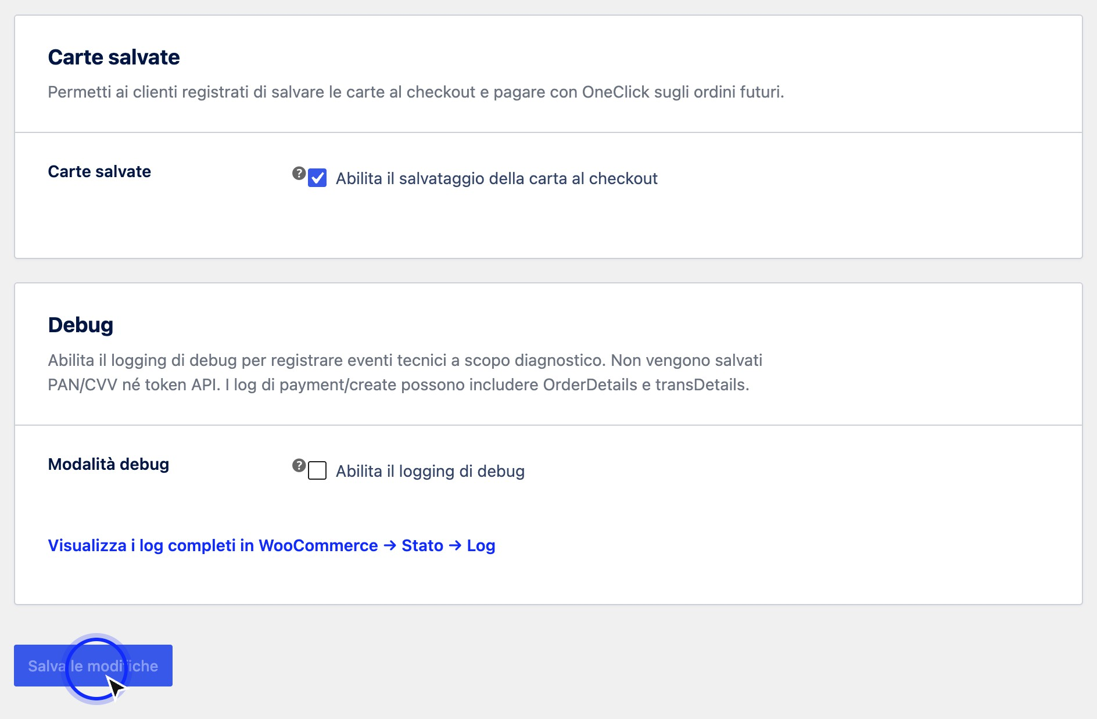
Figure 4. At the bottom of the page, a single button saves the changes of all the panes.

- Press Save changes. The page reloads with the recorded values; in the WooCommerce list → Settings → Payments, the method is active and shows the title you have chosen.

Sandbox environment and transition to Production
The store communicates with the Fabrick platform in only one of two environments at a time: the sandbox, where each payment is simulated and does not produce charges, or the live, where transactions are real and the money really moves

Hosts contacted by environment
Environment | Calls from the store server | Payment form in the customer's browser
Sandbox | https://sandbox.gestpay.net | https://sandbox-web.axerve. com
Live | https://ecomms2s.sella.it | https://web.axerve.com

Procedure
- Open WooCommerce → Settings → Payments and select Fabrick Payment Orchestra. The first card contains the Payment Environment section, with the description Choose whether this store should use the sandbox or live Orchestra API. "Save changes to apply" (Figure 1).

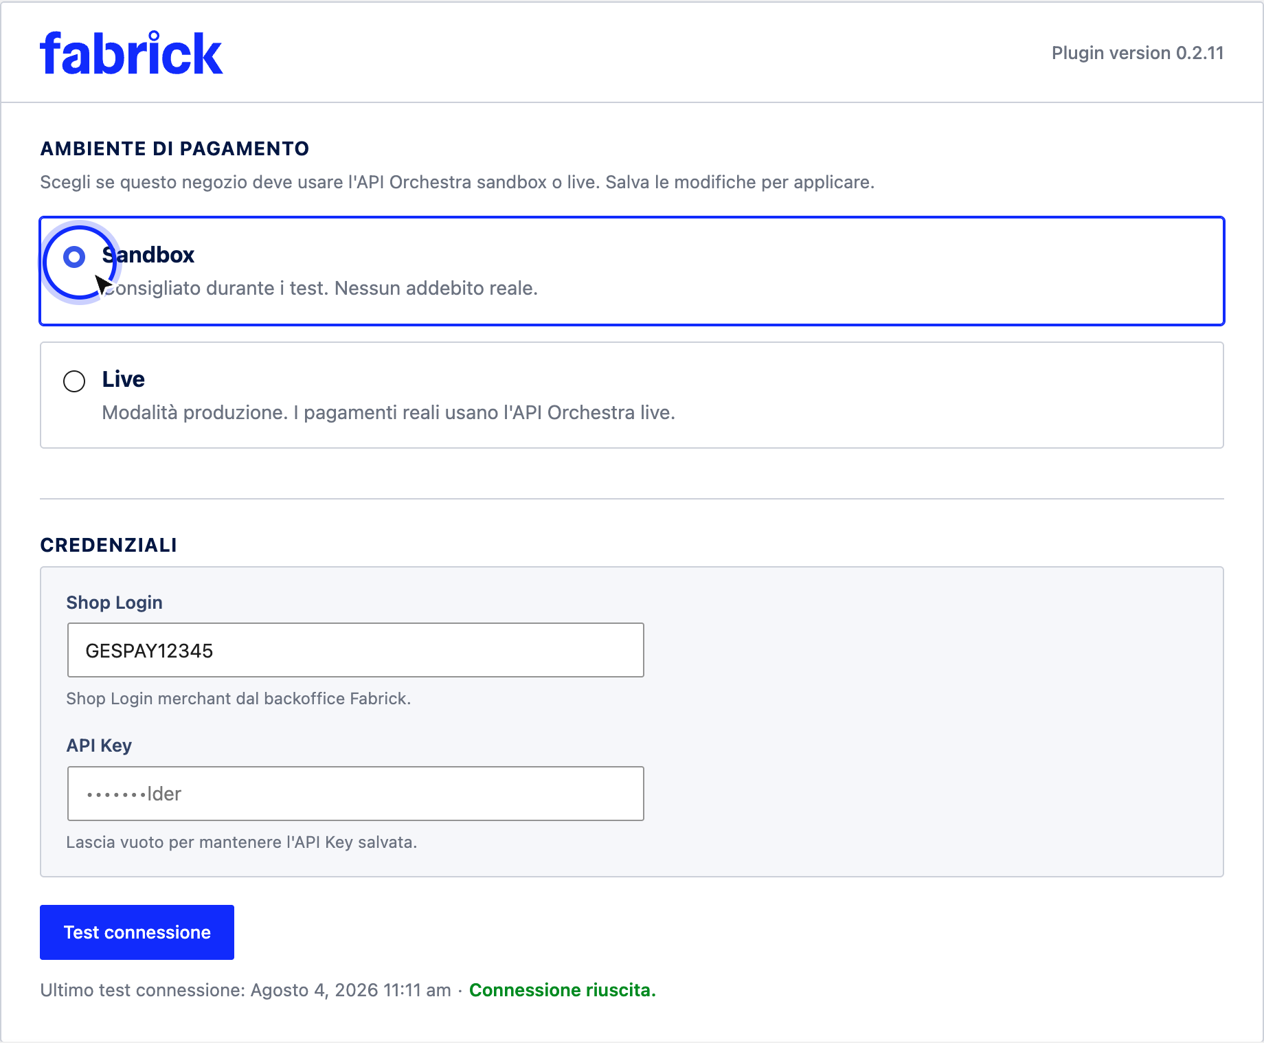
Figure 1. The initial gateway settings card brings together the environment, credentials, and connection verification.
- Before switching environments, complete the sandbox test: one successful card payment, one declined, and one test for each alternative method you intend to propose. Fabrick sandbox test cards available here

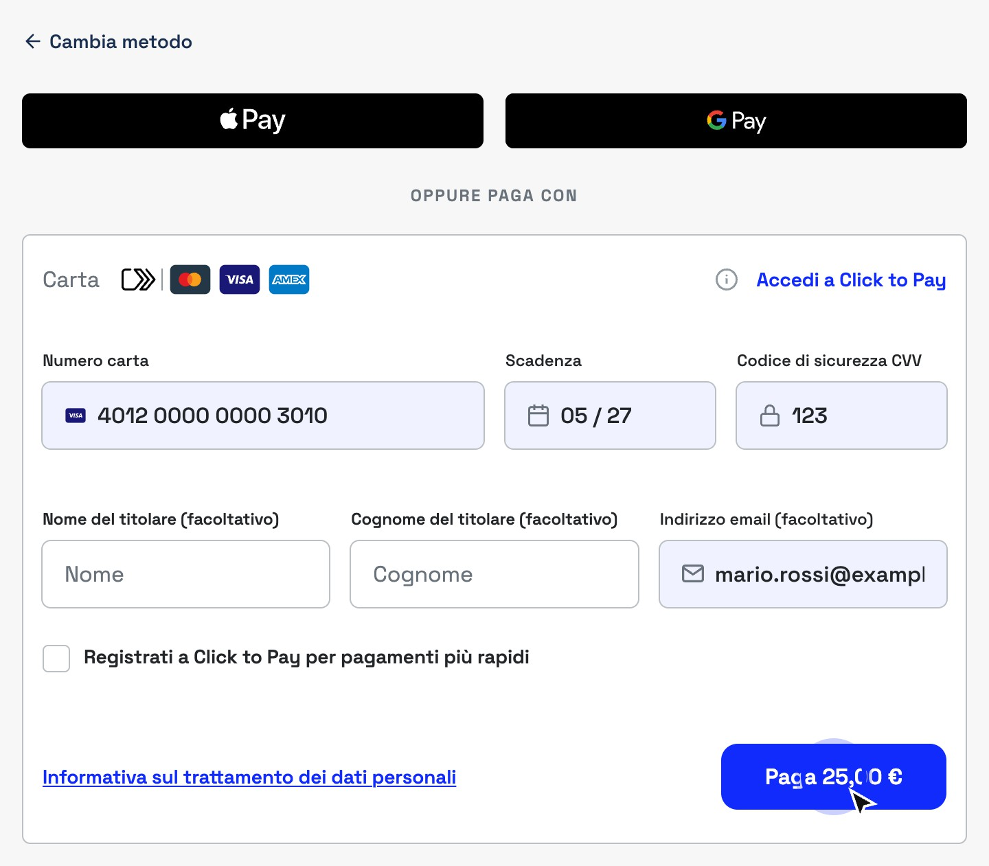

Figure 2. In sandbox, the payment module only accepts test cards published by Fabrick.
- When testing is closed, select the Live option, described as Production Mode. Live Payments use the Live Orchestra API. The Live Mode Processes Real Payments warning appears. You can switch back to sandbox at any time and the I understand that Live Mode will process real payments box – check it, otherwise the save will be rejected (Figure 3).

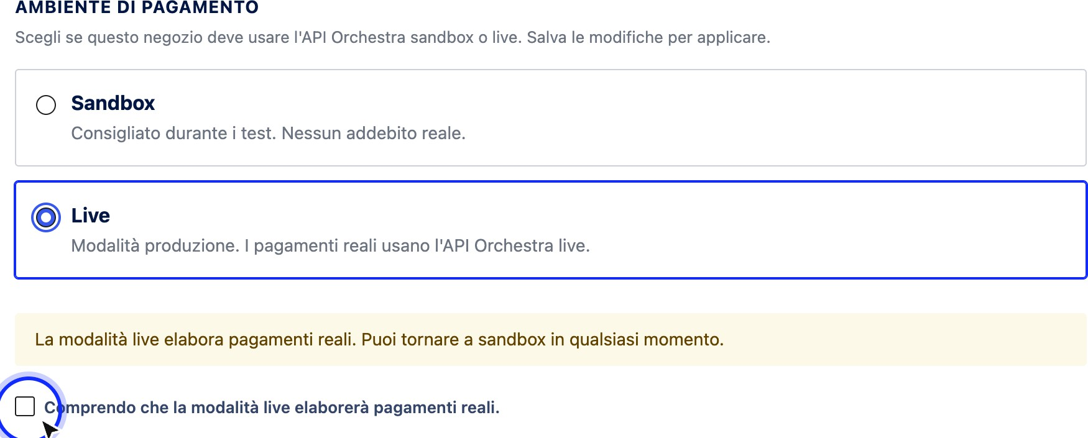

Figure 3. Selecting the live mode requires explicit confirmation before saving.
- Press Save changes. The plugin performs three operations in sequence: it returns the merchant account stored for the sandbox to the production environment, registers the new environment, and verifies the connection to the production hosts. If the verification fails, the message Test connection failed for the selected environment appears. Check the credentials and try again: the environment has already changed anyway, so the next step is not to go back but to fix the credentials.
- If your production account is different from the one used in the sandbox, now the Credentials section shows the fields of the live environment: enter the production Shop Login, paste the production API Key and save. Then press Test connection and wait for the confirmation Connection successful. The Last connection test row keeps track of the date, time and outcome of the last test.
- On the Payment Methods card, press Update Methods: The list is read back by the production terminal, which can expose methods other than the active ones in the sandbox. Check that the toggles reflect what you want to offer to real customers.
- In the Debug card, uncheck Enable debug logging, if you had it enabled for testing: the description of the field itself recommends keeping it disabled in production. Finally, check that in the Display at checkout card the Enable Fabrick Payment Orchestra box is checked and save (Figure 4). In the Shoplogin field, enter the production code

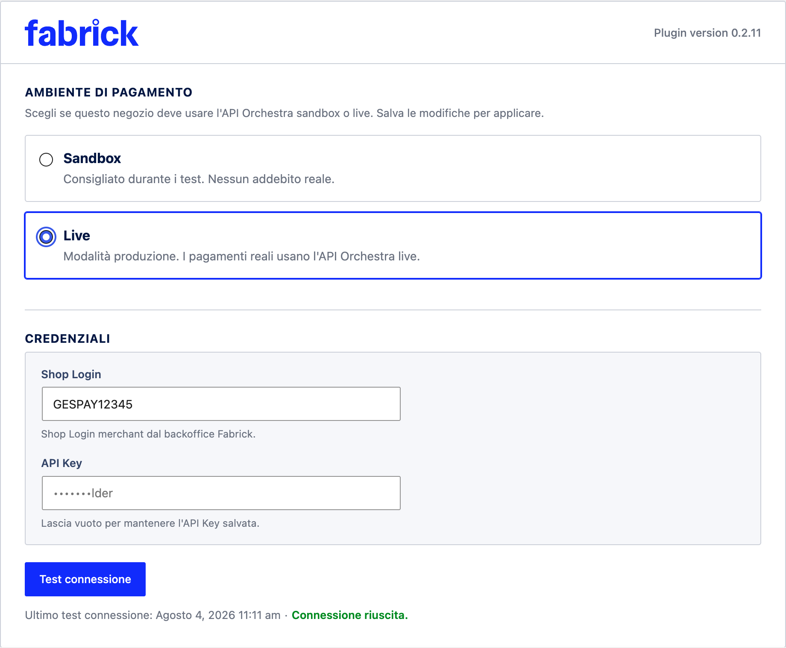
Figure 4. At the end of the step, the environment remains on Live and the status line shows the last successful test.

Step-Up Checklist

Verification | Where to check it out
At least one successful card payment and one declined in sandbox, with the WooCommerce order finished in the expected state. | Test orders on the sandbox store.
Try alternative methods you want to offer, for those that can be tested with a test account. | Checkout in sandbox, card Payment methods.
Production credentials available and stored  safely. | Backoffice Fabrick o referente Fabrick.
Contract payment methods active on the production terminal. | Fabrick sales representative: the plugin can only hide what the terminal displays, not enable it.
Agreed card handling method, because it depends on what you can do after payment has been made (total cancellation or even partial refund). | Fabrick contract and backoffice.
Outbound HTTPS calls allowed to  production hosts. | Hosting provider or system administrator.
Updated site security rules with production domains, if you apply a  Content-Security-Policy or an application firewall. | Configuring the security server or service.
Checkout served in HTTPS with valid certificate. | Browser on the real site.
Environment on Live, connection test successful, sandbox alert disappeared. | Gateway settings initial card.
Gateway enabled, title and description revised as li  will see the customer. | Card Display at checkout.

Payment methods
The gateway tab contains a section dedicated to the methods that the store offers when the customer arrives on the Fabrick payment page: card, wallet and the alternative methods provided for in your contract. Here you decide which ones to show, update the list when Fabrick activates or deactivates something on your terminal and check from which origin the list you are seeing comes.

Procedure
- Open WooCommerce → Settings → Payments and select Fabrick Payment Orchestra. Scroll down to the Payment Methods tab, under the sections dedicated to account and checkout. The description of the tab reminds you that the selection is applied when Fabrick creates a payment, and a second warning clarifies the perimeter: Limit what the customer sees on the Fabrick payment page. It does not deactivate methods on the Orchestra terminal: for that it uses the Fabrick backoffice (Figure 1).

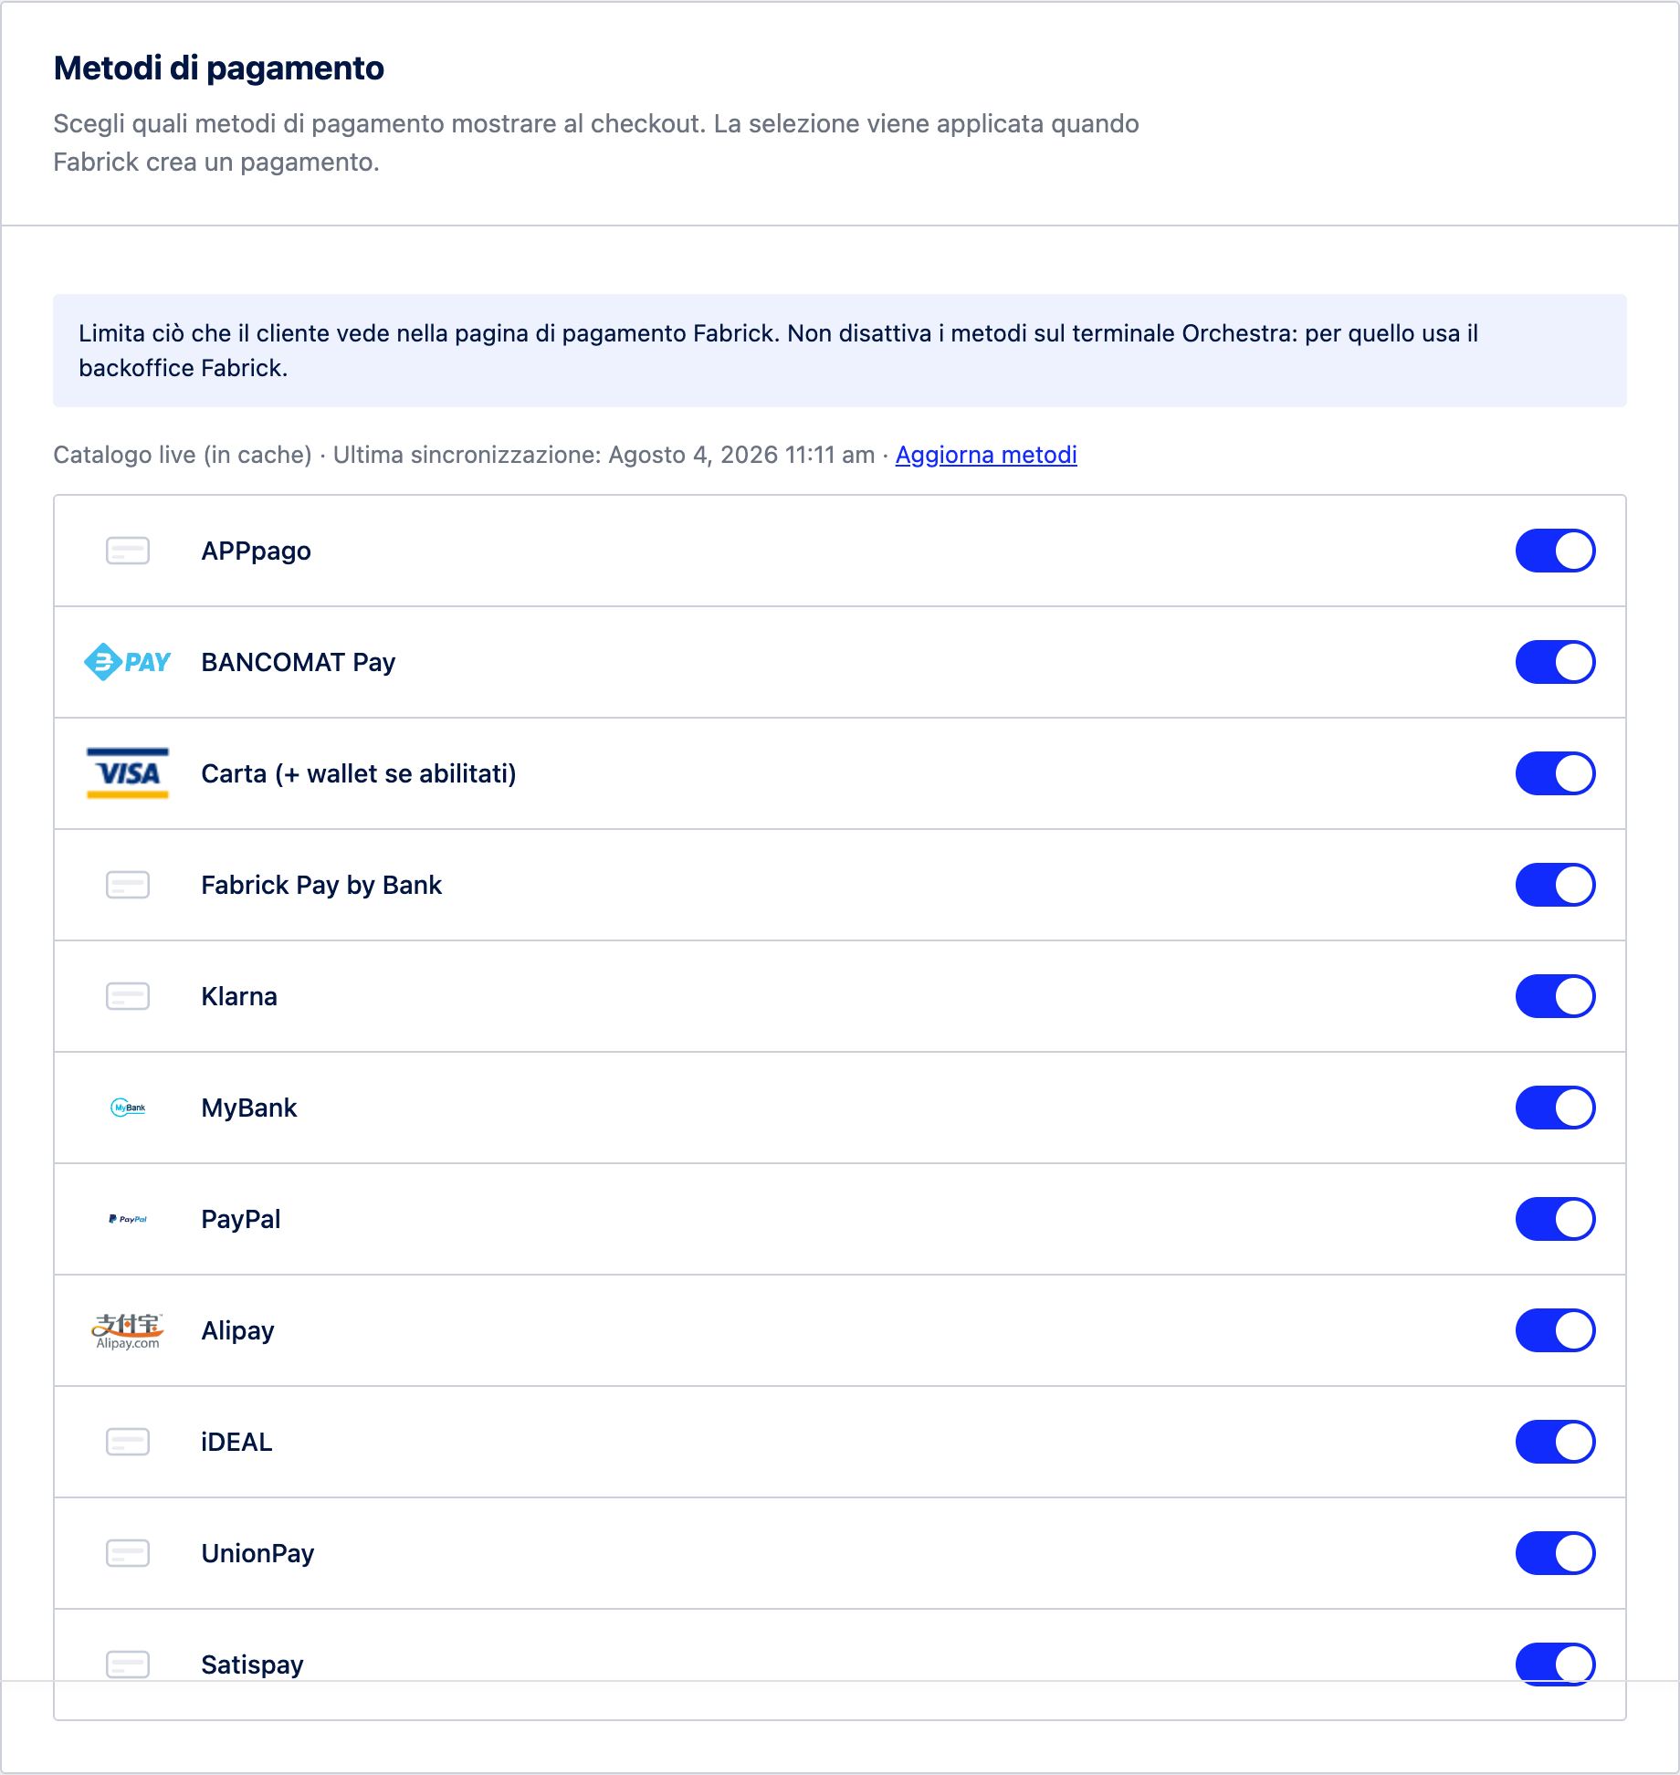
Figure 1. The payment methods tab brings together the list source, update command, and individual method toggles.

Press Update Methods to read the list again from the terminal. During the operation, Update Methods... appears; when finished, the box indicates the number of methods and indicates any differences, grouped into New Methods, Removed Methods, and Removed but still enabled in your selection. With a partial selection, the new methods show the invitation to enable them to make them visible at checkout (Figure 2).

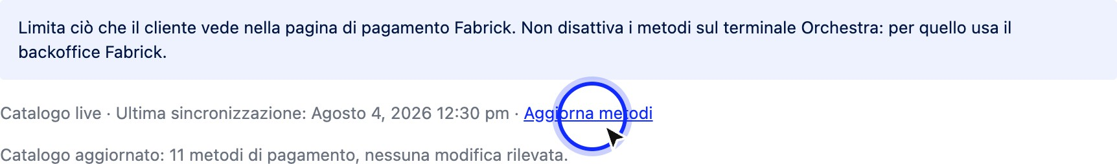

Figure 2. After the update, the plugin declares how many methods it has found and, if necessary, which ones have appeared or disappeared since the last reading.
- Scroll through the list and use the toggles to choose which methods to show at checkout. Each row has the method's logo, or a generic icon if not available, the name, and its toggle. Card (+ wallet if enabled) also includes Apple Pay and Google Pay, which don't have separate toggles because they depend on the Card category. Methods added relative to the default list are labeled New (Figure 3).
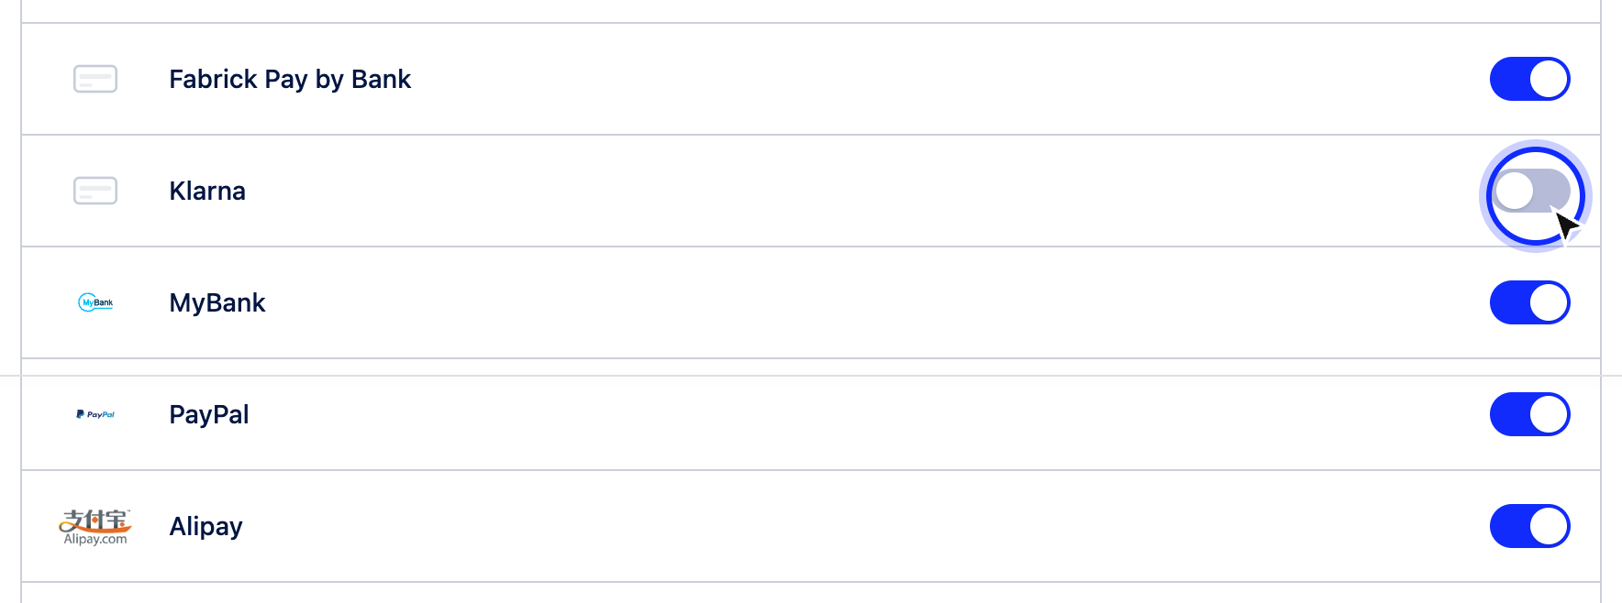
Figure 3. The off switches remain visible in the list: they are methods available on the terminal but excluded from checkout.
- Some methods cannot be deactivated by the plugin and do not show any switches. In this case, the row shows Always enabled and invites you to manage the method from the Fabrick backoffice or through your account manager. If a partial selection is active, the row shows Excluded from filter and Hidden with active filter instead: the method appears at checkout only when no filter is applied, i.e. when all switches are on.
- Press Save Changes at the bottom of the page to apply the selection. Updating the catalog and saving are separate operations: Update Methods only reads the list, while the checkout continues to use the previous selection until you save. If all the switches are on, the plugin does not apply filters and leaves it to the terminal to choose which methods to show.

The plugin also supports OneClick, PayByLink payments, and subscriptions using the WooCommerce Subscriptions plugin (not included).
For further information on operation, we recommend consulting the complete manual

